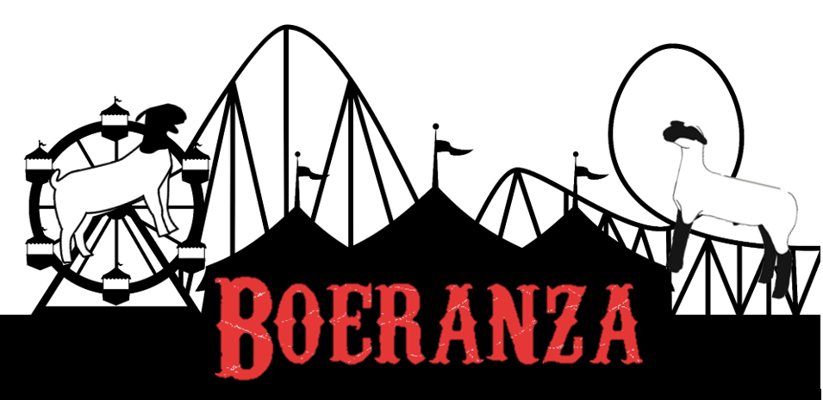

Schedule of Events

Friday November 30th
Check in 2 pm – 10 pm
Kenny’s Killer Jerky Goat Roping- 5 pm

Saturday December 1st
Check in 7 am – 9 am
JABGA Area 1 Show- 9 am
Judge: Cooper Bounds
(see JABGA Schedule)
Dorper Show- 10 am
Judge: Robert Dinsmore
South African Style Show- 11 am
Judge: Fred Homeyer

Sunday December 2nd
Check in 7 am – 8 am
ABGA Show A- 9 am
Judge: Robert Dinsmore
Jackpot Show Starting with Sheep- 9am
Judge: Matt Hayes
ABGA Show B following the conclusion of Show A
Judge: John Tart III

