Home Leisure Activities
This program was developed to encourage you to stay engaged in activities during your time at home. Participation in leisure activities is associated with improvements in physical, mental and emotional health and overall well-being. For any of the activities listed below, encourage your family members to join you in the fun. Also feel free to call your loved ones that do not live with you to share what you have done or completed! Staying connected is important!

Activity | Description | Link/Instruction
Dancing | Incorporate physical activity into your day by listening to some fun tunes while coordinating some groovy steps. The link below will help you get started. If any movement is too difficult, you can move at your own pace, enjoy the music and complete small steps side to side. If the dances are too easy, increase the challenge by completing the movements with 2-lb dumbbell weights in your hands or without breaks. If you do not have weights, you can use canned goods or filled water bottles. | Line dancing  - https://www.youtube.com/watch?v=uZXQuqPnp8g  Rumba  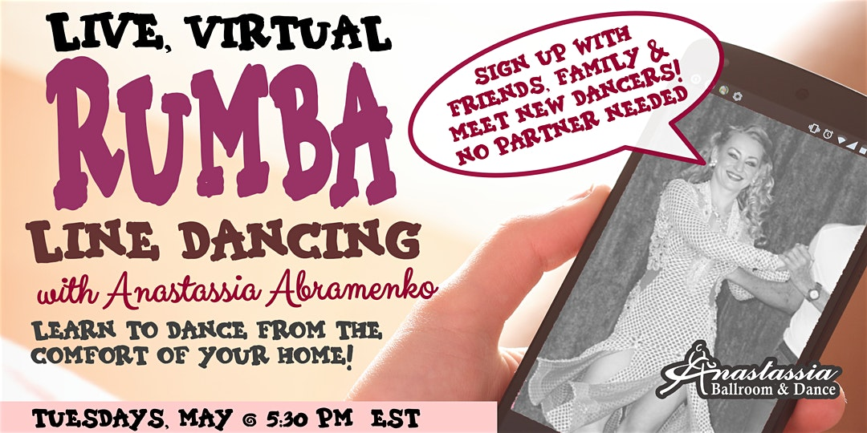  - https://anastassiaballroom.square.site/product/group-online-ballroom-dance-classes/7
Yoga/stretching | Stretch your muscles and practice deep breathing to help reduce stress and build strength. Completing these movements while seated on a sturdy chair is recommended for your safety. However, if you would like to further challenge your strength and balance, try some of these poses in a standing position while holding onto the chair. | Chair yoga  - https://www.youtube.com/watch?v=KEjiXtb2hRg  Stretching  - 19 minute chair stretching exercise for seniors  - https://www.youtube.com/watch?v=YGRje8p5gbc
Exercising | Exercise can help prevent falls, improve strength, endurance, blood pressure, bone health, and heart rate. It helps maintain the ability to live independently while decreasing symptoms of anxiety and depression. | Chair exercises  - 20 minute chair exercise for seniors  - https://m.youtube.com/watch?v=2fpIva72q_k  - https://youtu.be/azv8eJgoGLk  - Seated exercises for older adults  - https://m.youtube.com/watch?v=8BcPHWGQO44  - 5 minute simple chair exercises for seniors  - https://m.youtube.com/watch?v=iJUTvAHKYMY  - 17 min chair exercise for seniors & beginners  - https://m.youtube.com/watch?v=H9eKsp6faJA  Home workouts  - National institute on Aging sample workout for older adults  - https://m.youtube.com/watch?v=Ev6yE55kYGw  - 15 minute senior workout - low impact exercises  - https://m.youtube.com/watch?v=2fpIva72q_k  - Senior home workout  - https://m.youtube.com/watch?v=DKNDAiSvNbc  - Home exercises for seniors  - https://m.youtube.com/watch?v=LxFT78_Iz-c  Walking  - Take a nice stroll around your neighborhood to get some fresh air and exercise. Make sure to walk with someone to ensure your safety if you need assistance and don’t feel comfortable walking alone.
Meditation | Helps improve blood pressure, heart rate, anxiety, and relieves stress. It is important to do at least one meditation activity/exercise a day. Find a quiet space outside or in your home. These activities can be completed seated or lying down. | Journaling  - Journal is a great way to record your favorite memories, activities you enjoy doing, things you want to be able to do or even what you did yesterday. Reflection is key for progression! Use your favorite journal/notebook and an assortment of writing utensils such as pens, pencils or bold markers. https://www.youtube.com/watch?v=bbZWX9QZESc  Bird watching  - Grab a pair of binoculars, a bird book, and your outdoor gear and enjoy the peaceful sounds of the birds.  Deep breathing exercises  - https://www.therapistaid.com/worksheets/deep-breathing-worksheet.pdf  - https://m.youtube.com/watch?v=bvdzTs0m510  Meditation online session  - May be required to register online at:  https://www.eventbrite.co.uk/e/zoom-mental-health-immunity-strength-kunadalini-yoga-pranayammeditation-tickets-100634840517?aff=ebdssbonlinesearch  Listen to calming music  - https://m.youtube.com/watch?v=V1RPi2MYptM  - https://m.youtube.com/watch?v=hlWiI4xVXKY  - https://m.youtube.com/watch?v=HmLdWMG6q7w  - https://m.youtube.com/watch?v=go99WqXWGgk
Cooking/Baking | Challenge your physical abilities and thinking skills by preparing a tasty snack or meal. Make your favorite recipe/baked good! Remember to gather all of your materials first placing them within reach and take seated breaks as needed. Please ask for assistance with hot, sharp or heavy items as needed. If you need adaptive tools to assist when cooking, use this link:  http://mdod.maryland.gov/mdtap/Pages/MDTAP-Home.aspx  https://www.alimed.com/household-kitchen-aids/
Gardening | Gardening provides some outdoor opportunity to work in the sun. It’s relaxing and a great way to move and work with nature. | Raised bed gardens  - This will eliminate excessive bending.  Container gardening  - http://www.vistaspringsliving.com/blog/container-gardening-for-seniors
Trivia | Test your knowledge and stimulate your brain with trivia. | Online games  - https://www.youtube.com/channel/UCEZ-7-zxRLt9i2pAsZlGaFg  - https://www.youtube.com/watch?v=ekXW7LC3Aek  - https://www.youtube.com/watch?v=c3gy-HNSguo  - https://www.youtube.com/watch?v=v3a6ANixZ0c  - https://www.youtube.com/watch?v=Ye4MoJvD1F0
Arts and Crafts | Arts and crafts are amazing. They are good for the brain. It improves motor skills, reduces stress, and exercises your creativity. If you need adaptive tools to assist you, use these link:  http://mdod.maryland.gov/mdtap/Pages/MDTAP-Home.aspx  https://www.dickblick.com/categories/studio/adaptive-art-supplies/ | Scrapbooking  - Gather some of your favorite pictures, construction paper, scissors, tape and markers and exercise your creativity to create a collage full of memories. Your scrapbook can be related to a variety of topics or one specific event. You can also create a collage of your favorite things (outfits, foods, vacation spots) from a magazine/newspaper and create a vision board. If you have difficulty with cutting, slowly fold and tear the paper.  Make beads or pendants out of salt and dough beads  - https://www.youtube.com/watch?v=0SmfpX-GmDs  Color  - Scroll down for the coloring pages. https://www.goldencarers.com/pdf/4244/  - Scroll and select pictures of paint or coloring templates  http://www.supercoloring.com/collections/coloring-pages-for-seniors
Caregiver/Family Activities | Enjoy some family time with some of these exciting activities. These are activities that your caregiver can do for you or with you. Some options may even be applicable to the entire household. | Spa and self-care day  - Have your caregiver or loved one treat you to a spa and self care day with massages, skin care activities, manicures, and more.  Plan a paint night  - Painting activities can be challenging. If you are having trouble use adapted paint brushes, slant boards, dish scrubbers, and large canvases. Make sure the picture you are painting isn’t too complex and includes bright colors, a high contrast, or raised line drawings. Materials with scents and textures will also help guide you as you paint.  Plan a movie night  - Movies are always fun to watch. I challenge you to stand and stretch after each commercial or do a workout after each finished movie.  Make a family cookbook  - Put family recipes together in a book to pass along to other members in the family.

