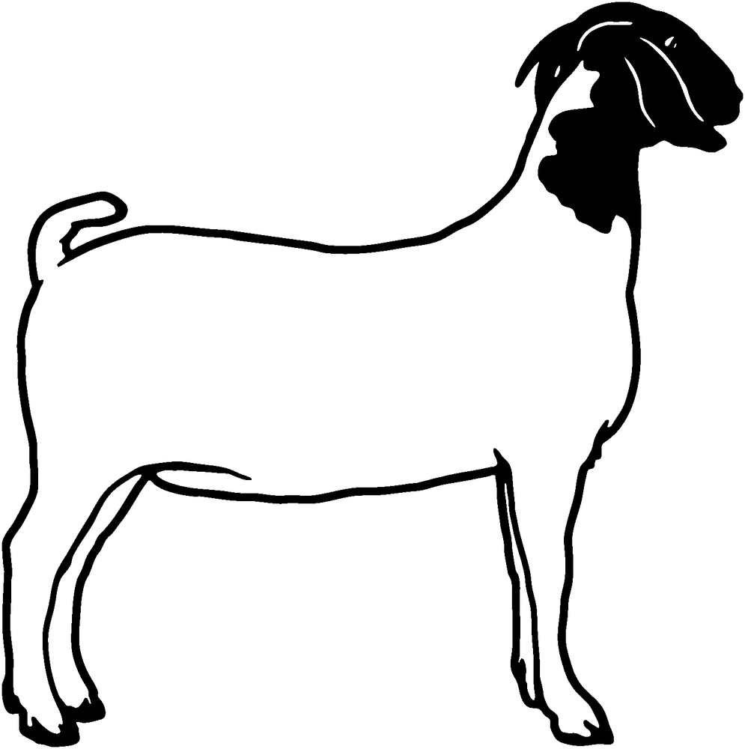
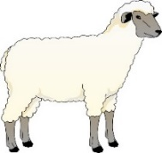
2ND Annual Mason County Showdown
Market Lamb & Market Goat Jackpot Show

Dear Prospective Sponsor:
The Mason County Showdown Committee will be hosting the 1st annual Market Lamb and Market Goat jackpot show on July14, 2018 at the Mason County Fairgrounds. This will give the youth an additional opportunity to present and show their market animals prior to their county fairs. The youth will receive cash awards for the Grand and Reserve Champions in the market shows. The Market showmanship winners will also receive a cash award.
We are looking for businesses and individuals to help support the Mason County Showdown through their donations. Your donations will be used to help offset the cost of the show and awards. We will announce sponsors during both shows and we will list the sponsors on our website and facebook page. Sponsors will also have the opportunity to hang a banner in or around the showring (sponsor must provide banner).
Thank you for your continued support of the youth livestock exhibitors in our area.

Name: ___________________________ Business Name: ________________________

Address: ____________________________________________________________________

Phone: ___________________________ Email: _________________________________

Please circle which show and award you wish to sponsor:

Market Lambs Market Goats

Grand Champion - $250 Grand Champion - $250

Reserve Champion - $100 Reserve Champion - $100

Showmanship - $25 Showmanship - $25
Please choose division: Pee Wee / Junior / Senior Please choose division: Pee Wee / Junior / Senior

Other - $ ________ Other - $_________
For more sponsorship information contact:
Heidi Wood
304-593-5363
hjsturgeon2002@yahoo.com
Please make checks payable to Mason County Fair and mail to:
Heidi Wood
Mason County Showdown
757 Stoneybrook Drive
Point Pleasant, WV 25550

