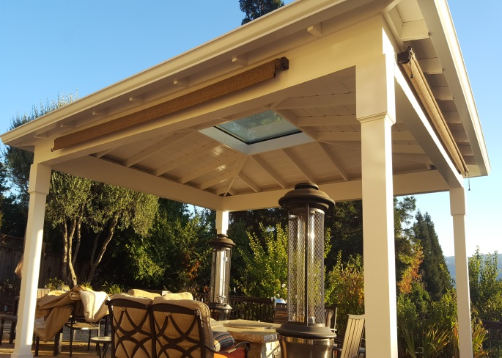

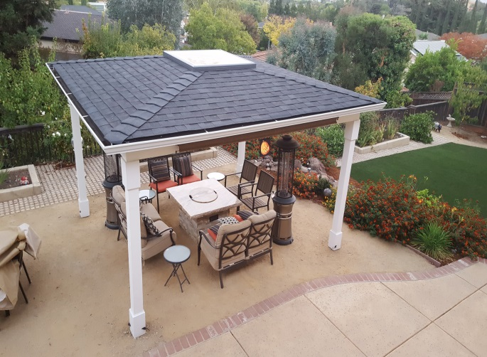
Hello from Howard Lamcke. Fall has arrived, my favorite season, as soon as it cools down a bit! Ordinarily we would decorate our newsletter with a picture of colored leaves, or pumpkins, or maybe my skeleton pirate themed graveyard extravaganza currently being erected for Halloween night. Instead we have a picture of a backyard pavilion that we are particularly proud of. It was designed by Howard and expertly constructed by Kenny and his crew. Perfect for enjoying the fire pit on those autumn nights. But more about that below.
The pace of construction has not slowed one bit. Based on the number of plans we have seen, it appears that next year will continue to be busy. Plan early and be patient. We have a large crew that does most of the trades “in house”. We are able to complete many projects without waiting to schedule a lot of subcontractors. God bless our wonderful tile man and his very professional crew for keeping up with the pace. We look forward to seeing you soon!
On a very personal note, we lost one of our “customers for life” this year. I worked for Sylvia for almost 40 years; she was like a second mother to me, and a dear friend. She had the unique ability and need to connect with each man who worked in her home over the years. Our entire crew is deeply saddened for her passing. I’m having a glass of wine at the fire pit for you, Sylvia!

Pavilion
We love this hip roof pavilion. The total size is 14’x12’. It is anchored in the ground with 4 poured concrete piers and wet set post bases. The posts and beams are Douglas fir. The beams are mitered at the corners with angle iron rabbited in to the posts for shear strength. The hip roof is framed with redwood con common lumber and the rafters are bolted into the beams. The ceiling/roof sheathing is laminated 1x8 V rustic siding. At the center is a 4’x4’ Velux fixed glass skylight. The roof is composition shingles with a seamless ogee gutter and one downspout. A little trim on the posts and a Kelly Moore durapoxy paint finish complete the look.
All the materials are top quality and the look is very professional. The four corner hip design generates a lot of waste for materials, and is quite labor intensive. An added touch are the retractable shades mounted on the beams. Ten foot wide, they sell for around $125 at Home Depot. Altogether, this project would cost between $15,000-18,000. I even built the fire pit. But that’s another story!

