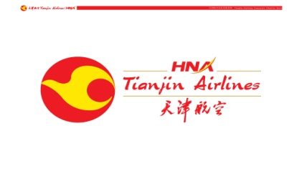
Tianjin Airlines Application Form
Apply for the position:
- Captain
- First Officer
Please attach a recent passport-size photograph of yourself here. | Full Name  (name on passport) |  |  | Languages spoken  (Indicate Ability) |  | Gender
 | Nationality |  |  | Country of Birth |  | Date of Birth (DD/MM/YYYY)
 | Marital Status |  |  | Religion |  | E-mail
 | Cell Phone No. |  |  |  | Home Tel. No.
Current Address
Apply for aircraft type | □ A320 □ A330
PHYSICAL STATUS | Heights in CMs |  |  |  | Weights in KGs
How did you learn about this job advertisement? |  |  |  | - Captain friends | - Aviation websites |  |  | - Agency
 |  |  |  | - Advertisement | - Magazines
Highest education degree
ICAO English level on License?

FLYING  LICENCES | ⋅Licence Type/Validations | Licensing Country | Type Ratings | Number | Valid Until(D/M/Y)

TOTAL FLYING HOURS IN YOUR CAREER: (H)
Flying Hours, By Type (please give as many aircrafts type as you can and give separate details on EMB140 and EMB145 if applicable, please make sure to fill in the details of last SIM and most recent flight)
Aircraft  Type | Total Time | Command  Time | Co-Pilot Time | Instructor Time | Date Of Last SIM Check and most recent flight (D/M/Y)

TOTAL FLYING LAST 6 MONTHS
Aircraft | Command Time | Co-Pilot Time | Instructor Time

Training Qualifications
Company Name | Aircraft Types | Training Type(TRE,TRI,CRE,CRI,FI) | Specify Approvals i.e. Line Base,Sim,CAA,FAA
Remark | TRE: Type Rating Examiner; TRI: Type Rating Instructor; CRE: Class Rating Examiner; CRI: Class Rating Instructor; FI: Flight Instructor ; LTC: Line Training Captain.

Medical Information
Class |  | Starting Date (D/M/Y) | Expiry Date (D/M/Y)
Remark | TRE: Type Rating Examiner; TRI: Type Rating Instructor; CRE: Class Rating Examiner; CRI: Class Rating Instructor; FI: Flight Instructor; LTC: Line Training Captain.

Passport Information
National ID/ Passport No. | Starting Date (D/M/Y) | Expiry Date (D/M/Y)

Interview Experience in Chinese Airlines（Including in China and abroad）
Company(in China) | Interview Time | Reasons of failure or not continue
EMPLOYMENT HISTORY
COMPANY | Country | FROM | TO | POSITION | AIRCRAFT TYPE

Chief Pilot’s information of the last company
COMPANY | Chief Pilot’s name | Telephone number of his office | Email

Any accident / incident: …………………………..………………………………………………
Availability for next two months: ………………………………………………………………..
Notice Period …………………………………………………………..…………………………

I promise the information above is true and correct。
Signed… (print) Date…
Please keep this form in word format, Thank you.

