**CENTER DIRECTOR: NANCY LEE**

**ASSISTANT DIRECTOR: DEANA DILLON**

**TELEPHONE: (614) 837-3020 / FAX (614) 833-6471**

**HOURS: MON-FRI: 8:30 a.m. - 4:30 p.m.**

|  |
| --- |
|  |

**WEB PAGE:** [**http://pickeringtonseniorcenter.org**](http://pickeringtonseniorcenter.org)

**EMAIL:** [**NLee@pickeringtonseniorcenter.com**](mailto:NLee@pickeringtonseniorcenter.com)

**EMAIL:** [**DDillon@pickeringtonseniorcenter.com**](mailto:DDillon@pickeringtonseniorcenter.com)

|  |
| --- |
| **Follow us on Facebook at:**  **Pickerington Senior Citizens Center** |

**DONATIONS**

Just a reminder you can donate any amount you would like to our center. The money donated helps with the purchase of items needed for our kitchen, office, and other supplies.



Jim Brackbill, Annette Breeckner, Terri Campbell, Teresa Christy, Barb DeBoard, Roger Phillips, Laura Ray, Dianne Schlicher, Ellie Schneider and Jerry Woodruff.

**SUNDAY / NOVEMBER 5TH**

Daylight Savings Time ends the first Sunday in November. Remember to set your clocks back one hour before retiring on Saturday night.

This is also a good time to check the batteries in your smoke detectors, carbon monoxide detectors, and other electronic devices. Please don’t climb on ladders or chairs to change them. Ask one of your kids or a neighbor to take care of it for you.

**TUESDAY, NOVEMBER 7TH**

**GENERAL ELECTION DAY**

Pickerington Senior Center will be closed

**VOLUNTEER OF THE MONTH**

Our Center would like to honor Steve Tedrick as volunteer for the month of November. Steve calls Bingo every month and helps out anytime we ask for help. Steve will receive a $15.00 gift card. Enjoy your reserved parking space for the month.

**HEALT2TOE FOOT CARE SERVICES**

**Thursday /November 30th / 9 a.m.**

Tonia is a State of Ohio Registered Nurse. She charges $35.00 for the following:

* 30-minute treatment – Trim, thin & file nails
* Corns & callouses filed & buffed smooth
* *All* tools are sterilized for each patient
* Payment due at time of service – Self-pay only
* No Medicare or Insurance will be billed

To schedule an appointment at our Center call: HEAL2TOE FOOT CARE SERVICES (614) 686-3646.

**BOARD OF TRUSTEES ELECTION**

**DECEMBER 12th**

We will be electing three members for our Senior Center Board of Trustees. They will be serving for the next three years. We have two Board members that are up for re-election: Pat Carroll and Vickie Witten. The following members would like to run: Bill Cook, Faith Hoek, Jan Holmes, and Jimmy Schumacher. Stop in and vote from 8:30am - 3:30pm or sign up for our Christmas party that’s being held on the 12th and vote while you’re here.

**SOUP DINNER AND BINGO**

Thanks to Annabelle Marion for being in charge, Julia Archer, and Patty Bond for making the bean and vegetable soups, and to the kitchen helpers Cecelia Behrens, Jeanne Carroll, Shirley Coburn, Karen Edwards, and Vickie Witten.

**UPCOMING ANNUAL BREAKFAST WITH SANTA**

**Saturday, December 2nd.**

**Seating times: 8:00, 9:30, or 11:00 AM.**

Pancake Breakfast, Music, Secret Santa Shop, Bake Sale, Crafts & fun for the whole family! The cost is $10 per person and 1 and under FREE! Everyone must purchase a ticket.

**No tickets sold at the event.**

**Tickets available online starting November1st** [WWW.PICKERINGTON.NET](http://WWW.PICKERINGTON.NET)

Questions? Contact Parks and Recreation at City Hall

614-833-2211

**EUCHRE TOURNAMENT**

Thanks to Patty Bond and Sunny Schewe for hosting the 15th Euchre Tournament.

**STRENGTH CLASS**

**Mondays and/or Wednesdays / 10 - 11 a.m.**

Join us for our strength classes led by Kelley Deibert. The focus is on building upper and lower body strength, stretching, and improving your balance. If you have weights, please bring them with you.

**LINE DANCING**

**Mondays / 11:15 a.m. - noon**

Line Dance Classes November 6th, 13th, and 20th. There will be a Holiday break for the remainder of the year and resume on January 8th, 2024. You can sign up for 12 weeks for $12 or register to “pay-per-class” at $1 per class. Sign-up forms are available in our office or from our instructor Marilyn. Make checks payable to Marilyn Morgan.

For additional information contact Marilyn at: [mnm@columbus.rr.com](mailto:mnm@columbus.rr.com)

**BID EUCHRE**

**Mondays / 12:30 p.m.**

We play bid euchre every Monday.

**WATERCOLOR CLASS**

**Every Monday / 1-3 p.m.**

Join Jenene Warmbier for adventures in watercolor painting. Jenene is a great teacher. No previous training, or talent necessary, just the desire to express yourself with “Paints and Brushes.” You can stop in our office and get a list of supplies you will need for the class.

**CORNHOLE**

**Every Tuesday / 11 a.m.**

We play Cornhole every Tuesday. We have a tournament on the last Tuesday of each month. with prizes for the winning team. *The winning team for October was Richard Anderson & Richard Villec.*

**AFTERNOON MATINEE**

**Tuesday, November 14th / 1:15 p.m.**

Join us at our Center for a classic movie on our big screen t.v. The movie for the month of November will be ‘North to Alaska,” an adventure-comedy set in the hey-day of the Alaskan gold rush, starring John Wayne, Stewart Granger, Ernie Kovacs, Fabian and Capucine. We supply movies, popcorn, snacks, coffee, and water. You may use our chairs or bring your own folding chair.

**BOOK CLUB**

**FRIDAY, NOVEMBER 17TH**

**“LESSONS IN CHEMISTRY”, by Bonnie Garmis**

The meeting is at the Senior Center in the Library at

9:30am. New participants are welcome, If you have any questions call Carole Pruiksma, 614-558-2190.

**CRAFT GROUP**

**Every Wednesday / 10 a.m. – noon**

Our craft group offers fun activities for our members, but also raises money for our Center. They provide tray favors for two carry out meals which our Center provides for our shut-in members. Anotherimportant fundraising activity the Craft Group participates in is our Breakfast with Santa, usually held on the first Saturday of December.

**SEWING CIRCLE**

**Every Wednesday / 1:00 – 2:30 or 3:00 p.m.**

We now have a sewing circle and would love to have anyone interested in sewing, knitting, crocheting, cross stitch, or needlepoint come and participate. We get together to sew and socialize in our craft room. Bring along your own project and materials and join us!

**DUPLICATE BRIDGE**

**WEDNESDAYS / 9:30 A.M.**

**AND**

**BRIDGE THURSDAYS/ 12:30 P.M.**

We are looking for more members to play Bridge. Anyone interested in joining us, please call our Center and give your name and phone number. The cost to play either Bridge or Duplicate Bridge is $1.00 per week.

**EUCHRE**

**Every Wednesday / 12:30 p.m.**

Come in, join your friends, and play some Euchre. We start playing at 12:30 p.m. The cost is only $2.25 which includes the games and the loner pot. Please be here at least 10 minutes ahead of time to get signed up so we can begin on time at 12:30.

**TITLE BOXING**

**Thursdays / November 2nd, 9th & 16th**

Maria Manzo from Title Boxing will lead the class from **9:15 to 10 a.m.** Sessions are around the Rock Steady Boxing curriculum which increases the neuroplasticity of the brain to help produce healthy brain cells. The exercises are designed to improve quality of life, have fun, and get results. You can purchase a bag and gloves for $35.00 at the class.

BINGO

**Tuesday/November 28th/ 1:00pm**

No Potluck this month. Bingo starts at 1:00 p.m.

The cost is $1.50.

**CHAIR VOLLEYBALL**

**Thursdays / 11:30 a.m. /Nov. 2nd, 9th, 16th & 30th**

We play Chair Volleyball at our Center on Thursdays. It’s led by Darie Wilson. We now have 2 nets. If you have any questions, please call Darie at (740) 358-6394.

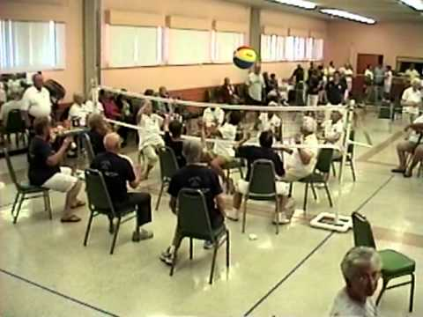

[This Photo](https://rcanogilabert3.blogspot.com/p/videos_75.html) by Unknown Author is licensed under [CC BY-SA-NC](https://creativecommons.org/licenses/by-nc-sa/3.0/)

**FRIDAY FITNESS CLASS**

**Every Friday / 9:15 – 10:00 a.m.**

This is a 45-minute Cardio Class. It’s a total workout. Come see the power you have and make great things happen for your health and well-being. We have plenty of room for you to move and groove to great music with instructor Maria Manzo.

**PICKLEBALL**

**EVERY FRIDAY/10:30 a.m.**

Join your friends for this fun game of Pickleball. If you have never played our instructor Fred will be happy to teach you.

**SOCIAL EUCHRE**

**Every Friday / 11 a.m.**

This is a relaxed pace Euchre game where we can meet and play cards non-competitively. If you like to play cards for fun and you don’t mind teaching others when needed, then please join us.

**PICKERINGTON FOOD PANTRY**

Some of the most needed items are personal hygiene products, soap, paper towels, toilet paper, toothpaste, toothbrushes, spaghetti & sauce, juices, condiments, Cooking Oil, tomato (paste, sauce or diced), baking & pantry staples (flour, sugar, salt, baking soda & spices), peanut butter & jelly, bread, and butter. We have a collection container in our library.

**LIBRARY**

We have videos, puzzles, and a large selection of books to choose from. If anyone has any large print books to donate, we would appreciate it. We have a puzzle started in the library feel free to stop in and work it.

**GAME ROOM**

Our Game Room is open all day, Monday through Friday. We have a shuffleboard and a dart board.

**EQUIPMENT**

Our Center has several walkers and a wheelchair that are available for our members to borrow. Just give us a call at 614- 837- 3020 to check availability

and we will have it ready for you to pick up.

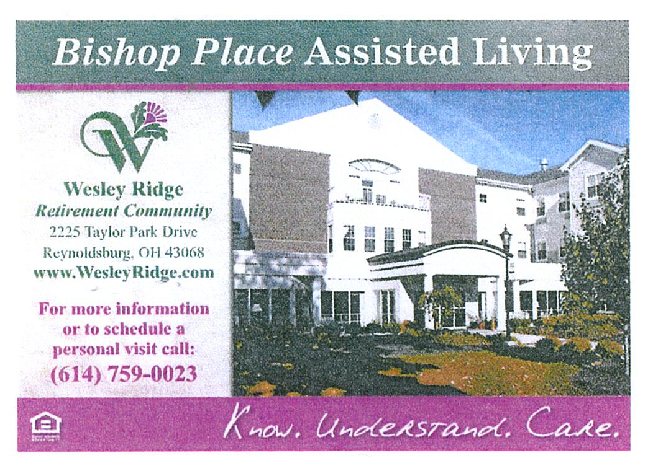

**TRIPS FOR 2023**

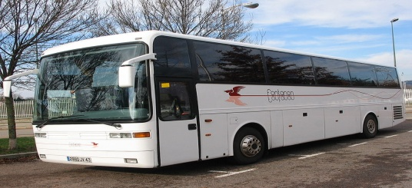

**SNOOTY FOX**

**WEDNESDAY / NOVEMBER 1ST**

**BUS DEPARTS AT 7:45AM**

**PLEASE ARRIVE BY 7:30AM**

Join us as we venture to the Cincinnati area for a shopping adventure full of fun, food, and great deals! We will visit 4 upscale clothing and furniture thrift stores and enjoy beverages, danish, snacks, a boxed lunch, dessert, and wine tasting along the way. Different items at each stop but beverages at all of them. They accept cash and major credit cards, no checks. This trip will be a blast so grab your friends.

**LACOMEDIA DINNER THEATRE**

**THURSDAY, NOVEMBER 30TH**

**“MIRACLE ON 34TH STREET**

**BUS DEPARTS AT 8:00am**

The story of the real Santa Claus. Miracle of Christmas is one of the most beloved holiday films of all time and one of the most popular

shows ever produced. The touching musical

version of the classic holiday film proves that

miracles do happen and is sure to fill both the

young and the young at heart with the Christmas

Spirit.

**Cost IS $63.00 per person – due on sign up.**

**LANCASTER, PA**

**MONDAY 12/4 -12/7**

**FEATURING**

**MIRACLE OF CHRISTMAS AND THE FIRST NOEL**

3 Nights Lodging

3 Breakfasts

3 Dinners including a Smorgasbord Dinner

Guided Tour of the Amish Countryside, including stops at an Amish Craft Farm and Bake Shop.

“The First Noel” at the American Music Theater

“Miracle of Christmas” at Sight & Sound

Tanger Outlets

Kitchen Kettle Village

Cost: Single $848.00

Double: $649.00 per person

Payment is due on sign up.

**THANKSGIVING POEM**

**Turkey dinners are a tradition.**

**Happiness is people getting together.**

**All pies are a treat.**

**No diet today!**

**Kind hearts are gathered.**

**Sing your hearts out.**

**Get together with family and friends.**

**I remember all my family.**

**Visitors are always welcome!**

**Indians supplied the corn.**

**No one leaves hungry.**

**Grateful to remember those who need help.**

**NOTES FROM DEANA 😊**



(1) Michelle Acquista, Ann Budreau, Pat Gemeinherdt, Bettie Hurley, Douglas Keadey,

Danny Mathew (2)Susan Couden, Donna Potts (3)Daniel Murphy, Cecelia Simeone, Mary Stemen (4)Melissa Bechtel, RuthAnn Garand, Nelda Johnson, Fran Skinner (5)Leslie Annetta, Joe Fox, Sharon Greedy (6)Eleanor Berry, Judy Creviston, Bill Taylor, Thomas Tooill, Lori Wagner, Cindy Williams (7)Marti Fisher, Carolyn Moore (8)Donna Bowers, Marlene Mueller, Bonnie Murphy (9)Pam Cheek, Lisa Huff, Mary Stafford, Kay Vankeuren (10)Brenda Albertini, Karen Callahan, Polly Kupniewski, Ellen Laughery (11) Susan Carr, Karen Hixenbaugh, Gene Luidhardt, Vera Nixon (12) Kyonghui Amos, Linda Boisvert, Etha Brown, Norman Hopkins, Jeannie Mathew (13) Mary Jane Brandt, Shirley Massey (14) Vicki McCullouch, Bessie Miller, Margaret Wolfinger (15) Jim Eringman, Charlene Newlon (16) Maggie Arendt, Brian Casner, Paula Gross (17) Sylvia Chadwell, Marti Fisher, Sue Grinstead, Veronica Lamb (18)Becky Ashcroft, Patti Biltz, Denise Hoermle, Pam Knoblauch, Larry Larson, Sunny Schewe (19)Linda Scott, Rosalee White (20) Brenda Dunnette, Melody Fuller, Becky Todd (22)Lois Bushby, Mike Kilroy, Steve Knorr (23)Edward Akers, Jennie Chrysler, Jerry Howell, Vicki Hunt (24) Ann Hackworth, Vikki Perry, Patty Schlager (25) Donna Carr, Debbie Faiella, Cheryl Lewis, Beverly Wilson (26) Floyd Collins, Cheryl March, Susan Fetters, Sara Schwab, Janice Wharton (27)Joyce Collins, Jean Cox, Doris Moore, Stan Runyan (28)Lillian Delavo, Al Sharpless

(29) Shirley Kotchou, Janet Kuhn, Leona Manzo, Janie Martin, Frances Marchese, James Northrop,

Rick Schulze, Frank Simeone (30) Rex Bentzinger, Denise Feeley, Nancy Johnson

**MEMBERS IN SORROW**

Lee Daniels

Donna Braidic

Kathy Sheline (Nancy Lee’s niece)

**MEMBERS KNOWN ILL**

Darie Wilson

Tom Jones

Joe Douglas

**CHRISTMAS PARTY**

**VOTING FOR TRUSTEES**

Join us for our Christmas party!

Tuesday, December 12th

12:00 - 2:30pm

Entertainment by:

Pickerington HS Central Chorale

Sign up in our office starting

Monday, Nov. 13th

