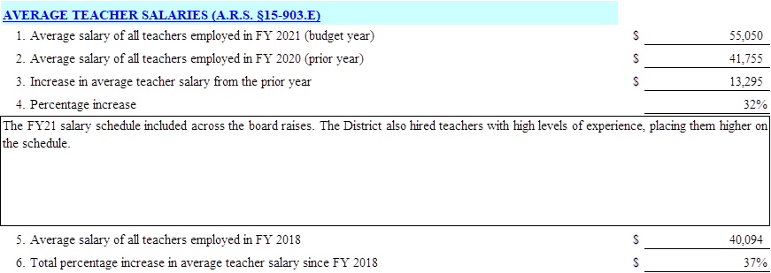
AVERAGE TEACHER SALARIES (A.R.S. $15-903.E) 1. Average salary of all teachers employed in FY 2021 (budget year)
55,050 2. Average salary of all teachers employed in FY 2020 (prior year)
41,755 3. Increase in average teacher salary from the prior year
13.295 4. Percentage increase
32% The FY21 salary schedule included across the board raises. The District also hired teachers with high levels of experience, placing them higher on the schedule.
5. Average salary of all teachers employed in FY 2018 6. Total percentage increase in average teacher salary since FY 2018
40,094
37%

