CODE:
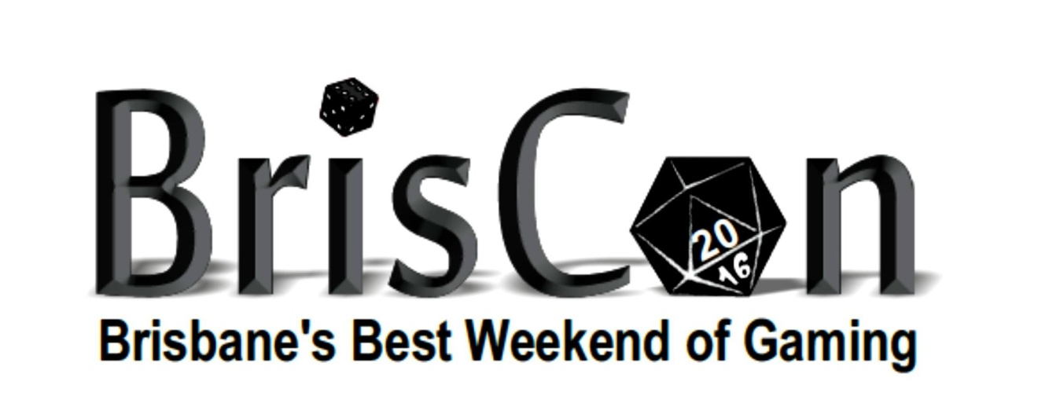Briscon Bring and Buy
www.briscon.com.au
29 and 30 April 2023

Thank you for participating in the Brisbane Gaming Society Bring and Buy.

- Items can be dropped from 8am Saturday.
- Sales commence at 9:30am Saturday 29 April.
- Collection of money from sold items will be at or before 2.00pm Sunday 30th. The stall will close around 2.30 - 3pm. Items must be collected by then.
- Please note – all pay outs over $150 will be made via electronic transfer

Please ensure your sale items are packed, and complete the form prior to arriving. When naming ID numbers on items for sale please follow the standard outlined below:

Items should be marked with: first initial of both names then a 3 digit number

example: Fred David Jones names his three items FDJ001, FDJ002 and FDJ003.

If your goods are sold, we will keep 12.5% of the sale price. The Brisbane Gaming Society takes no responsibility on lost or missing items, once this form has been signed. Thank you, we are looking forward to a great weekend.

Name:

Sign:

Contact Email:
Contact Mobile number:

Bring and Buy Name: Contact Number:
Item For Sale, short description | I.D. Number | Sale Price
 |  | $
 |  | $
 |  | $
 |  | $
 |  | $
 |  | $
 |  | $
 |  | $
 |  | $
 |  | $
 |  | $
 |  | $
 |  | $
 |  | $
 |  | $
 |  | $
 |  | $
 |  | $
 |  | $
 |  | $
 |  | $
 |  | $
 |  | $
 |  | $
 |  | $
 |  | $

