THE WORLD CHAMPIONSHIP CRAWFISH ETOUFFEE COOK-OFF

NORTHWEST PAVILION – 651 Samuel Drive - EUNICE, LOUISIANA

SUNDAY, MARCH 25, 2018

Dear Participant:

Eunice’s World Championship Crawfish Etouffee Cook-off Contest continues to lead the pack as one of the most unique and enjoyable events around. Each participating team will sell their own Crawfish Etouffee, allowing you to recoup your expenses. You may also sell other food items to help bolster revenue OR, to advertise your specialty.

The Eunice Chamber of Commerce will sell tickets for beverages – only the Chamber of Commerce will sell beverages. PLEASE, DO NOT accept any tickets at your booth, these tickets are to be used to purchase beverages only! Below is more information about the contest:

1) You may set-up your booth Saturday or Sunday morning.
(Note: Try to set-up booth on Saturday there will be security at Pavilion Saturday night. If Sunday you must be set-up by 9:00 am).

2) You may begin selling your Crawfish Etouffee by 11:00 am.

3) Size of booth space: 12 FEET BY 12 FEET – You may purchase more than 1 booth space if you require more than 12 feet.

4) Electricity is NOT available. Use butane burners, camping stoves, etc…, NO GROUND FIRES ALLOWED. All cooking of etouffee must be done ON SITE! Rice may be brought precooked. Generators may be used to cook Other food items Only!

5) We suggest that you cook a minimum of fifteen pounds (15 lbs.) of crawfish. This will help you to recoup your expenses and help feed the crowd we expect. We SUGGEST you sell you Etouffee in 8 ounce cups and that you charge at least $3.00 per sample. You must bring your own cups, utensils and napkins. You must provide your own start-up money (for making change), as well as, your own shelter, cover, tent, chairs, etc…

6) The “Chief Cook” is responsible for keeping your area clean and for bringing your booth’s sample for judging between 10:30 A.M. and 11:00 A.M.

7) The winners will be announced from the Music Stage at approximately 3:30 P.M. Trophies are given for Cooking and Best Booth Decoration. We will give a trophy for a Listeners Choice Award. Voting will take place at the KEUN van for the Cook-off Entry of your choice. Anyone will be able to vote for Listeners Choice.

For more information you may contact the Eunice Chamber of Commerce at (337) 457-2565 or go to our web site: www.crawfishetouffee.org or find us on facebook.com/crawfish.etouffee or to the city of Eunice’s website www.eunice-la.com

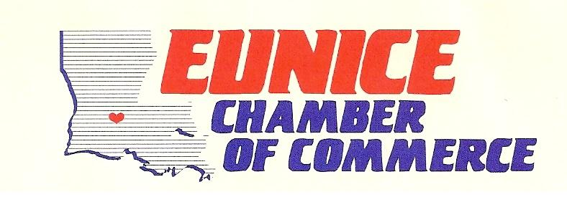

THE WORLD CHAMPIONSHIP CRAWFISH ETOUFFEE COOK-OFF

NORTHWEST PAVILION, EUNICE, LOUISIANA

SUNDAY, MARCH 25th, 2018

OFFICAL ENTRY FORM

CHIEF COOK:
ADDRESS:
CITY/STATE/ZIP:
TELEPHONE:
Cell Phone # for Booth________________________

ASSISTANT COOK:

SPONSORED BY:

TEAM NAME:

# Pounds of Crawfish you plan to cook:

Other food items to be sold:

ENTRY DEADLINE: Wednesday, March 21, 2018


(Trophies given for Cooking, Booth Decoration & “Listeners Choice”)
Categories: (PLEASE YOUR CATEGORY)

AMATEUR ( ) $35 (1st, 2nd & 3rd place)
PROFESSIONAL ( ) $50 (1ST & 2ND place)
CLUB/ORGANIZATION ( ) $50 (1ST & 2ND place)

MAKE CHECKS PAYABLE TO: EUNICE CHAMBER OF COMMERCE

Signature: Chief Cook Date:

Return Entry Form to: Eunice Chamber of Commerce
Post Office Box 508
Eunice, LA 70535
Phone # 337-457-2565
Fax # 337-546-0278

