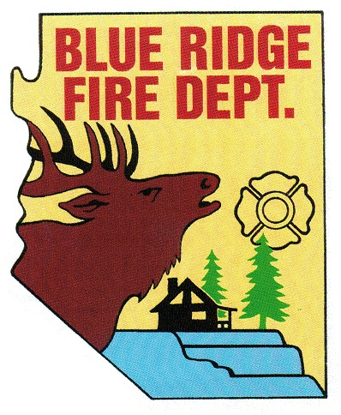
BLUE RIDGE FIRE DISTRICT
BLUE RIDGE FIRE DISTRICT
5023 Enchanted Lane
Happy Jack, AZ 86024
928-477-2751
www.brfdaz.org

Public Safety Personnel Retirement System
LOCAL BOARD

NOVEMBER 15, 2019

MEETING MINUTES DIRECTLY FOLLOWING WORK STUDY SESSION

Chairperson Perelli called the meeting to order at 2:45 PM

The Pledge of Allegiance said by all present:

Roll Call of PSPRS Local Board Members and Accepted, Quorum met:
Cindy Perelli
Linda Blosser
Tammy Rosenhagen
Brandon Sewell—- present by phone
Ryan MacNeal

Old Business: Discussion and Possible Approval
- Obtaining and retaining a PSPRS Local Board Attorney.
Discussion was made to move forward to retain a specialized PSPRS Attorney for the Local Board. Tammy Rosenhagen will bring to the board the cost of retaining said Attorney for district budget adjustments.
Motion made by Tammy Rosenhagen
2nd made by Ryan MacNeal
Motion passed by all

2 Obtaining and retaining a PSPRS Independent Medical Examiner (IME):
Discussion was made to move forward to retain an Independent Medical Examiner. Tammy Rosenhagen gave an update on 2 agencies used for an IME. Also 2 Orthopedic Physicians.
A. MCN
B. IME
C. Doctor Sievert
D. Doctor Steinguard (spelling?)
Motion made by Tammy Rosenhagen
2nd made by Cindy Perelli
Motion passed by all

Chairman Perelli made a Call to the Public:
None

Adjournment: 2:45 PM

Respectfully submitted November 20, 2019

Linda Blosser______
Secretary

