BELBROUGHTON and FAIRFIELD PARISH COUNCIL
NEWSLETTER & ANNUAL REPORT 2016-17
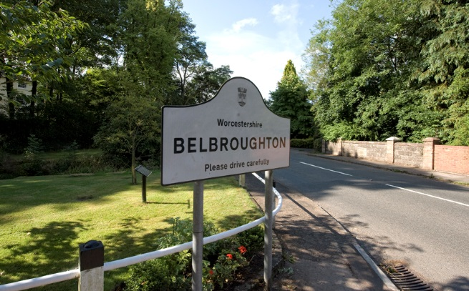
Review of the Year
Report Distribution Methods
As advised in our last Newsletter the Council is to phase out the delivery by councillors of paper copies, and so this will be the final issue distributed in this way. Future reports and newsletters will be issued electronically to our growing e mail database. If you would like to join this database please contact our clerk at belbroughtonpc@live.co.uk The reports will also be available on the website which contains details on what we do along with general community information www.belbroughtonandfairfield-pc.info
We appreciate that not all residents have access to a computer and so you may opt into having a hard copy delivered to you. If this is your desired format then please inform the parish clerk by letter or phone call.

Velo Birmingham
While in favour of cycling as a healthy pursuit we have been active in opposing the Velo event due on 24th September, including encouraging the 300 households whose homes lie directly on the route through Belbroughton to object, if they wish. The County Council has made Orders to close these roads from 9.00 to 5.15 on the day. The promoter CSM Ltd, has made some arrangements to reduce the adverse impact on the village, but the Council considers that these have been late, consultation arrangements very poor, and the results inadequate. We encourage residents and businesses, to advise us of both the positive and negative aspects of the event. The Parish Council aims to collate these comments and generate input to the full review that the County Council has undertaken to carry out. This evaluation will decide whether such an event would be held in Worcestershire in future years, as is planned by Birmingham Council and CSM Ltd.

Severn Trent Birmingham Resilience Project
The performance of the Velo promoters is in stark contrast to the admirable efforts made by Severn Trent and their contractors, Barhale, in carrying out the ‘Resilience’ project necessary to sustain water supplies to Birmingham and the West Midlands. The pipeline is required to enable maintenance work to take place on the Elan Valley Aqueduct, which is over 100 years old.
We are grateful to them for their efforts in limiting the local impact when this very large pipeline is being laid.

Veolia ES Ltd Application and Other Quarry Developments
Veolia’s application to recycle incinerator ash on their site in Sandy Lane was rejected last autumn, after strong objection by local residents and the Parish Council. The period for an appeal has now expired, so we hope for no similar proposals in the future. A retrospective change of use for the Wildmoor Quarry site has also been rejected and the Council will continue to do what it can in supporting local residents’ efforts to maintain the quality of their neighbourhood.

Parish Room, Belbroughton, and Fairfield Post Office and Shop
‘The Deli’ recently opened in the former Parish Room in Hartle Lane has started successfully, and we hope will continue to provide a well-used facility for the village as well as a useful rent for the Council. Less happily, the shop and Post Office in Fairfield are faring less well, and the Council recently decided to support an application for the premises to be declared a ‘Community Asset’. Bromsgrove District Council accepted this and they would support a community effort to sustain the premises should they be put up for sale in the future.
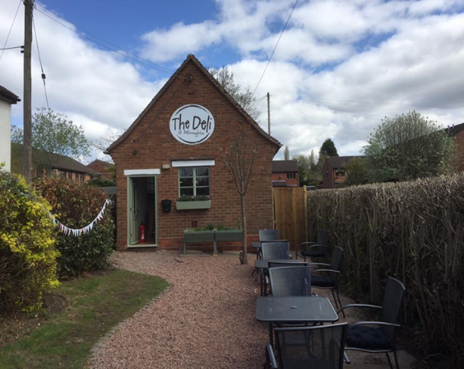
The Green, Belbroughton
There has been a little further progress towards the legal agreement with the developer of the site behind the The Green, which includes how much he will pay the Council for his prospective impact on the Green. However it has been frustratingly slow. If the agreement can be concluded the housing for which there is planning permission could then be built, and the Council would expect to consult residents (again) on what might be done to enhance the use and attractiveness of the Green.

Little Bell Hall Pool, Belbroughton
Having installed a new trash screen to protect the dam at Little Bell Hall Pool the Council has taken steps to assess the possible future treatment of the Pool area. We have some advice on the likely costs of restoring it and of properly maintaining it, both of which are likely to be significant, and we are also considering whether the site could be sold.

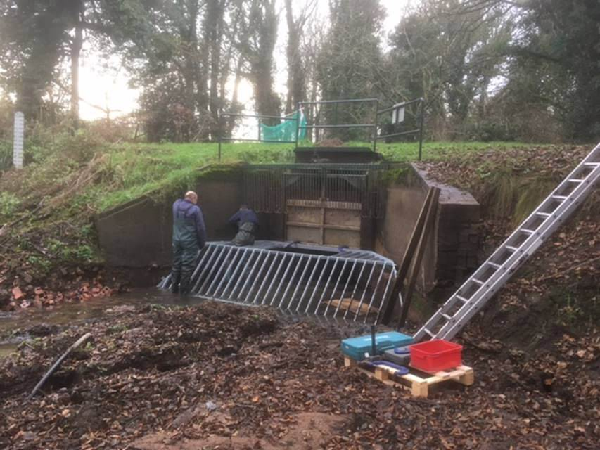

Footpaths and Green Spaces
We have contributed towards some improvements of footpaths and bridleways and plan increased spending for this purpose. We would like to reiterate our thanks to the footpath wardens, Paul and Lynne Hardcastle for all their efforts in keeping paths open despite the best efforts of vegetation to close them. After much delay, the County Council has begun the process necessary to divert the footpath near Brookfield Farm near Hackmans Gate Lane. The footpath is currently very unsafe, so we have the support of the Countryside Service, but the process is not quick or cheap. We continue regular maintenance of our green spaces, unfortunately a diseased tree at the foot of Ram Alley (Dark Lane) had to be felled. We are consulting those most affected on whether to replace it.

Fairfield Recreation Ground
Limited car parking at Fairfield Rec contributes to parking problems in the village. We proposed to add a further 12 spaces, using a green ‘grasscrete’ type surface, but we have not yet been able to obtain planning permission from the District Council. Discussions continue. We have made some repairs to the surface of the play area and are considering whether more needs to be done to maintain it.
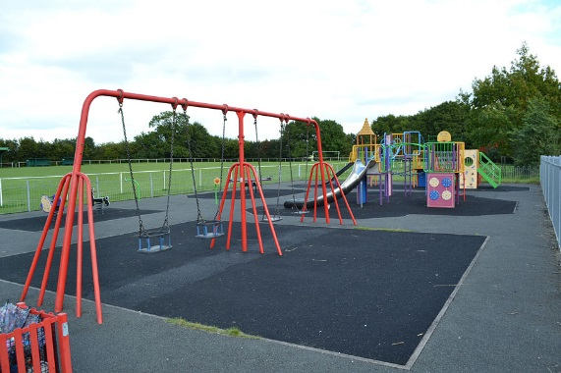
Traffic and Lighting
Traffic through both villages is a perennial problem and a major concern for many residents. Any solutions have to be agreed with the County as Highway Authority, who have to reflect the role for through traffic of the main B - Road in each village. In Fairfield crossings and traffic calming options have been raised with ‘Highways’ and County Cllr. Shirley Webb. We await the outcome of these discussions. In Belbroughton the entrances to the village have been emphasised in various ways to slow traffic down and we hope to do more. Lighting in both Belbroughton and Fairfield is footway lighting and the property of the Parish Council. We will consider further whether we need to do more to modernise it, while retaining the atmosphere of the rural villages.
Finance Overview
The Council sustained a small deficit in 2016/17, of £1k on a budget of around £65k, the great majority from the precept, our element of your Council Tax. This equates to around £52 for a Band D property. On our “other” income of £15k, from our reserves and other assets, there was an underspend of £3k. This income is generally used to finance “capital” improvements, by the Council or other village bodies, in ways which vary from year to year. In the coming year we face decisions on various potentially significant sums, particularly on the parking at Fairfield Rec, on the future of Little Bell Hall Pool, on a possible playground improvement in Belbroughton, and a possible Neighbourhood Plan. We shall need to balance the prospective benefits with the costs to you as taxpayers. We will need to seek views from you in the most appropriate ways.
Planning
The council has an advisory role to the District Council on planning applications and considered 35 planning applications during the year. Of these the council had ‘no objection’ to 17, ‘no objection but with conditions’ to 11 and ‘objected’ to 7 applications.
Veolia ES Ltd - Sandy Lane site – In Oct 2016 The Council objected strongly to the Incinerator Bottom Ash planning application and was pleased that Worcs. County Council refused the permission. The Council awaits Bromsgrove District’s criteria for its Green Belt review and will continue to monitor and work to ensure the residents’ best interests are fully represented.

Detailed Finances – Year ended 31st March 2017
The Council’s ‘Ordinary Income’ was £65,790. Of this £60,000 came from the ‘Parish Precept’, (your council tax), with £3,148 from the County Council to fund the Lengthsman Scheme, £1,311 from the Council Tax Support Grant and £1,331 from the Parish Room rent. Spending on ‘Ordinary’ items covers the Council’s day to day administration, open spaces and footpaths maintenance, street lighting and maintenance grants made to parish organisations.
Maintenance grants approved increased to £4,815:-
£730 each was paid to Fairfield Village Hall and
Belbroughton Church Hall, £1,155 to Belbroughton Recreation Centre. The Parochial Church Council received £2,200 for churchyards maintenance and the maintenance of the Holy Trinity church clock.
The table indicates the main areas of spending.

Ordinary spending | £
Administration, including the Clerk, rents for meetings, insurance, and audit costs | 24,108
Communication, including newsletters & memberships | 2,463
Councillors’ expenses / training | 128
General Maintenance items | 1,838
Maintenance grants to parish bodies | 4,815
Open spaces, including grass cutting, Lengthsman, emptying dog bins and pathway improvements | 14,444
Street Lighting | 5,493
Replenishing of reserves from prior year’s Queens Hill wall repairs (final year) | 5,000
Donations | 573
Little Bell Hall Pool repairs | 4,509
Consultant’s report into Veolia planning app. | 1,250
Legal & Professional fees | 1,900
Total | 66,521

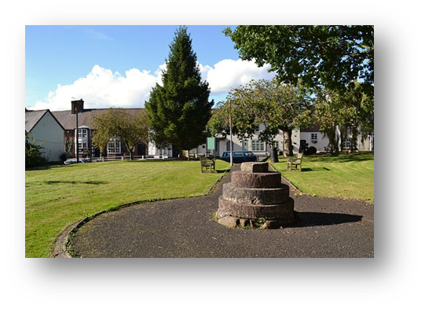
The Parish Council’s ‘Other Income’ totalled £15,316 This was achieved from the owned assets:-
Rental of 85 acres of agricultural land on 13 Farm Business Tenancies - £7,295*.
Lease of the Parish Room Belbroughton (a new lease is now in place of 6 years to Belbroughton Deli) - £1,187.
Lease (11 years from Sept 2011) of part of Fairfield Recreation Ground to Fairfield Villa F.C. - £2,554. Wayleaves - £514.
Cash reserves investment Income - £3,766.
*The triennial rent review of the 13 farm business tenancy agreements took place during the year. After taking advice from professional bodies but also acknowledging the issues facing tenants the rent per acre is increased by £5 to £90/acre with effect from Sept.2017.

This income, after admin. costs is generally allocated to fund capital and minor grants to parish bodies and local organisations. Capital grants are bid for and if approved are offered towards assisting with one-off costs for up to 50% of the total cost of the item. In addition specific Parish Council projects can benefit.

Agreed for 2016-17:
Capital Grants of £1,000 each to:
Belbroughton First Steps Nursery - Redevelop gardens & play area. Fairfield Village Hall - Replacement lighting
Belbroughton Cricket Club - Refurbishment of pavilion.
Minor Grants -
Fairfield Welcome Club £250. Fairfield Community Association £200. Fairfield Social club £200. Belbroughton History Society £150.
Parish Projects Fairfield Bus shelters upgrades £600. Fairfield Gardening works £265.

A copy of the full accounts and the Annual Return are available on our website.
Neighbourhood Plan
The Parish Council resident survey is complete. The results are collated and being prepared for distribution to residents. The Working Group’s report and recommendations will be presented to the Parish Council on 2ndOctober and made available on the parish website afterwards. Initial assessment of the survey shows common themes and issues (e.g. traffic) in both parish wards. The council will endeavour to address concerns expressed and consider any next steps towards development of a Neighbourhood plan. Such a plan offers an opportunity to shape and influence our community as it develops over time.

People
We would like to thank former Cllr. Dave Roberts, who resigned as Chair of the Council during the year, for all the efforts that he put in for the benefit of the parish. His place on the Council has been taken by Sharon Boss.

We would also like to thank John Farrell, our Clerk, for all his efforts on our behalf, which go well beyond the call of duty.

Council Meetings

Your council meets on the first Monday of the month (except allowing for bank holidays) with Planning and Finance Committee meetings on each third Monday. Meetings are held in the Jubilee Room, Belbroughton Recreation Centre and the Fairfield First School on a 2:1 month rotational basis – Residents are welcome to attend all meetings and to raise issues with their councillors or comment on items on the agenda. The agendas are posted on the notice boards in Belbroughton, Fairfield and Bell Heath. Agendas and minutes of meetings can also be found on the Parish Council website belbroughtonandfairfield-pc.info

Your Councillors’ contact details:
Belbroughton Ward
Sharon Boss Belne Brook Cottage 11 Drayton Rd Belbroughton DY9 0DX
01562 731227 bossfamily98@gmail.com
Janice Boswell 1 Stoneybridge Farm Stoneybridge, Belbroughton DY9 9XT 01562 731239 janice.boswell@outlook.com
James Bradley (Chairman of the Council)
26 High St. Belbroughton, DY9 9SU
01562 731025 jmbradley10@btinternet.com
Allan Hood (Chairman of Agricultural Holdings Committee) Fiveways, Quantry Lane, Belbroughton DY9 9UY 01562 710755 a.t.hood@btinternet.com
Scott MacDonald Sunglo, Broom Hill, Dordale Road, Belbrougton DY9 0BB 07872 607391 scott4belbroughton@gmail.com
Paul Margetts Field House Farm, Dark Lane, Belbroughton DY9 9SS 01562 730003 margettssculpture@btinternet.com
Dr Bob Morgan (Vice Chairman of the Council) Fennbrook Cottage Chapel Lane Madeley Heath Belbroughton 01562 710337
Morg1952@gmail.com
Sue Pawley 59 High Street Belbroughton DY9 9ST 01562 730996 sue@cmcschoolfood.co.uk

Fairfield Ward
Gez Ingram 3 Pepperwood Close Fairfield B61 9ND
01527 880788 gez.ing@sky.com
Trevor Jones 42 Mount Rd, Fairfield, B61 9LW
01527 833774 tpajones@aol.com
Alan Mabbett (Chairman of the Finance Committee)
26 Yew Tree Lane, Fairfield B61 9LT 01527 871103 alan.mabbett@btinternet.com
Simon Nock Farmhouse Barn Stourbridge Rd Fairfield B61 9NG 01384 575684 simon-nock@tnmca.com
Gemma Parsons 87 Stourbridge Rd Fairfield B61 9LY 01527 835188 theparsons5@btinternet.com
Chris Scurrell (Chairman of the Planning Committee)
16 Yew Tree Lane, Fairfield,
B61 9LT 01527 876485 chrismeriel@gmail.com

Clerk to the Council
John Farrell Millers Cottage Pinkham Cleobury Mortimer DY14 8QE 01299 270722
belbroughtonpc@live.co.uk

Published by Belbroughton and Fairfield Parish Council Sept. 2017

