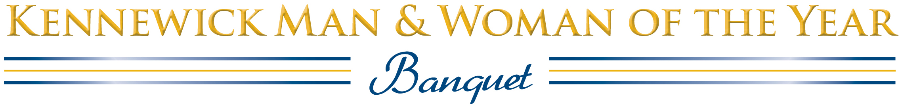

Title sponsor: Sun Pacific Energy
Produced by:
Soroptimist International of Pasco-Kennewick & Kennewick Past Men of the Year Club

2019 Sponsorship Opportunities
Honoring the 2018 Kennewick Man & Woman of the Year

Thursday, Feb. 28, 2019 • Three Rivers Convention Center • Reception 6:15 p.m.

Presenting Sponsor: One only— $1000
Sun Pacific Energy
You will receive name sponsor mention on all of the printed and electronic material that supports this event—a link on the official Web page, www.kmwoy.com, invitations, the evening’s keepsake program, and on those all-important nomination forms. Your logo and/or URL will appear wherever possible. Your Presenting Sponsorship will include a table for eight located in the front of the room, 4 invitations for your special guests to the pre-event honoring past women and men of the year, and the right to place a banner next to the podium.

Sustaining Sponsors: Six only—$500
Soroptimist International, Tri-Cities Cancer Center, Esprit Graphic Communications,
This sponsorship includes a table for eight, best possible placement. You will also be recognized by name from the podium and in the keepsake program, and your logo will be prominently displayed in the banquet room.

Reception Sponsor: One only—$500
Kennewick Past Men of the Year Club
Your organization will be the sole sponsor of pre-event and public receptions honoring past Kennewick Men and Women of the Year. In addition to your name and logo will appear in the keepsake program.

Table Sponsors: 8 tickets included—$400
Your table for eight will be placed prominently near the front of the banquet hall, and will display a sign indicating your sponsorship. You will be recognized from the podium and in the keepsake program.

Special Reserved Table Recognition: $75 (Tickets must be purchased separately.)
This recognition is for organizations or individuals who want to sponsor a reserved table for 8 people who have already purchased individual tickets. You will be recognized in the keepsake program, and with a sponsor sign on the table.

To reserve your sponsorship:
Kirk Williamson at 539-2036
E-mail: kennewickmen_women@charter.net

Kennewick Man & Woman of the Year
2019 Banquet Sponsor Reservation

Please reserve the following Sponsorship(s):

_____ SUSTAINING SPONSORSHIP (Includes 8 meals) $500
Please include the names of your guests.

_____ COMPANY TABLE SPONSORSHIP (includes 8 meals) $400
Please include the names of your guests.

_____ SPECIAL RESERVED TABLE (meals must be purchased separately) $75
Please include the names of your guests.

Sponsor organization name as it will appear in the Keepsake Program:

Person ordering the Sponsorship: ____________________________________________

Mailing address: ____________________________________________

City, State, Zip: ____________________________________________

Best daytime telephone: ____________________________________________

Email: ____________________________________________

Please email this form to:
kennewickmen_women@charter.net
Questions: 509-491-1291

Reservations are due and must be paid by Thursday, February 21, 2019

This meal is NOT gluten-free, to request vegetarian or gluten-free, please note here:
1. | MENU  Moroccan Glazed  Salmon Filet  Pistachio-golden raisin couscous. grilled vegetables,  house salad with ranch and Italian dressing,  ice tea, coffee, water,  rolls with butter  dessert  no-host bar
2.
3.
4.
5.
6.
7.
8.
9.
10.

