CUSTOMER APPRECIATION DAY 2016

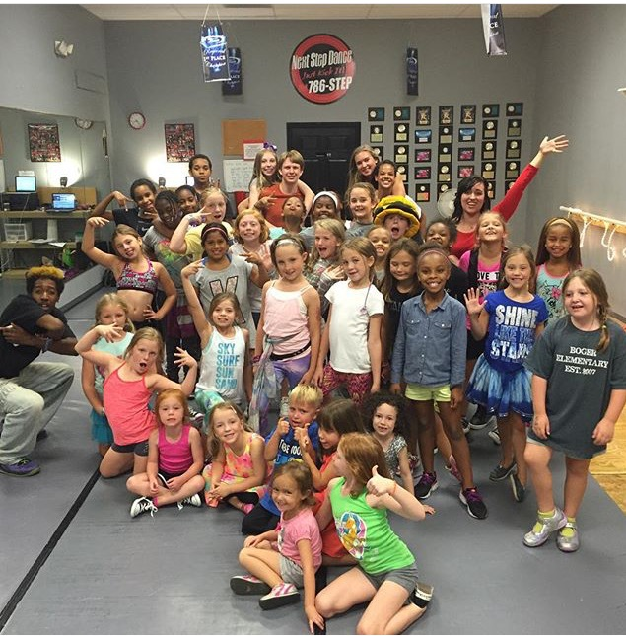

Fun, food, and classes start the day off at 10:00am and conclude at 2:00pm. Bring a friend and enjoy the day. Prize drawing every hour. Zumba classes for adults, hip hop classes for ages 2-20, just check out our schedule on our homepage.

**RECITAL 2016**

**WE’RE TRENDING**

**This year we have separated our recital into mini shows for your convenience.**

**1:00pm Our Tiny Steppers (2-4)**

**1:30pm Solo Showcase**

**2:15pm Tumble Students**

**2:45pm Cinderella Ballet**

**3:30pm Main Show**

**We’re Trending**



**Don’t forget your favorite dancer on recital day! Order forms for recital flowers can be picked up at the front desk.**

C:\Users\Stephanie\Pictures\Microsoft Clip Organizer\j0416014.wmfC:\Users\Stephanie\Pictures\Microsoft Clip Organizer\j0416014.wmfC:\Users\Stephanie\Pictures\Microsoft Clip Organizer\j0416014.wmf

**#students of the month** C:\Users\Stephanie\Pictures\Microsoft Clip Organizer\j0416014.wmf

***OUR SENIORS***

**Congratulations to our graduating 2016 seniors as you enter the next phase of your life!**

**Kiara Blue**

**Courtney Gordon**

**Adrienne Quesada**

**Madison McGough**

**Carolyn Mitlehner**

**#nsdSummerSizzle**

**Don’t forget, July is the month to SIZZLE with Next Step Dance. Try something new or continue to work in your favorite class. This is a fun 4-week session that will add something extra to each class. You don’t want to miss out on the FUN! This is also a great time to schedule a private with one of our teachers to work on something specific you would like to master…..turns, back handspring, flexibility, or just some quality one on one time for a critique. NSD instructors love to work towards helping each individual student become the best they can be!**



C:\Users\Stephanie\Pictures\Microsoft Clip Organizer\j0416014.wmf C:\Users\Stephanie\Pictures\Microsoft Clip Organizer\j0416014.wmf

Steppin’ into May/June 2016 with Next Step Dance

[**www.thenextstepnc.com**](http://www.thenextstepnc.com)

**7712 Sossamon Lane, NW Concord, NC 28027 (704) 786-7837 nsdcalendar@gmail.com**

**OPEN HOUSE THIS MONTH!**

Time to think about summer activities and fall 2016! Have a friend or relative interested in dance? Have a younger sibling that will be old enough for our Tiny Steppers program? Find out schedules and all the important stuff at our Open House on Saturday, May 14, 2016 from 10:00am-2:00pm. There will be classes to tryout and informational sessions to learn more about Next Step Dance and what is happening with us for the rest of 2016.

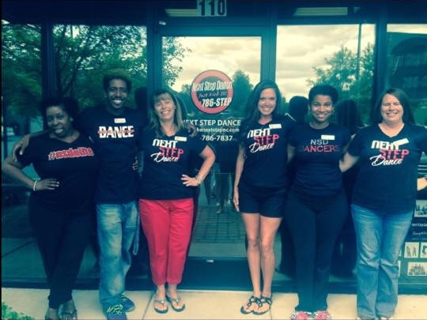

**SAVE THE DATE** C:\Users\Stephanie\Pictures\Microsoft Clip Organizer\j0416014.wmf

May14th –Customer Appreciation Day/

Open House-Register for Fall & Summer

10:00am-2:00pm

May 30th- Memorial Day Studio Closed

June 17th- Dress Rehearsal

June 18th- Dance Recital

Shoe orders take approximately 1-week for delivery and some we have in stock!

REMEMBER TO JOIN US ON

Facebook, Twitter, & Instagram!