CELEBRATION OF WORSHIP May 1, 2022

Prelude “The Glory of the Lord is Here” Norris

Welcome and Announcements

Call to Worship

*Hymn # 493 “Glory to His Name”

Confession of Sin
Merciful God, We confess that we have sinned against you in thought, word, and deed, by what we have done, and by what we have left undone. We have not loved you with our whole heart and mind and strength. We have not loved our neighbors as ourselves. In your mercy, forgive what we have been, help us amend what we are, and direct what we shall be, that we may delight in your will and walk in your ways, to the glory of your holy name.

*Affirmation of Faith (The Apostle Creed)
I believe in God the Father almighty, maker of heaven and earth; and in Jesus Christ his only Son, our Lord; who was conceived by the Holy Ghost, born of the Virgin Mary, suffered under Pontius Pilate, was crucified, dead, and buried; he descended into hell; the third day he rose again from the dead; he ascended into heaven, and sitteth on the right hand of God the Father almighty; from thence he shall come to judge the quick and the dead. I believe in the Holy Ghost; the holy catholic church; the communion of saints; the forgiveness of sins, the resurrection of the body; and the life everlasting. Amen

*Gloria Patri “Glory Be to the Father”
Glory be to the Father, and to the Son, and to the Holy Ghost; As it was in the beginning is now and ever shall be, world without end. Amen, Amen.

Giving of Tithes and Offerings

Offertory “Holy Ground” Davis

*Doxology
Praise God from whom all blessings flow. Praise Him all creatures here below. Praise Him above ye heavenly host. Praise Father, Son, and Holy Ghost. Amen

Hearing God’s Word
Scripture Reading:
Old Testament “Exodus 2:11-15” NRSV Pg. # 61

Sermon “Realizing Who You Are” Dr Michael Askew

Celebrating the Lord’s Supper

*Hymn # 508 “Love Lifted Me”

Prayers of the People
Lord’s Prayer
Our father who art in Heaven, hallowed be Thy Name, Thy kingdom come, thy will be done on earth as it is in heaven. Give us this day our daily bread, and forgive us our debts, as we forgive our debtors; and lead us not into temptation but deliver us from evil; for thine is the kingdom, and the power, and the glory forever. Amen.

Benediction

Postlude "More Precious Than Silver" DeShazo
*Congregation Stands (All who are able may stand)

May 1, 2022

Worship: 11:00
******************************************************************

We welcome all visitors who are worshipping with us today. If you are not regularly attending another church, we invite you to make this your church home. Please sign our Fellowship Pad (found on pew near the center aisle) as it is passed and please give us your phone number. Thanks for visiting with us. If you are interested in joining this congregation, you may do so by 1) profession of faith, 2) transfer of letter of membership from any Christian congregation, or 3) re-affirmation of faith when you meet with the Session. Please ask our Pastor or one of our Elders for additional information.
Nursery Provided, Please ask an Usher.

LET US JOIN IN PRAYER FOR
Church Members: Sid Jenkins, Rose Stallins, Rose Owens, Geneva Porter and Dixie Retherford,
St. Andrew’s Friends: Ricky and Emily Hattaway

Announcements:
May birthday wishes: Geneva Porter -15th,
Jimmy Whisenant – 29th.
A second dinner event will be held at Grace Presbyterian on Thursday, May 26th at 5pm. The Bay County Christian Youth Choir will perform. Cost is $10.

VILLAGE CHURCH OF
SAINT ANDREWS
Established September 13, 1836

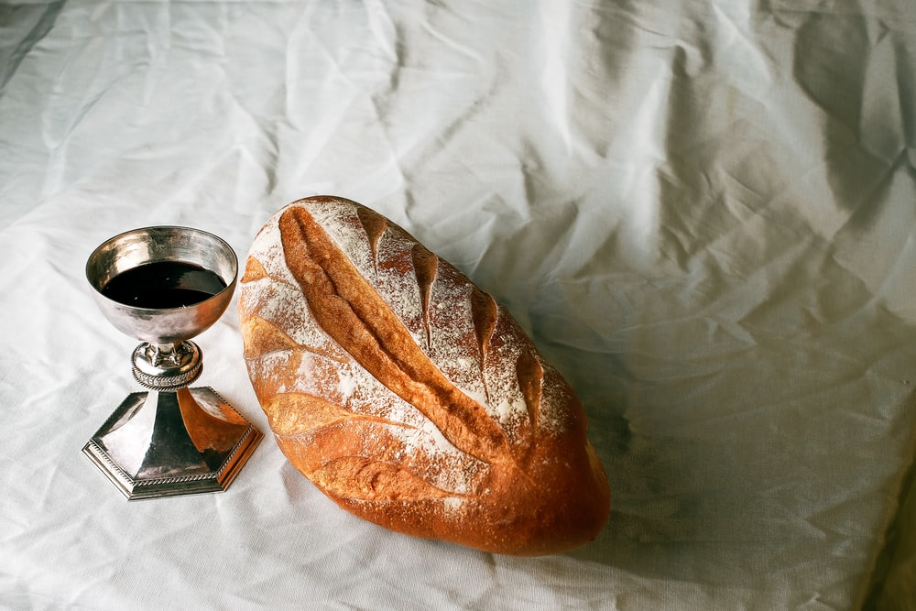
Where a warm welcome awaits you!
3007 West 14th Street, Panama City, Florida 32401.
Phone 850/785-8358 standrewspresch@knology.net
Supply Pastor Dr Michael Askew
Music Director Wanda Sherman
May 1, 2022

