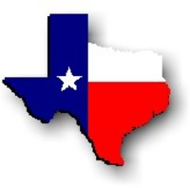Texas History with Mr. Brown Name ____________________________ Period _____
Chapter 3 Texas Regions Section 2 Review
Directions: Use your study guide to answer or define the following questions.
1) Subregion –
2) Escarpment –
3) Steppe –
4) Aquifer –
5) The Coastal Plains cover _____/_____ of Texas.
6) In which region are most of Texas’s large cities located?
7) Name two subregions of the coastal plains:
8) What happens to the precipitation levels as you rise in elevation across the North Central Plains?
9) Name the three subregions of the North Central Plains:
10) The Great Plains produces _______% of the world’s grains.
11) What is the name of the aquifer under the Great Plains region of Texas?
12) This aquifer supplies water for what major Texas city?
13) Which of the four Texas regions has deserts?
14) How tall is Guadalupe Peak?
15) Where are the forests in the Mountains and Basins region?

