

S K u t t l e b u t t

Newsletter for the

Macomb County Detachment
Marine Corps League and Auxiliary

Department of Michigan
Marine Corps League and Auxiliary

Christine Tonegatto-Salo, Detachment Commandant – (586) 801-0081 – catsusmc@gmail.com
Loretta Balderson, Auxiliary President – email: balde1010@hughes.net
JULY 2017
Elaine Arnold, Editor - (248) 303-5582 – email: elaine48178@gmail.com
Detachment WEB Site: www.macombmarines.com

Marines & Auxiliary Members:

JULY Meeting Notice

The next General Membership Meeting will be held on Thursday July 6 at 2000

The General Membership Meeting will be held at the American Legion, Post 351, 46146 Cass Avenue located in Utica. The telephone number to the Post is: (586) 731-9833.

New Members Reporting In
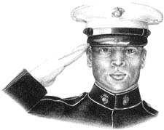
At the May 4th meeting Marine Michael Hall was sworn in to our Detachment.

Welcome Aboard!

Michael served in the Corps from 1986-1990, MOS 2542 Comm. Center (RTO). He was honorably discharged as a Lance Corporal, and stationed with the 8th Communication Bn. at Camp Lejeune. He traveled with the 6th MEB to Panama in 1989.

Michael comes from a long line of Marines.
Both of his Parents were Marines, as well as his Brother and three of his Uncles!

Chaplain's Corner

Remember this Holiday as we celebrate our Declaration of Independence since 1776, and the Birthday of America.

It seems like all Marines of Detachment # 154 are well, I didn't receive one phone call.
Wishing all a happy 4th of July, and safe driving.

John Sottrel
Chaplain

Check out The Detachment Facebook page for News and Events!
https://www.facebook.com/macombcountydetachmentmarinecorpsleague/

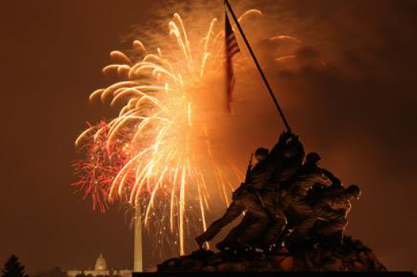

clawson 4th of july parade

The Clawson 4th of July parade details are the same as in years past. Participants must be in the staging area before 08:30 as they will be shutting down the road. Uniform is blues with white/short sleeves. If you don't have that uniform wear Detachment red shirt with black dress pants. Shuttles at end of parade will give participants a ride back to start. We need members to get involved with the honor /color guard or we will not be able to man these events in the future. Stanley L Moore Detachment is invited to join us and the Young Marines. The Pipes band will be marching in this one also.

Here’s the specifics for participation in the Clawson parade. Gather at Clawson Center parking lot, at the southeast corner of 14 Mile and Crooks Road. (Enter on 14 Mile, near the Rite-Aid drug store. Do not attempt to enter Clawson Center from Crooks Road near Taco Bell. (This is an exit only.)

Registration and assembly begins at 7:30 AM. Everyone must be in place by 8:40 AM. You will not be able to participate in the parade if you have not arrived by 8:40. 14 Mile Road between Main and Crooks will be closed at 8:45 AM for the 1-mile run and parade. The parade starts at 9:00 AM, rain or shine, right after the runners have left the starting line.

Park in the lot behind (south of) the stores or in the large lot past Dunkin’ Donuts on the northwest corner of 14 Mile and Crooks
See parade route (dated 2010 but it is 2017.)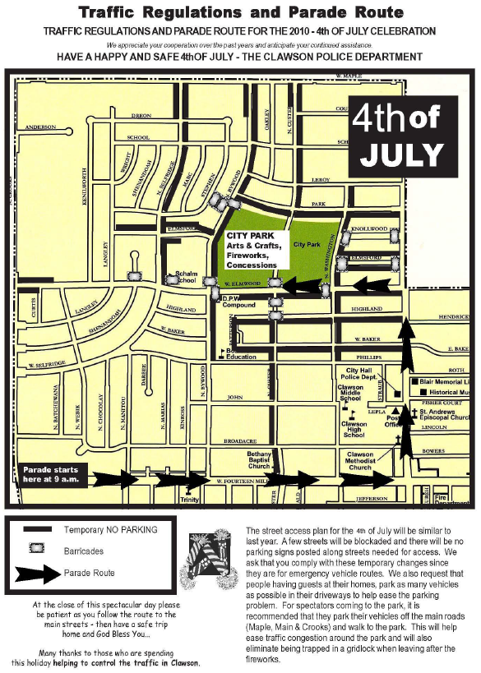

Any questions, contact Scott Neff

MARINES OF OUR PAST

Arthur J, Jackson
Rank: Private First Class
Company: 3d Battalion
Division: 7th Marines, 1st Marine Division
Born: 18 October 1924, Cleveland, Ohio
Departed: Yes (06/14/2017)
Date of Issue: 10/05/1945
Place / Date: Island of Peleliu in the Palau group, 18 September 1944

CITATION
For conspicuous gallantry and intrepidity at the risk of his life above and beyond the call of duty while serving with the 3d Battalion, 7th Marines, 1st Marine Division, in action against enemy Japanese forces on the Island of Peleliu in the Palau group, 18 September 1944. Boldly taking the initiative when his platoon's left flank advance was held up by the fire of Japanese troops concealed in strongly fortified positions, Pfc. Jackson unhesitatingly proceeded forward of our lines and, courageously defying the heavy barrages, charged a large pillbox housing approximately 35 enemy soldiers. Pouring his automatic fire into the opening of the fixed installation to trap the occupying troops, he hurled white phosphorus grenades and explosive charges brought up by a fellow marine, demolishing the pillbox and killing all of the enemy. Advancing alone under the continuous fire from other hostile emplacements, he employed similar means to smash 2 smaller positions in the immediate vicinity. Determined to crush the entire pocket of resistance although harassed on all sides by the shattering blasts of Japanese weapons and covered only by small rifle parties, he stormed 1 gun position after another, dealing death and destruction to the savagely fighting enemy in his inexorable drive against the remaining defenses, and succeeded in wiping out a total of 12 pillboxes and 50 Japanese soldiers. Stouthearted and indomitable despite the terrific odds. Pfc. Jackson resolutely maintained control of the platoon's left flank movement throughout his valiant 1-man assault and, by his cool decision and relentless fighting spirit during a critical situation, contributed essentially to the complete annihilation of the enemy in the southern sector of the island. His gallant initiative and heroic conduct in the face of extreme peril reflect the highest credit upon Pfc. Jackson and the U.S. Naval Service.

DID YOU KNOW….

Macomb County Detachment – 154
By Laws 2013 Edition
ARTICLE NINE, DUTIES OF OFFICERS

SECTION 5 – Adjutant
It shall be the duty of the Adjutant to keep proper minutes of all meetings of the Detachment. The Adjutant shall be custodian of all records of the Detachment other than Special Committees, financial records and the Young Marines. This is an elected position.

SECTION 6 – Paymaster
It shall be the duty of the Paymaster to keep all monies accounted for, including special funds for this Detachment. It shall also be the responsibility of the Paymaster to update and/or correct member’s information with National Headquarters and the Department of Michigan. This is an elected position.

- The Adjutant and Paymaster positions shall be held by a single individual to provide continuity and expedite the Detachments daily business activities. The Adjutant/Paymaster shall function in all capacities as listed under Adjutant and Paymaster.

MACOMB COUNTY DETACHMENT 154
2013 BY-LAWS
**************************************************************
New Stuff in Quartermaster!
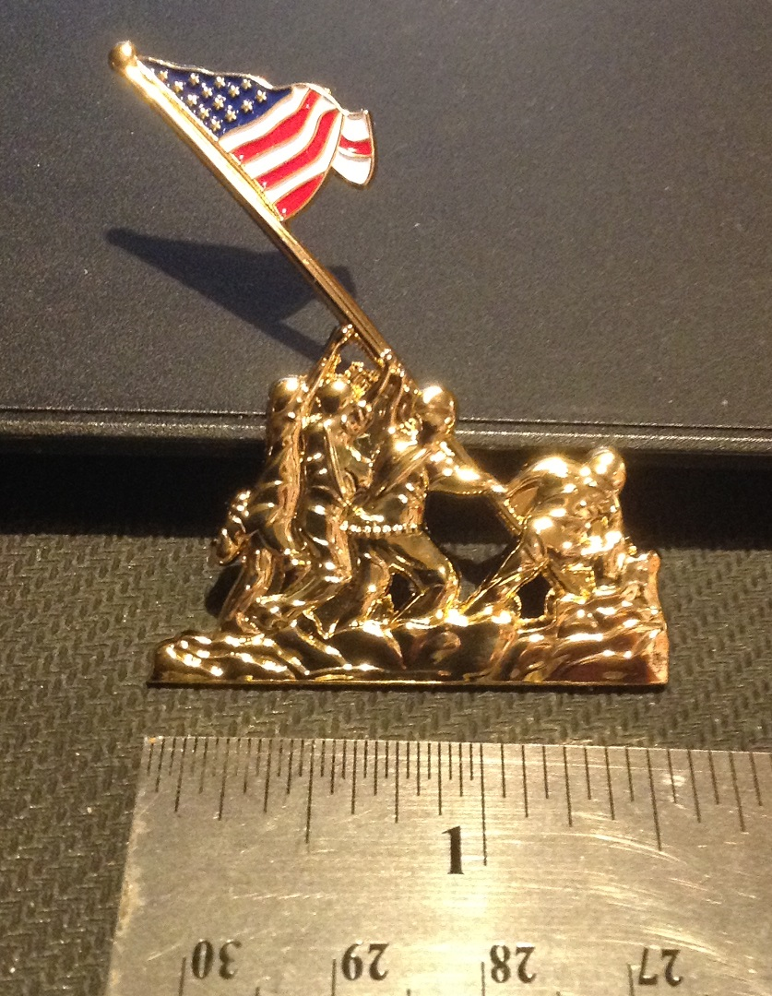

**************************************blast from the past

Send us a photo of a past Macomb County Detachment event and challenge your fellow members to name it and who is in the photo. Here's one to get us started:

Name this event and who is in the photo!
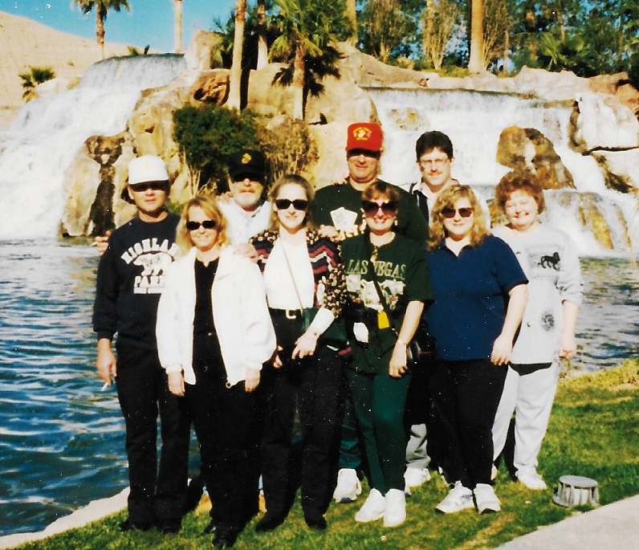

**************************************************************
The famous Marine in the May newsletter was Steve McQueen.
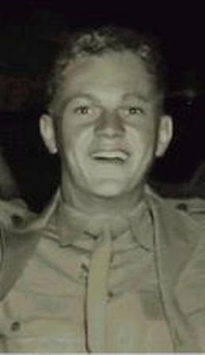
**************************************************************


Macomb County Detachment
Department of Michigan
Marine Corps League

Incorporated by Act of Congress
Mailing Address:
PO Box 183610
Shelby Township, MI 48318

Published monthly for members of the Macomb County Detachment and Auxiliary. SKUTTLEBUTT Newsletter is a non-profit monthly publication for the use of the Macomb County Detachment/Auxiliary, Department of Michigan, Marine Corps League. Article deadline is the 15th of each month
Detachment Officers 2012 - 2013
Auxiliary Officers 2012 - 2013
Change of Address: Send to the Detachment Adjutant/Paymaster at:
PO Box 183610, Shelby Township, MI 48318

New Address (please print):

Name___________________________________________________________________________________________________

Street __________________________________________________________________________________________________

City/Zip_________________________________________________________________________________________________

Phone__________________________________________________________________________________________________

Email address____________________________________________________________________________________________

Commandant | Christine Tonegatto-Salo | (586) 801-0081 |  | Auxiliary President | Loretta Balderson
Senior Vice Commandant | Don Teeples | (586) 292-8156 |  | Senior Vice President | Sharon Renaud | (248) 217-9558
Junior Vice Commandant | Dean Miles | (586) 457-7008 |  | Junior Vice President | Catherine Haustein | (586) 468-6906
Judge Advocate | Bill LaFave | (313) 720-0425 |  | Judge Advocate | Joan Pfaff | (586) 263-3448
Adjutant/Paymaster | Mark Spooner | (586) 466-5708 |  | Co-Chaplain | Dolores Tonegatto | (586) 781-6839
Chaplain | John Sottrel | () |  | Co-Chaplain | Mary Ann Music | (586) 783-2362
Sergeant at Arms | Bill Heise | () |  | Secretary | Irene Spooner | (586) 466-5708
Editor, Newsletter | Elaine Arnold | (248) 303-5582 |  | Treasurer | Irene Spooner | (586) 466-5708
Honor Guard Commander | Position open | (248) 798-5776 |  | Auditor | Gail Trevino | (586) 466-6206
Quartermaster | Brett Jacokes | (248) 761-6513 |  | Auditor | Gayle Brown | (586) 598-8533
Deputy Quartermaster | John Sternicki | (586) 468-1014
Historian | Greg Pawlik | (586)
Highway Cleanup Officer | Bill Lafave | (313) 720-0425
Web Sergeant | Don Lyon | (586) 925-5010

