Rock City Church Unoffendables
Curriculum

Contents

Introduction………………………………………………………………………..........Page 4

Table of Contents

Lesson 1: “A Clean Heart”……………………………………..………………….....Page
Lesson 2: “It’s Not Fair”...........…………………………………………………….. Page
Lesson 3: “Mad at Dad: When Fathers upset us.…………………………..Page
Lesson 4: “Because I say so”………...……………………………………….........Page
Lesson 5: “Stronger than the Giants”…………………………………………..Page
Lesson 6: “A Precious Stone”…………..…………….………………………........Page
Lesson 7: “Building others up”..………………………………..…………..........Page
Lesson 8: “Forgiving others” ………………………...........................................Page
Lesson 9: “He is My Defender”………….………………………………………...Page
Lesson 10: “Don’t Judge Others”……………………………………………........Page
Lesson 11: “Getting It Right”.........………………………………………………..Page
Lesson 12: “Will you Forgive Me?”……………………….................................Page
Lesson 13: “Walking in Forgiveness”…………………………………………...Page

He is My Defender Romans 12:17

KINGDOM KADETS: FALL LESSON 9
AGE: NURSERY (INFANTS & TODDDLERS 0-2)
Adopted From Bait of Satan by John Bevere

Lesson Topic: He is My Defender

LESSON | WHAT CHILDREN DO | SUPPLIES | PREPARATION
1  Getting Started | Introduction/Ice Breaker:  Simon Says | No Supplies Needed | No Preparation Needed
2  Bible Exploration.  Key Verse Activity | Key Verse:  Bible Story: | No Supplies Needed  Kids Bible | No Preparation Needed
 | Bible Activity For Infants:  He is my Shield (Play with paper plate shield) | -Paper Plates.  -Red, Blue and white tissue paper.  -Glue.  -Scissors.  -Pencil (to draw the stars)  -White construction paper (stars)  -Hair ties or rubber bands.  -Stapler.  -Duct Tape. | Gather supplies for the paper plate shield, you can make it before class.
 | Bible Activity for Toddlers:  Color the Shield (Coloring Page) | -Coloring Pages.  - Crayons. | -Make copies of the last page (coloring page).  - Make sure you have enough crayons in the classroom.
LESSON | WHAT CHILDREN DO | SUPPLIES | PREPARATION
3  Weaving Faith  Into Life | Craft/Make and Take For Toddlers:  He is my Defender (Paper Shield) | -Paper Plates.  -Red, Blue and white tissue paper.  -Glue.  -Scissors.  -Pencil (to draw the stars)  -White construction paper (stars)  -Hair ties or rubber bands.  -Stapler.  -Duct Tape. | Cut out the tissue paper into small pieces before class to save time. (Considering that there are 2 red rings, you will need more red than blue and white tissue paper.)
Prayer Points:
Thanking God that His peace has come into your life as a result of releasing the offenses that had blocked your heart

4  Lasting Impressions | Faith at Home:  Talk about how to share what they learned with their families. |  | What parents can do at home:  Write down Psalm 18:1-2 on a sticky note and put it on the mirror in the bathroom, read it to them every time you help them washing hands or brushing their teeth for a couple of days.

Lesson Topic: He is My Defender

Lesson Background/Foundation for Teachers:
It is unrighteous for us as children of God to avenge ourselves. We are admonished to be rooted and grounded in the love of God. Let God fight our battles.

Introduction Activity:
Simmon Says

Praise & Worship:
- Song 1: Wrong for Wrong (Rizers)
- Song 2: My God is Number One (Little Praise Party)
- Song 3: Taste and see (Little Praise Party)

Key Verse: Repay no one evil for evil. Have regard for good things in the sight of all men.
-ROMANS 12:17

Bible Story: He is my Defender.
- Scripture Reference: Psalm 18:1-2

Narrative of Story: For the director of music. Of David the servant of the Lord. He sang to the Lord the words of this song when the Lord delivered him from the hand of all his enemies and from the hand of Saul. He said:
¹ I love you, Lord, my strength.
² The Lord is my rock, my fortress and my deliverer;
my God is my rock, in whom I take refuge,
my shield^{[b]} and the horn^{[c]} of my salvation, my stronghold.

Bible Activity for Infants: He is my Shield (Play with paper plate shield)
Make one Paper plate Shield for all the babies (see craft/make & take for Toddlers) and give each baby a turn holding it and playing with it while you tell them that we don’t avenge ourselves or repay evil for evil, we let God fight our battles because He is our Defender and our shield.

Bible Activity for Toddlers: Color the Shield (see last page)
Give the kids crayons to color the page and tell them that we don’t avenge ourselves or repay evil for evil, we let God fight our battles because He is our Defender and our shield.

Craft/Make & Take for Toddlers:
- Title: He is my Defender (Paper Shield)
- Supplies Needed:
Paper Plates.
Red, Blue and white tissue paper.
Glue.
Scissors.
Pencil (to draw the stars)
White construction paper (stars)
Hair ties or rubber bands.
Stapler.
Duct Tape

- Directions:

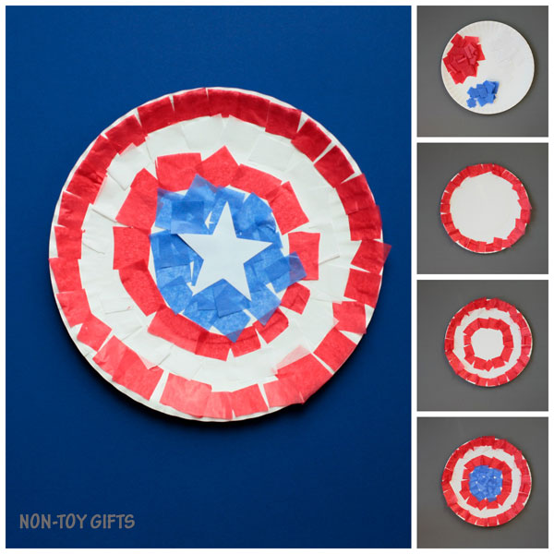

Step 1: Start by cutting the tissue paper into small pieces. Considering that there are 2 red rings, you will need more red than blue and white tissue paper.
Step 2: Apply glue on the paper plate and stick the tissue paper ring by ring. Start with the outer red ring, then move on to the white one, red again and finish with the blue one in the middle.
Step 3: Cut out stars and glue one on top of the blue ring.
Step 4: With Duct Tape attach a hair tie or a small rubber band to the back of the plate, you can add some staples to make it stronger, this will allow the kids to wear the shield on their hand or arm.

Closing Prayer: Thanking God that His peace has come into your life as a result of releasing the offenses that had blocked your heart

Faith At Home:
- Description: Write down Psalm 18:1-2 on a sticky note and put it on the mirror in the bathroom, read it to them every time you help them washing hands or brushing their teeth for a couple of days.

He is My Defender

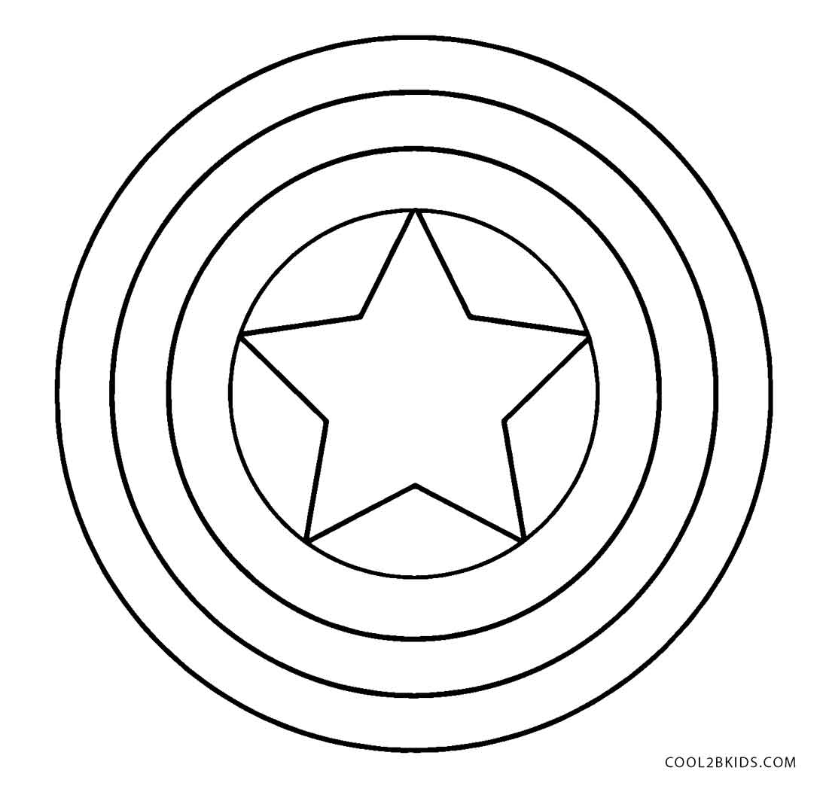

Repay no one evil for evil. Have regard for good things in the sight of all men.
-ROMANS 12:17

