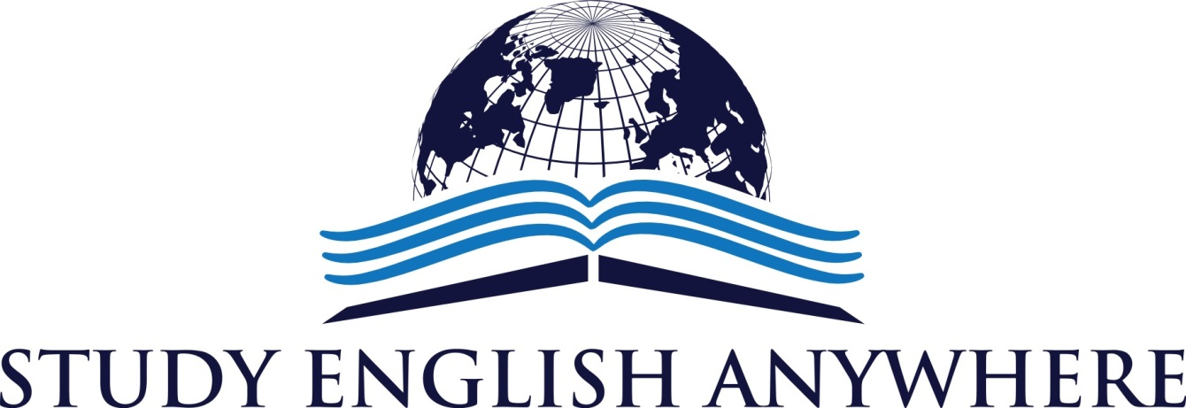
PODCAST EPISODE 2
THE NEWS
- German Aeroplane Crash
http://www.bbc.co.uk/news/world-europe-32035121
- Zayn Malik leaves One Direction
http://www.bbc.co.uk/newsbeat/32057401
THE GRAMMAR
Future Tenses
- I am (not) going to buy a house one day. (plan)
- I am (not)meeting my friend later. (arrangement)
- I am going to pass my test because I have studied. (prediction with evidence)
- I will have ten children. (prediction with no evidence)
- Shall I open the window? (suggestion)
- I will get some lunch now ( instant decision).
- I will buy you a car for your birthday. (promise)
- I will cook food for you today because I know you are tired. (offer)
THE VOCABULARY
Phrasal Verbs
- Cut down on
- Do up
- See off
- Pay back
- Work out
Idioms
- Not my cup of tea
- Run down
- Call it a day
- Runs in the family
- Once in a blue moon
- So far, so good
Pronunciation
- Vehicle
- Specific
- Ask
- Nervous
- Private

THE HISTORY
http://www.royal.gov.uk/historyofthemonarchy/kingsandqueensofengland/theyorkists/richardiii.aspx
THE MOVIE
http://www.imdb.com/title/tt0206634/

Follow us @StudyAnywhereUK
Visit us: www.studyenglishanywhere.com
Contact us: support@studyenglishanywhere.com
SoundCloud: https://soundcloud.com/study-english-anywhere
iTunes:Study English Anywhere

