Fire/Rescue Electronic Timesheets

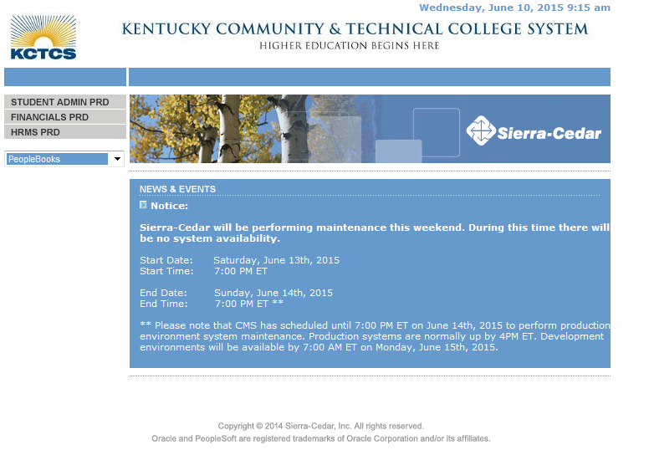
Step | Action
Begin by navigating to the Time and Absent page.
Click Main Menu.
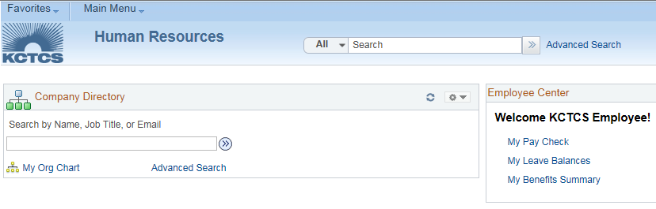
Click the Self-Service folder.
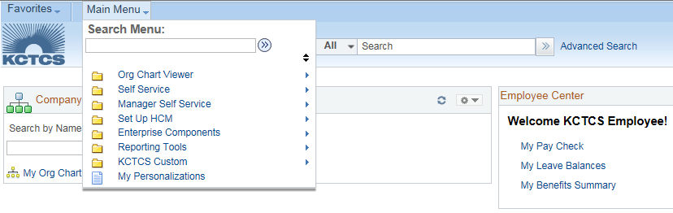
Click the Time Reporting folder.
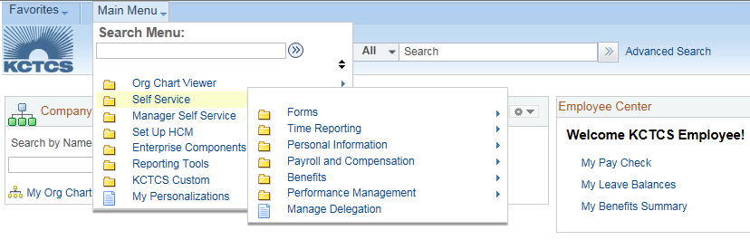
Click the Report Time folder.
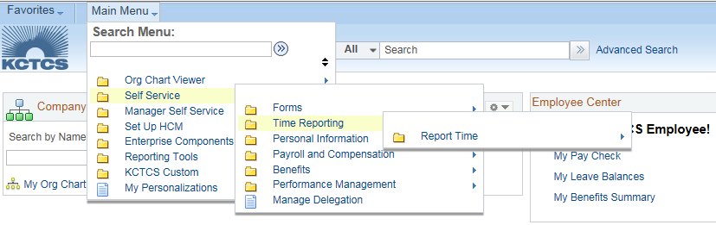
Click the Time and Absence link.
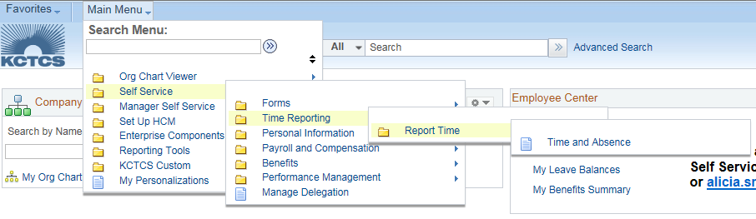
PeopleSoft opens to the Select Job page.

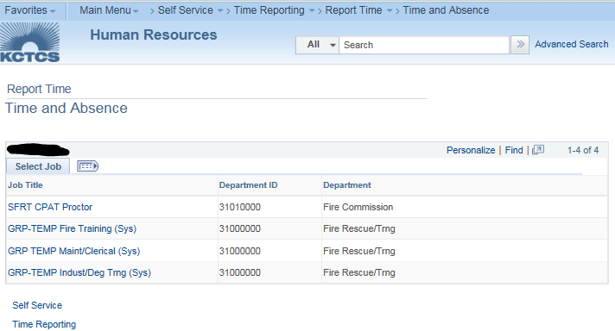
Click the Job Title link you need to submit time for.
- GRP-TEMP Maint/Clerical (Sys) = $10 pay rate
- GRP-TEMP Fire Training (Sys) = $21 pay rate
- GRP-TEMP Indust/Deg Trng (Sys) = $22 pay rate
*Note: Each job title will be reported separately. You may have to fill out 3+ timesheets in a given pay period.

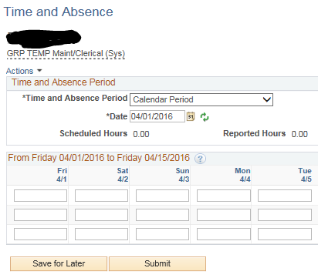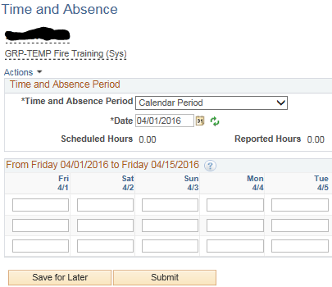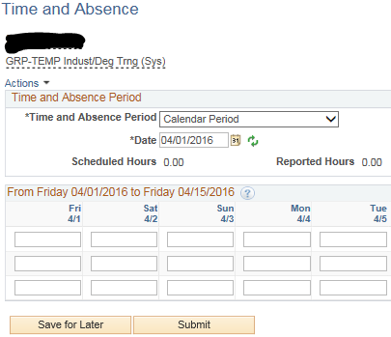
$10/rate
$22/rate
$21/rate

Step | Action
8. | Make sure the correct pay period is populated. If you need to choose a different pay period use the blue link “previous period” or “next period” to navigate to the correct date.  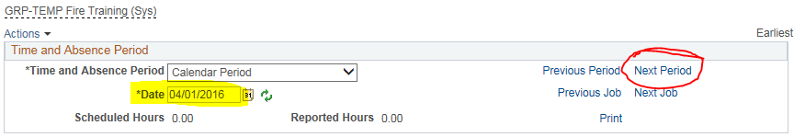
9. | Part time Fire/Rescue employees must report their locality worked. To select the locality worked, scroll all the way to the right and select the Addl. Info link.  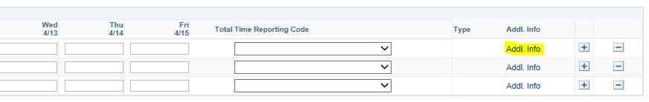
10. | Click on the magnifying glass next to the Locality box, to choose your Locality.  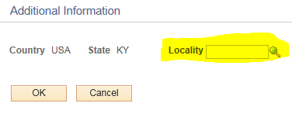
11. | This will display all of the different taxing localities. Clicking on the blue Locality code link will populate that row of the timesheet with the correct taxing locality. Not all locations charge a local tax. Hours needing to be reported in a location that does not charge a local tax, should be charged to the blank “NO LOCAL” selection.  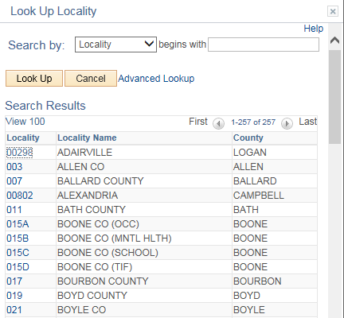
12. | Each locality should be reported on its own line of the timesheet. If working in the city limits, choose the city. If not working in the city limits, choose the county. If the city does not have a local tax, choose the county. If the county does not have a local tax, choose the “NO LOCAL” selection.
13. | Enter the number of hours for the days that you worked for the semi-monthly pay period (e.g. 4/1/16 – 4/15/16).
14. | Continue adding rows and selecting localities until the timesheet is complete. Additional rows can be added by clicking the “+” button, located on the far right-hand side of the page.  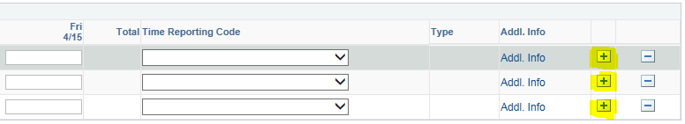
15. | Once the timesheet is complete, and on or before the due date, click on the Submit button to route the timesheet to the supervisor for approval.  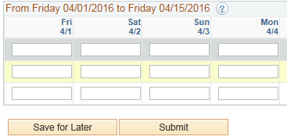  *Note: Every time that you click Submit your supervisor will get an email requesting time approval. So, use Save for Later until you are all finished with time entry. Clicking Save for Later will not request approval from your supervisor.

