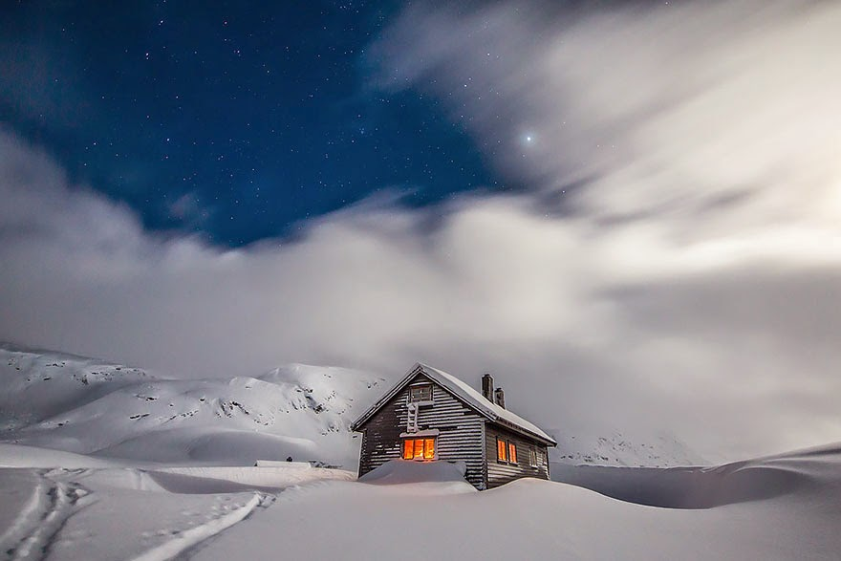
This Photo by Unknown Author is licensed under CC BY

Day 26. Bless Your Home
In The Celtic Spirit, Caitlin Matthews shares ideas, rituals, and practices that can help enrich your appreciation and understanding of the seasons. Here is a selection for December on blessing your home.
“The heart of winter is a time of homecoming and cessation of travel. We return home, ostensibly to celebrate the holiday with our family, but actually to attend to the domestic shrine that is our family home. Western spiritual culture has tended to emphasize the importance of the temple, church, or place of spiritual gathering over the domestic shrine, but in truth, the home is the primary abode of Spirit; if Spirit dwells not there, there is certainly no use seeking for it in other places.
The householder is a true priest or priestess who maintains the holiness of the hearth and gives all guests the welcome of the home’s indwelling spiritual presence. As guests gather or are expected, the householder can ritually acknowledge the house as a shrine of blessing by spiritual cleaning in preparation for holy days (“holidays”). This may entail going about the house with a bowl of burning aromatic herbs or a flame-warmed dish of sweet oils to cleanse the house-space of any worries, arguments, sorrows, or hidden fears. With intentioned prayer, the household can make all clean and clear again.
After the cleaning comes the hallowing or blessing of the house. Kindle your hearth, if you have a fireplace or light your heater or a candle if you have not. Be aware of the heart of the house as a beating, living, spiritual presence. Now, leaving the candle or flame at the hearth, kindle a fresh candle and take it throughout your house. Sing a wordless song of blessing.
Now the Spirit of your home can welcome all guests who come within its walls, that they might share in the blessing that is yours.”

