Central Alabama Emmaus Community

Speakers Prayer Chapel

Manual

Guidelines for Speakers Prayer Chapel
Purpose. The purpose of the Speakers Prayer Chapel (SPC) is to provide a worshipful, reverent environment for each speaker and others to seek God’s blessing and guidance before each talk and to offer prayers of praise and thanksgiving afterwards. SPC committee members and sometimes other members of the Emmaus Community remain in the SPC praying for the speaker, the pilgrims and special prayer needs during each talk.
Before Arrival at the Walk:
1. Contact the Lay Director (LD) to determine any special needs, the theme, and the schedule. Determine if the LD has a special work of art they would like hung in the SPC during the walk.
2. Remind speakers at the team meetings to invite special people to join in prayer in the SPC for their talk. This may include their spouse, other family members, reunion group members, and/or other special friends in the Emmaus Community.
3. Make or purchase 15 note cards with envelopes. These usually reflect the walk’s symbol or scripture verse. Large cards (8½” x 11” sheet folded in half) are preferred.
4. Make or purchase 65 note cards without envelopes to be used as Prayer Cards. These may or may not reflect the walk’s symbol or scripture verse. Small cards that can be folded are preferred. Each card should be personalized by handwriting or typing and reflect this saying: “Dear __________, while you were away at Dying Moments, someone was praying for you.”
5. Determine whether you will use a pitcher of water or bottled water for the speakers. You will need to purchase either plastic cups or bottled water.
6. Obtain worshipful instrumental CD’s to play softly during prayer times, if desired. You will also need a CD player.
7. Purchase either one large pillar candle or three tall tapers. These should be white and unscented.
8. Purchase regular and sugar-free mints.
9. Copy the list of pilgrims from the CAEC website or obtain a list from the Lay Director.
10. Obtain a list of the conference room team and a weekend schedule from the Lay Director.
11. Copy the Work Area Log-in Sheet from the CAEC website or obtain one from the CAEC Board Representative responsible for SPC.
12. Arrange to have the LD and SD crosses delivered either to you or to the SPC by the CAEC Board Representative responsible for SPC.
Set-up: (The SPC is located behind the large rainbow banner east of the lodge entrance.)
1. Logistics will deliver the SPC boxes and furniture the afternoon the walk begins.
2. Review the Inventory List in this manual and ensure all necessary items are present.
3. Place the brass Spiritual Director’s cross across the Open Bible on the alter.
4. Mark the back of the LD’s Crucifix with a small piece of masking tape and place it on the kneeling rail. (The tape will distinguish this crucifix from the two which are used at each walk for table prayer times.)
5. Hang the Jesus picture and any special artwork requested by the LD.
6. The room should be comfortable and a little on the cool side since speakers are dressed more formally. IF the weather is especially warm, you may need to place the alter in the corner nearest the air conditioner. A small fan is provided for the speaker’s use.
7. Ensure the SPC is ready with the drapes closed for privacy in time for the onsite commissioning service prior to Send-Off (usually about 7:00 p.m.)
8. If you will be using a cooler for bottled water, you may get ice from the ice machine in the serving area of the kitchen. Please be aware of how much ice is available and use sparingly.
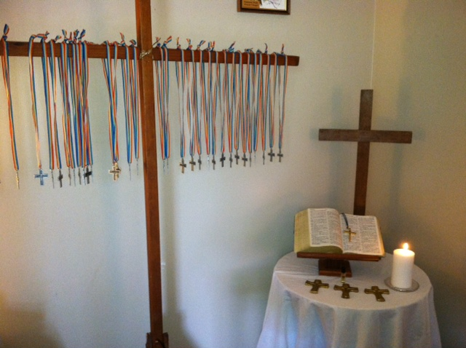
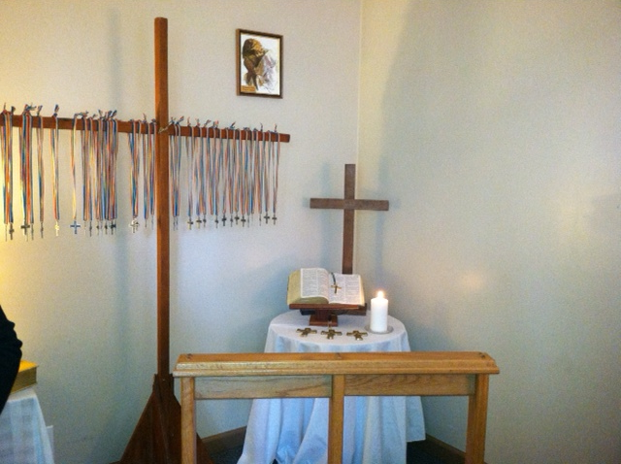
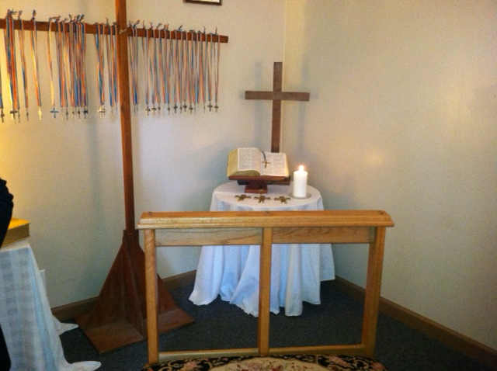
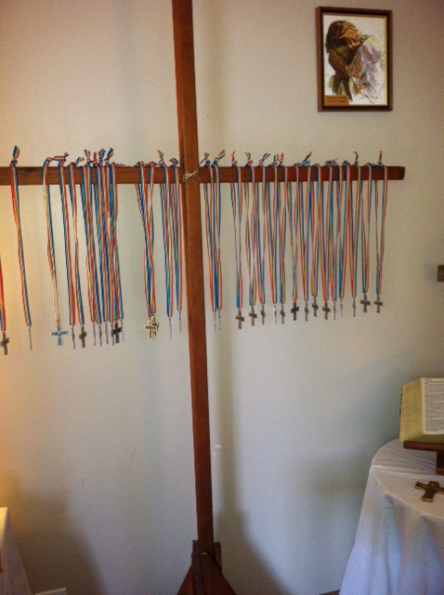

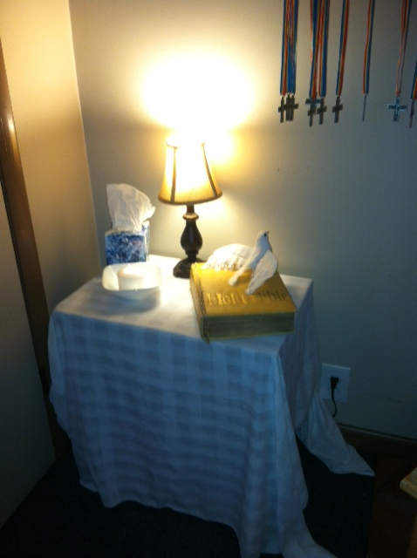
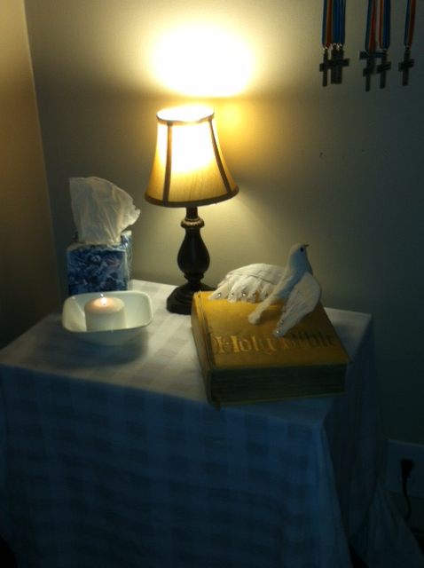

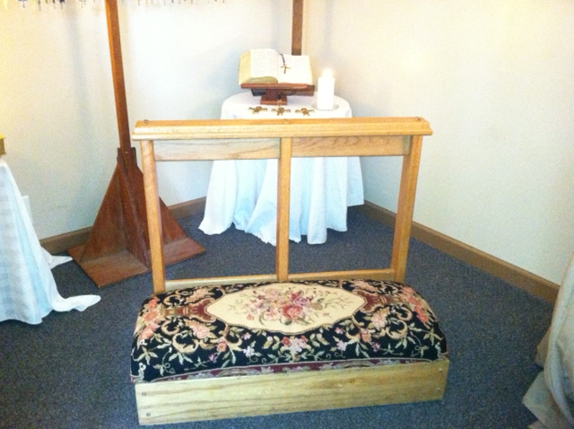
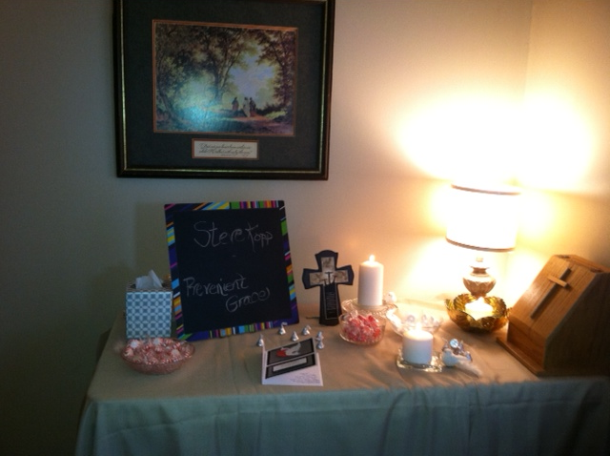
Procedures:
1. Persons in the Prayer Chapel should be unobtrusive and as low key as possible. Attention should be on the Speaker and his/her ability to focus and understand what the Holy Spirit is leading the Speaker to say. No one should be allowed in the Speakers Prayer Chapel that has not been on an Emmaus or Chrysalis Walk or a similar three day spiritual event.
2. Have lights on during the assembling time before and after prayers.
3. Light the candle and turn out the overhead light to signal time for prayer to begin. The overhead light remains off and the candle lit during the entire prayer session.
4. Play soft inspirational music during prayer sessions, if desired.
5. Maintain the privacy of the SPC from the pilgrims at all times.
6. Post the walk schedule on the wall and remain aware of talk times throughout each day.
7. Be in the SPC at least 30 minutes before schedules talk times.

8. Note on the chalkboard the name of the speaker and the talk before the speaker arrives.
9. Before the speaker arrives, set out the appropriate card and envelope. Ask everyone who prays for the speaker to sign the card.
10. Quietly welcome the speaker upon arrival in the SPC. Offer them water to drink.
11. Survey the speaker for buttons, zippers, turned under collars, hair, etc. and assist them in presenting their best appearance. All speakers, except the Priorities speaker should wear the Emmaus cross. If necessary, borrow one of the pilgrim crosses. Suggest they not wear name badges or other distracting jewelry.
12. Determine from the ALD the appropriate time to start. Do not start before the arrival of the LD and SD; however, one or both may have to be absent on some talks. In the SD’s absence, an ASD will be assigned the SD’s duties.
13. Ask the speaker to kneel at the alter rail. IF the speaker’s spouse is present, they may kneel also. Fellow team members and others gather around the speaker and lay hands on them.
14. Ask speaker if they would like to be the first to pray, either silently or aloud. Some speakers prefer not to pray oral prayers at all. IF the spouse is present they would normally pray second, followed by the SPC chairperson. Others gathered offer up SHORT prayers for the speaker in any order. The last person to pray is the SD or his designee.
15. Before talk prayers are usually prayers of praise or supplication for God to use the speaker, to give calmness, confidence and peace of mind, etc. This is often referred to as “praying up” the speaker.
16. When before-talk prayers are completed, remind the speaker to take the crucifix on the alter rail with them
17. The SPC staff and others remain in prayer, either silently or aloud, throughout the talk, praying for the speaker, the pilgrims and any special prayer needs. A list of pilgrims should be in the SPC at all times.
18. The speaker returns to the SPC after the talk is given and goes directly to the alter rail and kneels. See that the speaker returns the crucifix to the alter rail, except after Talk #6: Grow through Study when the crucifix is left on the lectern in the conference room.
19. After-talk prayers are usually of praise and thanksgiving for having used the speaker to effectively and lovingly communicate and witness to the pilgrims. This is often referred to as “praying down” the speaker.
20. Following the after-talk prayers, those present give the speaker the sign of peace (hugs).
21. Remind everyone present who has not yet signed the speaker’s card to do so.
22. Once again, offer water to the speaker, then remind them to go change clothes, but not to return to the conference room until after discussions and posters have been completed. (There are no posters on Saturday.)
23. Be sure the speaker receives their card before they return to the conference room. Sometimes the LD will have a small gift for each speaker; these may be handed to the speaker when they are given their card.
24. Get ready for the next speaker. Sometimes, the ALD will instruct you to pray up one speaker before praying down the previous speaker. This usually happens after lunch of Friday when the SD is fielding questions following Dying Moments and may happen on Saturday if they get behind schedule.
25. During the Means of Grace talk on Friday, when the Pilgrims leave the Conference Room to walk up the hill for Dying Moments, you will move to the Conference Room to pray for each individual by name and distribute the Prayer Cards at each chair, including the Conference room team.
26. When tables are ready to begin prayer time, after Dying Moments on Friday, an ALD will come to the Speakers Prayer Chapel and ask the Chair or Co-Chair for three hand held crucifix crosses. These crosses will be used by the Pilgrims for group prayer sessions. When the prayer sessions are over, one of the ALDs will return the hand held crucifix crosses to the Chair or Co-Chair, Speakers Prayer Chapel. The LD’s cross will not be used for the pilgrims’ prayer sessions and will remain in the Prayer Chapel when not being used by a Speaker.

What is said at the table stays at the table is said over and over again during a walk. If a Pilgrim or anyone else thinks that what they say in confidence cannot stay confidential, then all trust goes away. NO ONE even CLERGY should mention any specifics concerning a prayer request or anything else that is said in confidence. Even the people in the Speaker’s Prayer Chapel are not to have any specifics regarding any issues or prayer requests that are made in the Conference Room or at Dying Moments. God knows all specific issues which is all that is necessary. If you want to pray for a pilgrim or anyone else, it is not necessary to know the specifics, just pray! Trust is a must otherwise what we are doing at Emmaus is for nothing
Take-down:
1. Logistics will pick up the large cross to take to the Cross Ceremony.
2. As quickly as possible after the last talk, the Chair/Co Chair should begin packing Prayer Chapel items.
3. The Chair or Co Chair will do an inventory of all items on hand in the Prayer Chapel. A copy of the inventory will be placed in one of the SPC storage boxes and a copy of the inventory will be provided to the CAEC Board Representative responsible for the SPC.
4. The CAEC Board Representative for the SPC will ensure that items needed for the Prayer Chapel are replaced.
5. Take the LD’s crucifix cross and the Spiritual Director’s cross (in the original box) to the pavilion for closing. Be sure to remove the tape from the back of the LD’s cross. Place both crosses on the podium.
6. The Chair or Co-Chair will complete a Work Area Log-in Sheet for all people who work in the Speakers Prayer for a half day or more. Those who work less a half day will not be put on the Log-in Sheet. Instructions for submission of the log-in sheet are on the form.
Reimbursement:
- Reimbursement for any necessary items purchased can be made only with the submission of the appropriate receipt(s). Receipts will be submitted through the CAEC Board Representative responsible for the SPC for reimbursement.

SPC Helpers

Please print your Name (First and Last), Original Walk # Email Address, Phone Number
Walk # ___________
Chair:_____________________________
Co-Chair:__________________________

Name | Email | Phone # | Walk #
Note: Please see that each person who serves in your area logs in. Give the completed log to any member of the CAEC Board at Candlelight or Closing or mail to Rita Carswell, 538 Winding Road, Dadeville, AL 36853 or email to ritacarswell14@yahoo.com

