SPECIAL MEETING
DECEMBER 30, 2015

A Special Meeting of the Town Board of the Town of Hampton, County of Washington and the State of New York was held at the Town Hall, 2629 State Route 22A, Hampton, New York on the 30th day of December, 2015.

PRESENT: David K. O’Brien----------Supervisor
Tamme Taran---------------Councilwoman
David Jensen----------------Councilman
Donald Sady----------------Councilman
Andrea Sweeney-----------Councilwoman
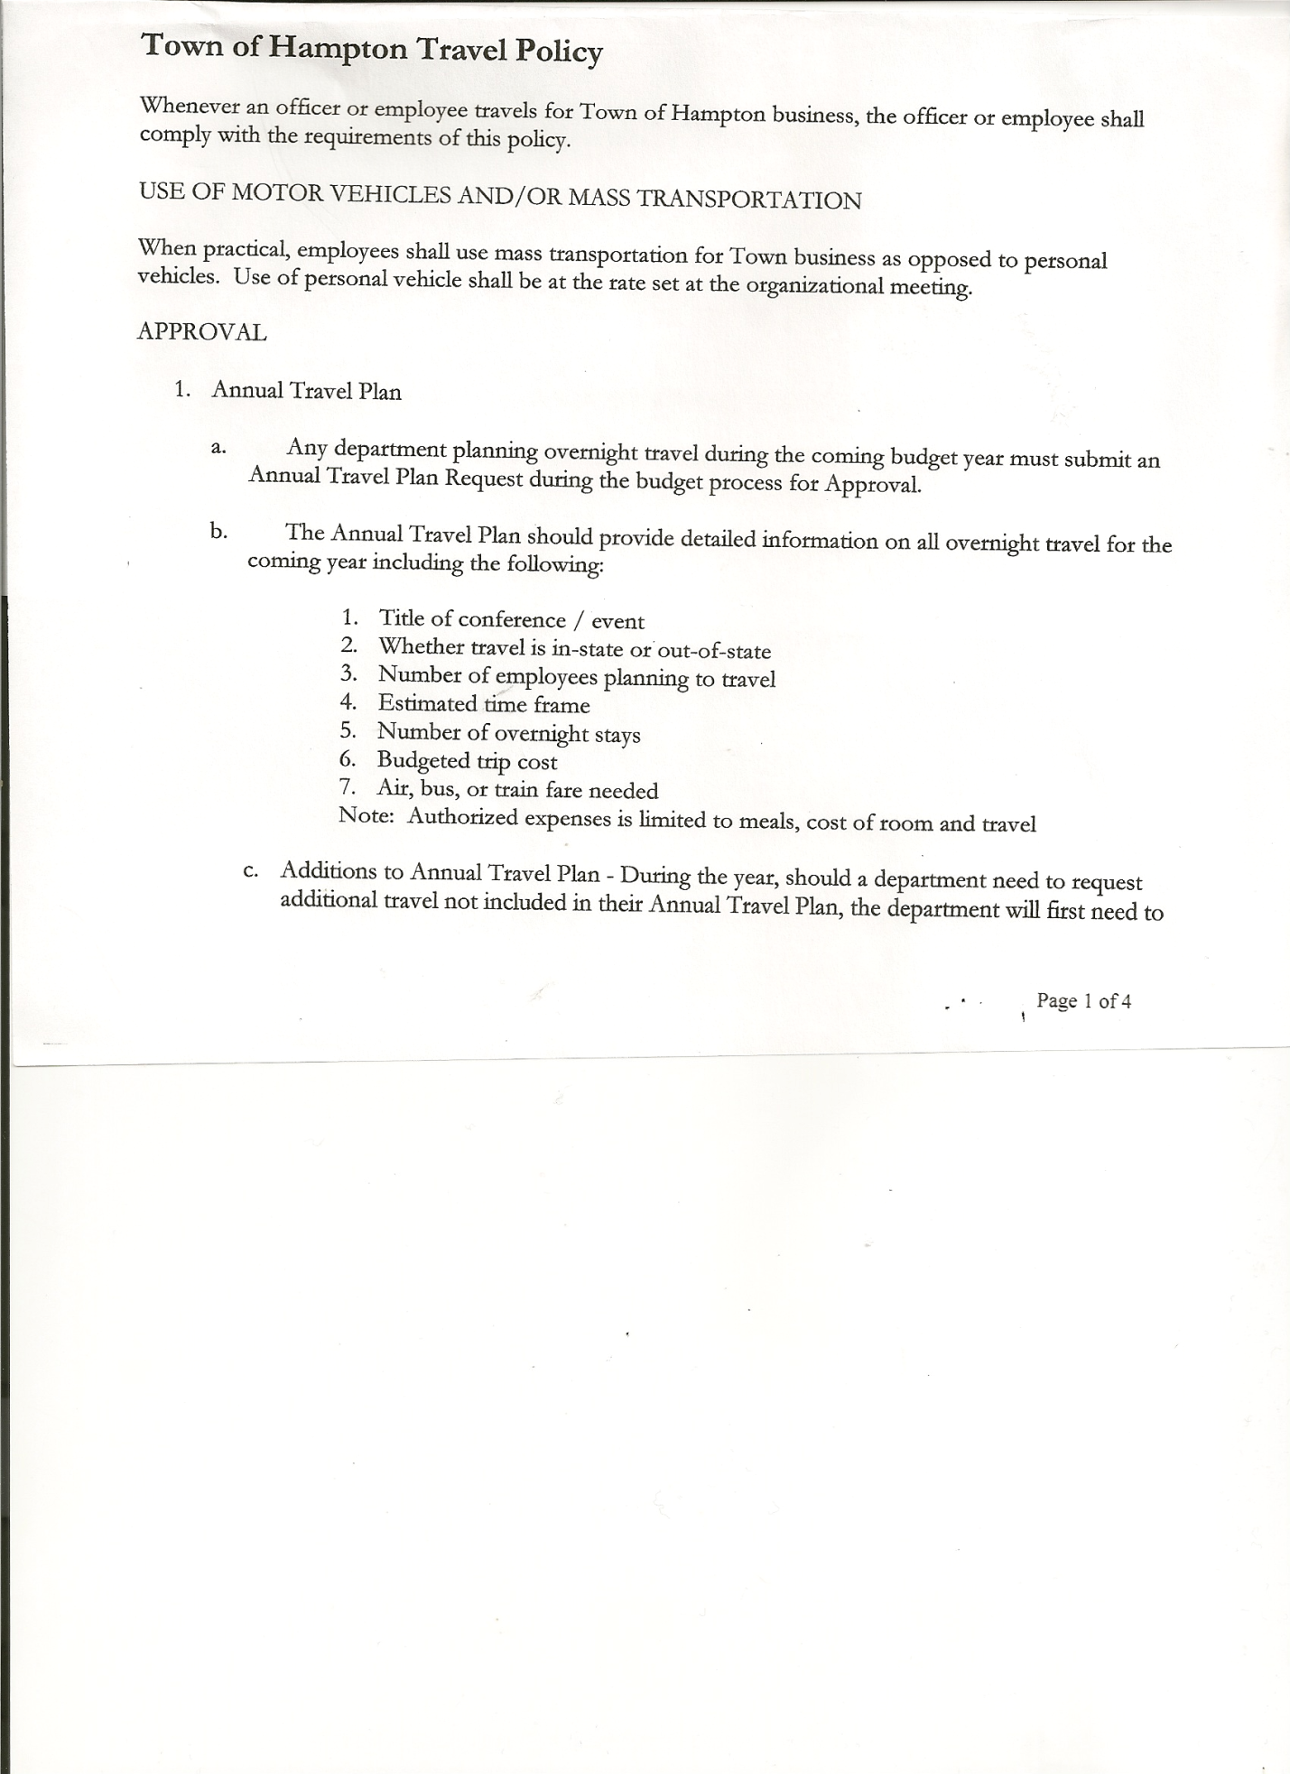
Rebecca Jones--------------Town Clerk
Camilla Shaw---------------Tax Collector/Deputy Town Clerk
Herbert Sady, Jr.------------Highway Superintendent

Also present: Roger Weeden

The meeting was called to order by Supervisor O’Brien at 7:00pm followed by the Pledge of Allegiance. Location of Fire Exits were given.

Supervisor O’Brien prepared and read a Proclamation to David Jensen for his dedicated service to the Town of Hampton as Town Councilman (copy is attached).

Miller Cemetery discussion….Jonathon Braun has donated 1 acre of land adjoining the Miller Cemetery. Town needs to cover cost of survey and closing costs.

RESOLUTION NO. 89 -2015
MILLER CEMETRY
On a motion of Councilman Sady, seconded by Councilwoman Sweeney the following resolution was ADOPTED Ayes 5 O’Brien, Taran, Jensen, Sady, Sweeney
Nays 0
RESOLVED, that the Town will cover the survey and closing costs associated with acquiring additional land adjoining the Miller Cemetery.

RESOLUTION NO. 90 -2015

AUDIT OF CLAIMS
On a motion of Councilwoman Taran, seconded by Councilman Sady the following resolution was ADOPTED Ayes 5 O’Brien, Taran, Jensen, Sady, Sweeney
Nays 0
RESOLVED that the bills have been reviewed by the Town Board and are authorized for payment in the following amounts.
General Fund No. 162 through No. 170 $ 22,331.87
Highway Fund No. 120 through No. 123 $ 7588.95
Total both funds $ 29,920.82

TOWN BOARD MEETING
DECEMBER 30, 2015 PAGE 2

RESOLUTION NO. 91-2015

CLOSE THE BOOKS FOR 2015
On a motion of Councilwoman Sweeney, seconded by Councilman Jensen the following resolution was ADOPTED Ayes 5 O’Brien, Taran, Jensen, Sady, Sweeney
Nays 0
RESOLVED to Close the Books for 2015.

On a motion of Councilman Sady, seconded by Councilman Jensen , the meeting adjourned at 7:10pm. All in favor Aye.

Respectfully submitted,

Rebecca S. Jones, RMC
Town Clerk

