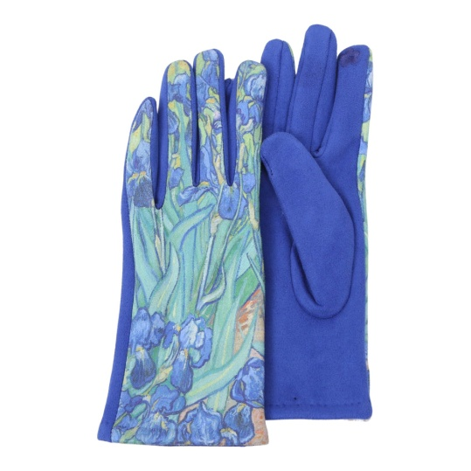
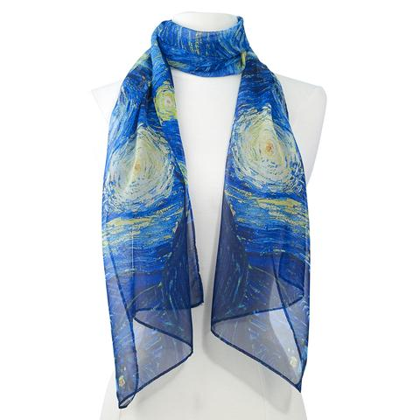

Famous Art Scarves, Starry Night $29 Famous Art Texting Gloves, Irises $29

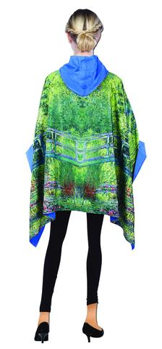
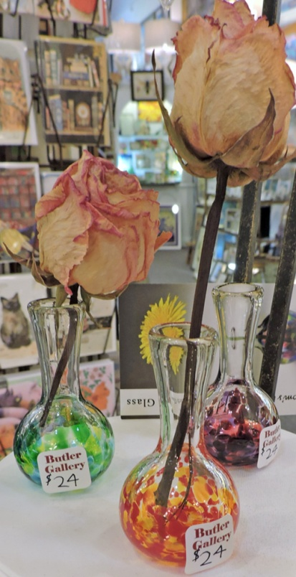

Handblown American glass, Famous Art Reversible Raincape,
Mom’s Little Vase, $24 Monet’s Waterlilies $69

