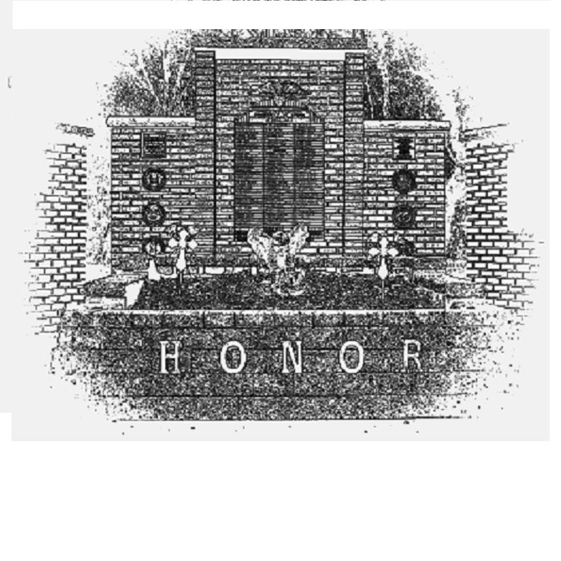
Lyons Area Veterans Memorial
“Honoring the men and women of the Lyons area who served their country”
Nameplate request form
for current and former residents of the Lyons, Muir and Pewamo areas.

Required fields are italicized.

Name, as it should appear on the Memorial:

_____________________________________

Service Number: ______________________

Branch: ______________________

Date of entry: _________________

Discharge date: ________________ Status: ______________

Date of Birth: _________________ Death: ______________

POW ______ MIA _____ KIA ______ WIA ______

Requested by:

Name: ________________________________

Phone number: _________________________

Please mail or fax to:

Village of Lyons - Memorial Office: 989.855.2125
212 Water St FAX: 989.855.2813
Lyons, MI 48851 ATTN: Bryon Bennett

Questions? Bryon: 616.902.0045

All requests are held on file. Nameplates/ plaques are purchased as funds allow.
This endeavor is funded in a variety of ways; donations are always welcome.

Thank you

