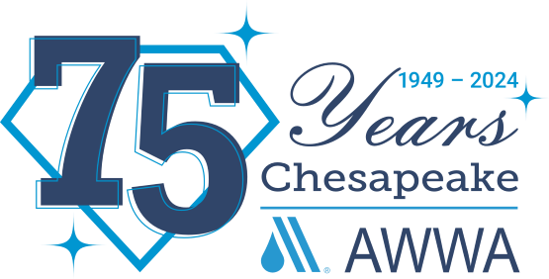

ONE AWWA OPERATOR SCHOLARSHIP

2024 Short Courses Scholarship Application
The Chesapeake Section of the American Water Works Association, Inc. (CSAWWA) is committed to providing training for its members. With the help of AWWA’s One AWWA Scholarship, the CSAWWA will be awarding 7 full and 3 commuter Short Courses scholarships. The Short Courses will be held in person on June 2nd – June 7th, 2024, at Mount St Mary's college in Emmitsburg, Maryland. Award of scholarships will be based on need.
Completed applications must be returned by April 5th, 2024 to Rob Swann at: pwswan24@aacounty.org
________________________________________________________________________________ AWWA Membership #:
Name: Job Title:
Company:
Street: City:
State: Zip:
Phone #:
Email Address:
Supervisor’s Name and contact information:
--------------------------------------------------------------------------------------------------------------------------------------------------- Temporary Operator (Yes or No)? Fully Certified Operator (Yes or No)?
Interested in Full or Commuter:
Short Course classes of interest you wish to attend:
◻- Water Treatment
◻-Wastewater Treatment
◻-Wastewater Collection Systems
◻-Water Distribution
◻-Superintendent

Please provide justification as to why you should be considered for one of these scholarships: [on back of application or on separate sheet(s)]

