Lecture and Workshop: Fabric Printing Using Pressed Images
Lecture
The lecture is open to all members present at the meeting and will last approximately 1 hour. I will come equipped with computer, printer, flower press, and fabric sheets. I will demonstrate my process for pressing, scanning, and printing objects (leaves, flowers, pictures). I will also talk about how you can make your own fabric sheets using Bubble Jet.

Workshop
The workshop is limited to those who signed up for the workshop. They will have completed the pre workshop tasks and sent me their scanned images so that I can print the images prior to the meeting. I will come to the workshop with printed fabric sheets for their projects. Using the printed images, we will be making ornaments, mug rugs, or trivets. This workshop should last approximately 2 hours.
The charge for the workshop will be $8 (1 ornament) or $10 (1 trivet or 2 mug rugs). Additional images can be printed as long as they are paid for. Payments will be paid to RPQG.
Pre workshop work:
1.Gather image (flowers or leaves) for pressing.
2.Make sure images are dry before pressing. Just let them sit out in the open.
3.Press between newspaper, card stock, or computer paper that is not shiny. I have even used paper towels. Try not to press anything too bulky. Place weighted books on top or used flower press.
4.After a day or two, check the object to make sure corners have not been turned over or part are not overlapped. As long as it is still pliable, you can straighten it out using tweezers or pins.
5.When dry but not brittle, place on your scanner face down and scan into your computer as a “jpg” file. If you do not know how to do this, let me know and I will help you.
6.Send the image to me and tell me what you want to make: ornament, mug rug, or trivet. *Note: you could send a picture rather than a pressed object for printing. Deadline is October 31, 2022. Send to cschoner@comcast.net

Supply List for Workshop
Sewing machine with new needle
Sewing supplies
Scissors and thin sharp pins
White or off white thread
Batting:
trivet/mug rugs: Insulbrite is good (I will have some extra)
ornaments: fusible fleece (I will have some extra)
Backing fabric for trivets and mug rugs
Ribbon if making ornaments
Rotary cutter & ruler
pinking shear blade if making the ornament (optional)

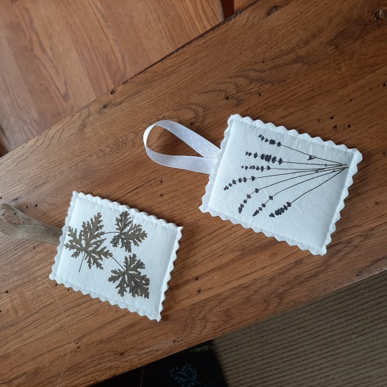 | Ornaments (image is printed on both sides)  Need thin batting or fusible fleece, thin ribbon
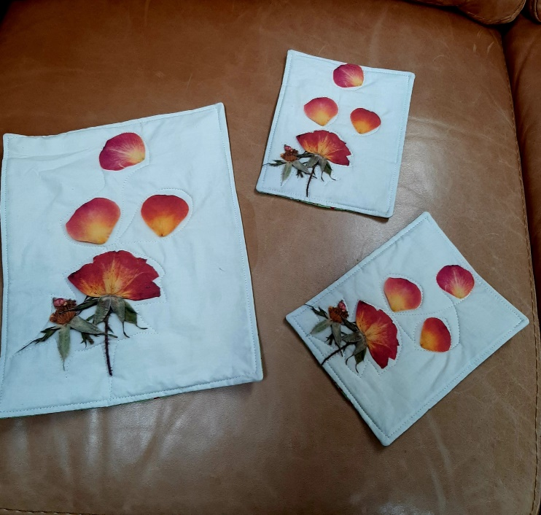 | Mug Rugs (usually 5” x 5” or 6” x 6”)  Need batting and backing  Trivet (usually 8” x 10” or 8” x 8”)  Need batting and backing

