CLINTON COMMONS JULY 2019
SUNDAY | MONDAY | TUESDAY | WEDNESDAY | THURSDAY | FRIDAY | SATURDAY
 | 1  10:00 Exercise (MP)  11:00 Bingo (MP)  6:30 Bible Study (MP) | 2  10:00 Exercise (MP)  11:00 Game Hour (MP)  6:00 INTRO TO GENEALOGY – (MP | 3  10:00 Exercise (MP),  11:00 Bingo (MP),  11:00 REFLECTIONS SALON | 4  BUSINESS OFFICE CLOSED  RESTAURANT CLOSED | 5  10:00 Sunshine Café | 6
7  11:00 Worship Service (MP) | 8  10:00 Exercise (MP)  11:00 Bingo (MP)  6:30 Bible Study (MP) | 9  10:00 Exercise (MP)  11:00 Game Hour (MP)  6:00 INTRO TO GENEALOGY – (MP) | 10  10:00 Exercise (MP),  11:00 Bingo (MP),  11:00 REFLECTIONS SALON | 11  10:00 Exercise (MP)  11:00 Game Hour (MP)  6:00 BOOK CLUB (MP) | 12  10:00 Sunshine Café  2:00 HAPPY HOUR/SHUFFLE BOARD | 13  11:00 Family Bingo (MP)
14  11:00 Worship Service (MP) | 15 10:00 Exercise (MP), 11:00 Bingo (MP),  6:30 Bible Study (MP)  RESTAURANT CLOSING AT 4PM, NO DAILY SPECIAL | 16 10:00 Exercise (MP),  BRIGGS LIBRARY 3:15  11:00 Game Hour (MP)  6:00 INTRO TO GENEALOGY – (MP) | 17  10:00 Exercise (MP),  11:00 Bingo (MP),  11:00 REFLECTIONS SALON | 18  10:00 Exercise (MP),  11:00 Game  Hour (MP), | 19  10:00 Sunshine Café | 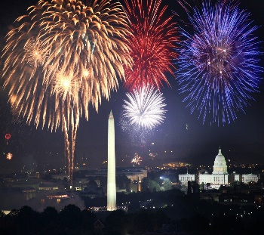  20
CLINTON COMMONS JULY 2019
SUNDAY | MONDAY | TUESDAY | WEDNESDAY | THURSDAY | FRIDAY | SATURDAY
21  11:00 Worship Service (MP) | 22 10:00 Exercise (MP)  11:00 Bingo (MP)  6:30 Bible Study | 23  10:00 Exercise (MP),  11:00 GAME HOUR  6:00 INTRO TO GENEALOGY – (MP) | 24  10:00 Exercise (MP), 11:00 Bingo (MP),  11:00 REFLECTIONS SALON | 25  10:00 Exercise (MP)  11:00 Game Hour (MP)  6:00 BOOK CLUB (MP) | 26  10:00 Sunshine Café  11:00 - 2:00 CLINTON COMMONS CARNIVAL | 27  11:00 Family Bingo
28  11:00 Worship Service (MP) | 29  10:00 Exercise (MP)  11:00 Bingo (MP)  6:30 Bible Study (MP) | 30 10:00 Exercise (MP),  11:00 OUT TO LUNCH BUNCH  11:00 GAME HOUR  6:00 INTRO TO GENEALOGY – (MP) | 31  10:00 Exercise (MP), 11:00 Bingo (MP),  11:00 REFLECTIONS SALON | JULY BIRTHDAYS  MARY MCLEOD-WISSNER - JULY 7TH  FRANK HOWARD - JULY 20TH  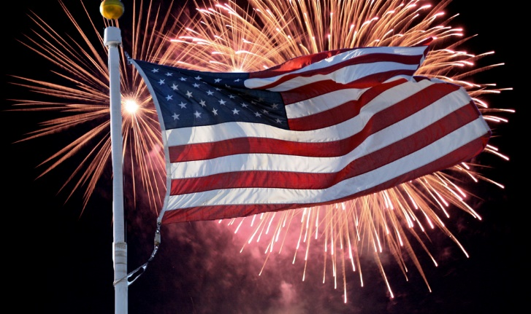  BARB SMITH - JULY 20TH  FRED MATICE – JULY 21ST  VAL KRONE – JULY 27TH

