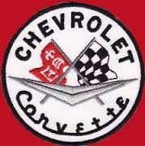

**SOUTHERN MARYLAND CORVETTE CLUB PRESENTS…**

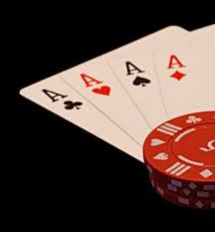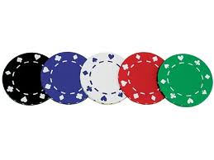

**2014 POKER RUN**

**On your mark…**

**Saturday, July 26, 2014**

**Rain or Shine**

10:00am -12:00pm Registration at Bert’s Diner

28760 Three Notch Rd

Mechanicsville, MD 20659

3:00pm Last hand submission

3:30pm Award Ceremony

*Get Set*…

**$20 Entry Fee**

**$5 for extra playing cards**

GO!!!

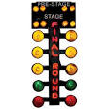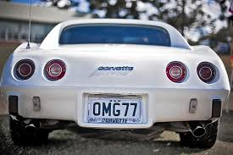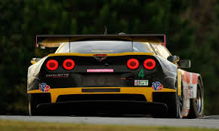

Top Hand

$100

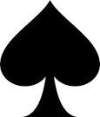

2ND

$50

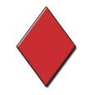

Lowest Hand

Refund

**50/50 Raffle!**

**Proceeds will benefit local Food Pantries, BECA Scholarship, and Toys for Tots.**

For more information, contact Ben Mendoza at 240-538-8827 or [bmwman@md.metrocast.net](mailto:bmwman@md.metrocast.net)

Stay connected: For updates on this event, check our website: <http://www.southernmarylandcorvetteclub.org/>

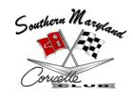

**ROUTE = 78.6 miles going through Southern MD back roads for a scenic cruise**



**Start: Bert’s Diner**

**28760 Three Notch Rd, Mechanicsville, MD 20659**

**($20 entry fee; purchase extra card for $5)**

**Stops**



1

**Chaptico Market** in 7th District: 1st stop to build hand (choose from two routes)

25466 Maddox Rd, Chaptico, MD 20621



2

**Back Road Inn**

22094 Newtowne Neck Road, Compton, MD



3

**WJ Dent & Sons/Chief’s Bar** (Purchase extra card for $5 to better hand)

Piney Point

44584 Tall Timbers Rd, Tall Timbers, MD 20690



4

**Abell’s Tavern**

20281 Piney Point Rd, Callaway, MD 20620



5

**Sea Breeze Restaurant & Crab House** (Purchase extra card $5 to better hand)

27130 S Sandgates Rd, Mechanicsville, MD 20659



**Finish: Bert’s Diner**

**(Turn in hand or purchase another card)**