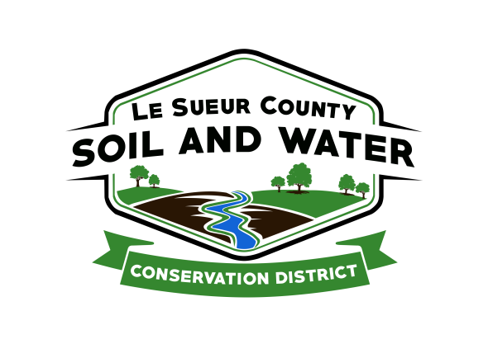

Le Sueur County Soil & Water Conservation District

Le Sueur County SWCD Tel. (507) 419-0365
181 W Minnesota St Website: www.lesueurswcd.org
Le Center, MN 56057

Minutes from January 11, 2022 regular meeting of the Le Sueur County SWCD Board of Supervisors. Justice Center, Le Center, MN.

Meeting was called to order by Chairman Struck at 9:00 am.

Members present: Chairman, Jim Struck
Treasurer, Cletus Gregor
PR&I, Glendon Braun

Members absent: Vice-Chairman, Greg Entinger
Secretary, Earle Traxler

Others present: District Manager, Mike Schultz
District Technician, Joe Jirik
Ditch Specialist, Nik Kadel
Program Specialist, Sue Prchal
District Conservationist, Steve Breaker
Le Sueur County Commissioner Rohlfing
Le Sueur County Commissioner Wetzel

Secretary’s report from December 15, 2021 was read and approved.

Treasurer’s report for December 31, 2021 was read. Motion by Braun, second by Gregor to approve as read and to pay bills.
Affirmative: All
Opposed: None
Motion carried

The election of officers for calendar year 2022 was discussed. Motion by Gregor to have all offices remain the same for 2022, second by Braun.
Affirmative: All
Opposed: None
Motion carried

Motion by Gregor, second by Braun to designate First National Bank of Le Center as the SWCD’s bank for 2022 and the Le Sueur County Newspaper as the SWCD’s official newspaper for 2022.
Affirmative: All
Opposed: None
Motion carried

Joe informed the board that there will be a Soil Health Session in Jordan on January 13, 2022.

Motion by Gregor, second by Braun to amend the Lake Washington cost-share policy stating that the Lake Washington Improvement Association contribute 25% of project costs allowing 100% cost-share to landowners.
Affirmative: All
Opposed: None
Motion carried

Motion by Braun, second by Gregor to clarify the November 2021 SWCD minutes for James Beckel cost-share contract #WASH-3 to clarify cost-share dollars. $15,200.00 cost-share consists of $3800.00 (25%) from the Lake Washington Improvement Association and $11,400.00 (75%) from the Lake Washington grant.
Affirmative: All
Opposed: None
Motion carried

Cannon 1W1P was discussed. Gregor volunteered to be the alternate board representative.

The kickoff meeting was held for the Lower MN 1W1P, Entinger and Traxler attended.

Mike gave the board updates on SWCD payroll and benefits. Also the clubhouse has moved out of the building and uses for the space were talked about.

Motion by Braun, second by Gregor to update and adopt the Professional County Ditch Services Contract between the SWCD and Le Sueur County. The update is for the increase in billable rates and is valid from 1-1-2022 through 12-31-2022.
Affirmative: All
Opposed: None
Motion carried

Motion by Gregor, second by Braun to approve and submit the pay equity report to the MN Management and Budget.
Affirmative: All
Opposed: None
Motion carried

Nik updated the board on county ditches. He discussed tree removal, spraying and mowing, buffer enforcement and non-compliant parcels.

Steve gave an NRCS report. He discussed certifying construction projects, planning new projects to be completed in 2022, CRP certifications, expiring contracts and possibly a new signup.

Motion by Gregor, second by Braun to approve and pay Dan Sullivan state cost-share contract #5-20 in the amount of $853.25.
Affirmative: All
Opposed: None
Motion carried

Motion by Gregor, second by Braun to approve and pay Dan Sullivan capacity cost-share contract #CAP-2020-2 in the amount of $1271.91.
Affirmative: All
Opposed: None
Motion carried

Vouchers were reviewed and filled out.

There being no further business, meeting adjourned at 10:25 am.

The board and staff relocated to Patrick’s in St. Peter to meet Francis and Shirley Budin and present them with their Outstanding Conservationist sign and lunch.

___________________ ______________________________________________
Date District Secretary

