Directions to Blue Mountain College:
From 22 (aka HWY 78) via Hickory Flat:
From I-22 take the Hickory Flat exit
Turn toward Hickory Flat. You will be on HWY 178. Continue until you see the flashing traffic light.(A Dollar General store will be on your left.)
Turn LEFT onto HWY 5 at the intersection. You will travel about .3 miles (You will pass the Post Office and a Mexican Restaurant).
Slight RIGHT at the intersection and merge onto HWY 2. Continue on for about .8 miles.
Turn RIGHT to remain on HWY 2. Continue on for 8.8 miles.
Turn LEFT onto HWY 15 (N. Guyton)
Take the first LEFT onto W. Mill St. You will pass the Public Library, City Hall and a set of railroad tracks, then the Coward Martin Building will be on your RIGHT.
Parking is available in front of and beside the building as well as across the railroad tracks near City Hall.

From New Albany
(if you are coming from South of New Albany, take I-22/HWY 78 to New Albany, exit 64 toward Pontotoc/Ripley)
Take Hwy 15 North toward Ripley. Continue a little over 14 miles. (When you see the Blue Mountain Methodist Church on the left followed by Coombs Gas Co. on the Right you will be close to the college.)
Turn LEFT onto W. Mill St. You will pass the Public Library, City Hall and a set of railroad tracks, then the Coward Martin Building will be on your RIGHT.
Parking is available in front of and beside the building as well as across the railroad tracks near City Hall.

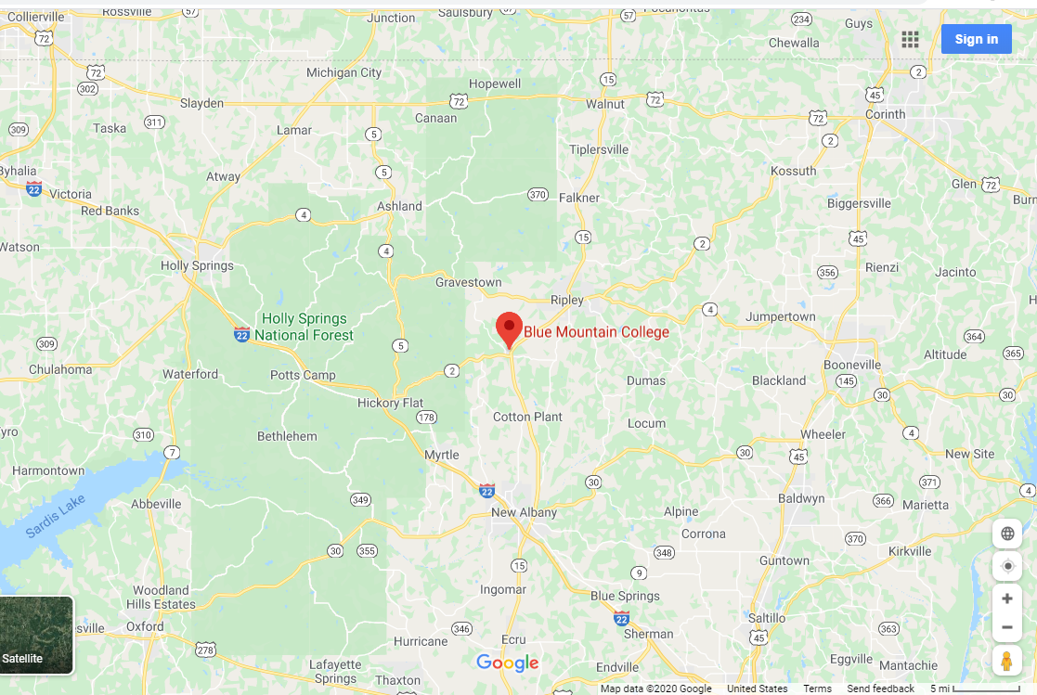

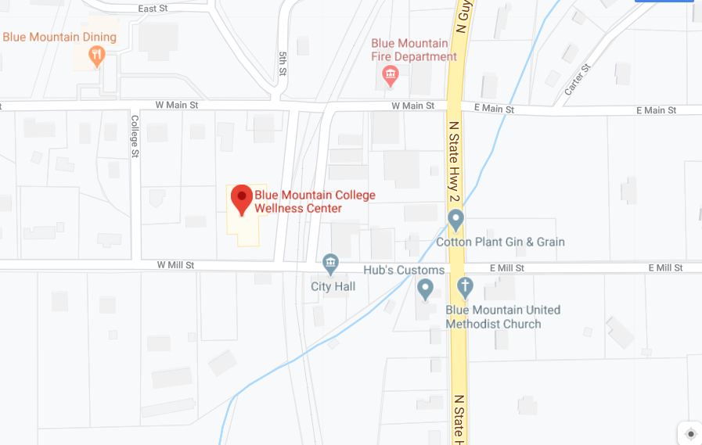
HWY 2 and HWY 15 re the same road
Parking is available in these locations
The Wellness Center and Coward Martin Classroom Building are in the same structure. The Entrance to the Coward Martin building is here.

