Funding and Flexibility for At-Risk Students:
A 2017 Legislative Priority
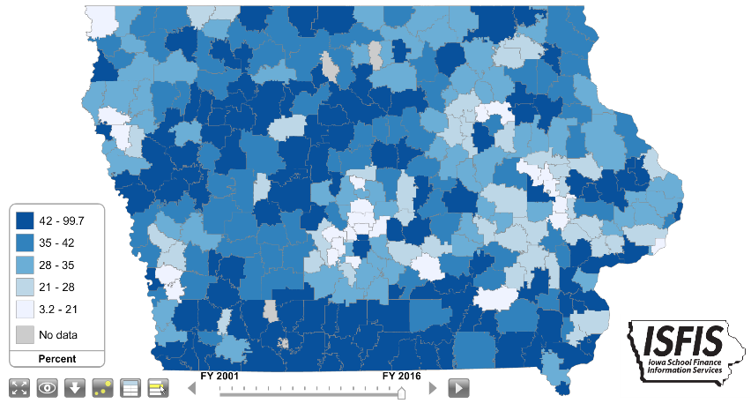
Background: Iowa has traditionally been a homogenous state with relatively low rates of poverty compared to the rest of the nation. As such, Iowa’s funding formula had little recognition of low income as a driver of at-risk student funding or programing. In 2001, about 28% of students were eligible for Free and Reduced Lunch, with the lowest district percentage of eligibility at 4.2%. Dropout Prevention funding is based on total enrollment count, not the percentage of students at-risk. DoP funding is limited to 2.5% of the total regular program district cost or up to 5% of regular program district cost based on historical practice.
Current Reality:
- In FY 2016, 41.8% of students enrolled were eligible for Free and Reduced Price Lunch. (Iowa DE web site, 2015-16 Iowa Public School K-12 Students Eligible for Free and Reduced-price Lunch B by District)
- Poverty is no longer concentrated in Iowa’s urban centers but found throughout the state. Of the 63 school districts in FY 2015 with more than half of their students eligible for Free and Reduced price lunch, 49 are rural school districts. In Iowa’s smallest enrollment category, districts below 300 enrolled, there were 47.2% eligible (Iowa Condition of Education Report, Jan. 2016)
- Iowa’s funding for at-risk students and dropout prevention resources, combined with targeted grant funds for high-needs schools, translates into a 9.8% additional funding commitment for these students.
- Other states invest resources in educating needy students. The national average investment is an additional 29% funding beyond the base for low-income students. (American Institute for Research, Study of a new Method of Funding for Public Schools in Nevada, Sept. 2012)
- Students from low income families are more likely to begin school behind their peers academically, exhibit nonproficient literacy skills, especially in early elementary grades, and to fall further behind over summer breaks, unless schools have the resources, staff and programs to meet their needs.
- Current requirements for dropout prevention and at-risk expenditures are still regulated by the state, not allowing school districts to truly engage in prevention for younger students at-risk of early and subsequent failure without significant state oversight.
- Quality teaching is critical for success of low-income students, yet teacher shortages and lack of funding for sparsity creates additional challenges for rural schools in hiring and supporting teachers.
RSAI calls on the Iowa Legislature to address the issue of Funding and Flexibility for At-risk Students: Resources for serving at-risk students should be based on need, such as the number/percentage of students eligible for Free and Reduced Price Lunch, rather than enrollment of the district. Districts should be given flexibility in determining the expenditure of at-risk resources to support students to graduate college/career ready for success.

