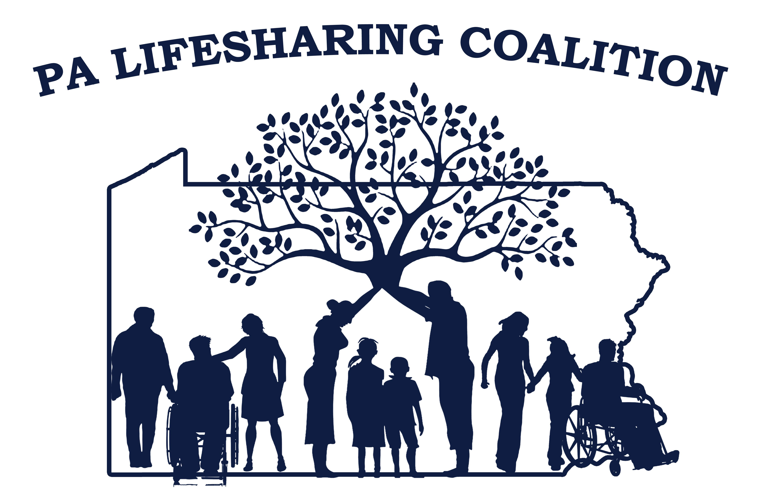
MINUTES Coalition Meeting – June 21, 2018
Mission: The Mission of the Pennsylvania Lifesharing Coalition is to promote, support and embrace the concept of Lifesharing and the
philosophy of self-determination and everyday lives.
Facilitator: Joe Agenda Builder: Alison Note taker: Carrie
Question or topic | Owner | Decision/ Information | Outcome | Come Prepared to | Allotted Time
Opening Round--Introductions | Joe |  | Introductions |  | 5 minutes
Update on Lifesharing Brochure |  | Update on Lifesharing Brochure- final stages of approval by Leadership Group.
Updates from RCPA and PAR | Carrie | PAR Conference- October 22, 23, Post Conference Day is October 24th. Conference will take place in Harrisburg  PAR Workgroup on Chapter 2380/2390 met 6/26/18. No change to 1 to 3 ratio in community. Kristen Ahren’s explained process for ODP to evaluate whether a provider agency meets 25% community service in July 2019.  EVV will not effect Lifesharing or group home programs. Will effect In-Home and Community Habilitation  House Bill 1641, codifying the Employment First Policy that the governor established by executive order in March 2016 to increase competitive employment opportunities for people with disabilities. |  |  | 5 minutes
Updates from ODP  HCBS Self Assessments  June Newsletter |  | ODP analyzing results- will be contacting any provider that did not submit the survey by the due date. ODP will extend the date to July 17th.  NEW Lifesharing sites opening – if not community living waiver you don’t need to do survey for this
Imagine Different Coalition |  | Large Discussion on how Lifesharing in PA can or should help the Imagine Different Coalition.  Agreement that All children should be in a home and family setting.  Lifesharing survey on Agency and children being survey will be sent out by the Lifesharing Leadership group. Please complete the survey and get it back. Review with regional groups that the survey will be released soon.
2018 Conference Committee Report | Sunday | Seven Springs Resort in Champion PA- October 15,16 . – Don’t forget the Bonfire on October 14th.  Kristen Mattei is the Key Note Speaker- promises to be a good conference.  Speaker requests are out now. Need a Panel of providers to present- prefer 10 years.  Caregiver Fatigue already approved, anything of interest would be entertained.  Imagine Coalition may present. HCQU family dynamics, autism presentation, therapy dog.  Ron Melusky will do a keynote on day #2.  Sponsorship at this time is up to: $11,900  Speaker gifts- create gift from consumer made products. If your agency is interested in how they can help, contact Sandy Zarko  Costs of the Conference will be similar to last year |  |  | 10 minutes
Conference Presentation—How to | Sarah | There is to be a presentation of the How to Start a Lifesharing Program during the Conference.  Leadership is looking for established agencies who may have knowledgeable Lifesharing staff persons to help present the “How to “. The Training is already developed from a previous year and just needs to be reviewed for any updates. Please contact Sarah Shaw email is: sshaw@skillsgroup.org Or any member of the Lifesharing Leadership group
2018 Path Areas of Focus | Birth Families in Lifesharing—  Service Definitions/RCG  Lifesharing Expansion | Report of Progress:  Pre-service Review – Final draft and will be released soon. Agency can add or take from the document. It is a best practice document for use with birth family prior to signing the contract.  Subworkgroup developed the document per the PATH. Emphasis is given to Incident Management items such as key to the house, removal during investigations.  Add as you wish to the document. Birth family training list for pre-service review. Discussion of listing them on the web page.  Discussion of a possible presentation at conference.  Service Definitions/RCG Workgroup- RCG Regulatory compliance guide being developed for ODP. Draft is completed with 14 items so far. Looking for more information that can help add to the initial draft- please send to Jen Tomaino at Jen.Tomaino@HRC.org.  Nothing from the service definitions as of yet.  Lifesharing Expansion – No report Available at the meeting
Rate Changes | Joe | 6 months in to new rates---how are agencies faring?  How are agencies doing this since January rate change.  Increase rate on SIS and Longevity. Unlicensed by Needs group 4 and with two people – rate is the same regardless of SIS level for unlicensed.  Input Agency #1 – increases as of July 1 based on needs group  Agency #2- not done it yet. Thinking of basing it on SIS-NG  Skills – gave out new stipend amounts  Agency #3- needs and longevity considered.  Agency #4- did increases on base level. May do a bonus’ at end of year.  Agency #5- increased July 1 across the board. SIS levels are not capturing the needs well. MH needs not captured.  Discussion of what happens if a person’s level goes down. Agencies not handled yet.  Agency #6- added to contract that first person rate will be reducted if they take a second person.  Community Living Waiver- AE Sue said the cap was lower than some waiver, how is it working? Can work but not a lot of experience. Counties are being told by ODP that they will move wavier slots to other counties as ODP sees the need. |  | Discuss what your agency is doing or planning to do | 10 minutes
Respite VS Sub CAre |  | Respite VS sub care- one agency said they are using both. It is very difficult to navigate.  Skills pays respite user or substitute care user directly.  Joe Karpinski- Addendum to contract is X number of days.  Agency – look for clearances, fire, ISP training, med training.  .  Some ag
Regional Reports | Joe  Regional Reps | Central – respite discussion, RCG,  July 18th Skills State College  SouthEast- Cheryl Nichols sent out flyer for family fun day at Mermaid Lake July 13th. Next meeting- July 10th  NE-July 11 Wilksbarough@ Step by step  Western- July 19 at Emlenton Truck Stop 10am to 2pm |  | Share information from last regional meeting
Recent licensing experiences | Joe | Not much news in this area |  |  | 10 minutes
2018 Dates—Coalition Dates | Joe | August 16, 2018—Camp Hill  October 15-16, 2018--Conference  December 6, 2018—Camp Hill | Hill |  | 5 minutes

- Next Coalition meeting will be August 16, 2018 at 10 am (Giant--Camp Hill).
Facilitator | Western Region
Agenda Builder | Western
Note Taker | SouthEast

