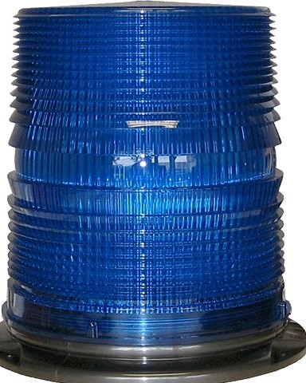
Cromwell Days
Fall Fest
Honors First Responders
Blue Light- First Responder Parade
September 23rd, 2023
7:15pm: Parade Line-Up Begins
@ Cromwell Park
Parade Starts at 8:00 PM

Contact Abby Cox at
sfdpio@gmail.com
for more information

Please let us know by September 20th if you can join us in the parade.

