The Lily Pad of NC
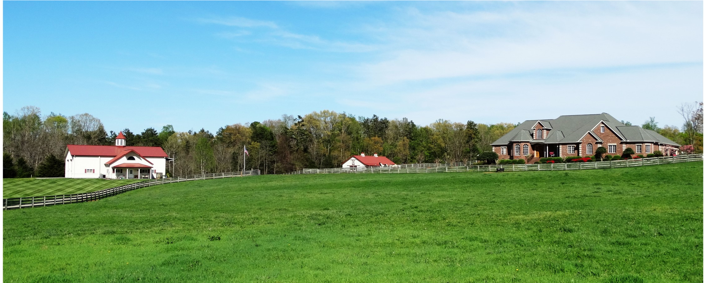
A Timeless Estate with Endless Amenities
The Lily Pad is a one of a kind destination located in scenic Whitsett, NC. We are conveniently located just 2 miles from the I-40/I-85 corridor, providing a short drive to Winston- Salem Greensboro, and the Raleigh-Durham area. Perched in the middle of an elegant farm, Lily Pad offers many packages for your own custom wedding. The days before your wedding are an important time as you prepare to become husband and wife. Allow us to help you spend this precious time with family and friends. The Lily Pad is an exclusive use, private estate with many amenities for up to 22 overnight guests. We work hard to ensure our grounds stay in pristine condition. Come and experience the graceful rolling hills of golden pastures full of magnificent horses. Indulge yourself in our luxurious estate with the perfect amount of rustic qualities and picturesque backdrops for your choice of outdoor ceremony locations. Uncooperative weather is no cause for worry. An alternative ceremony is planned for all outdoor events. Our fairytale-like facility is climate controlled and accommodates up to 175 guests. Come and experience the flexibility, included amenities, and impeccable service we offer.

The Lily Pad of NC
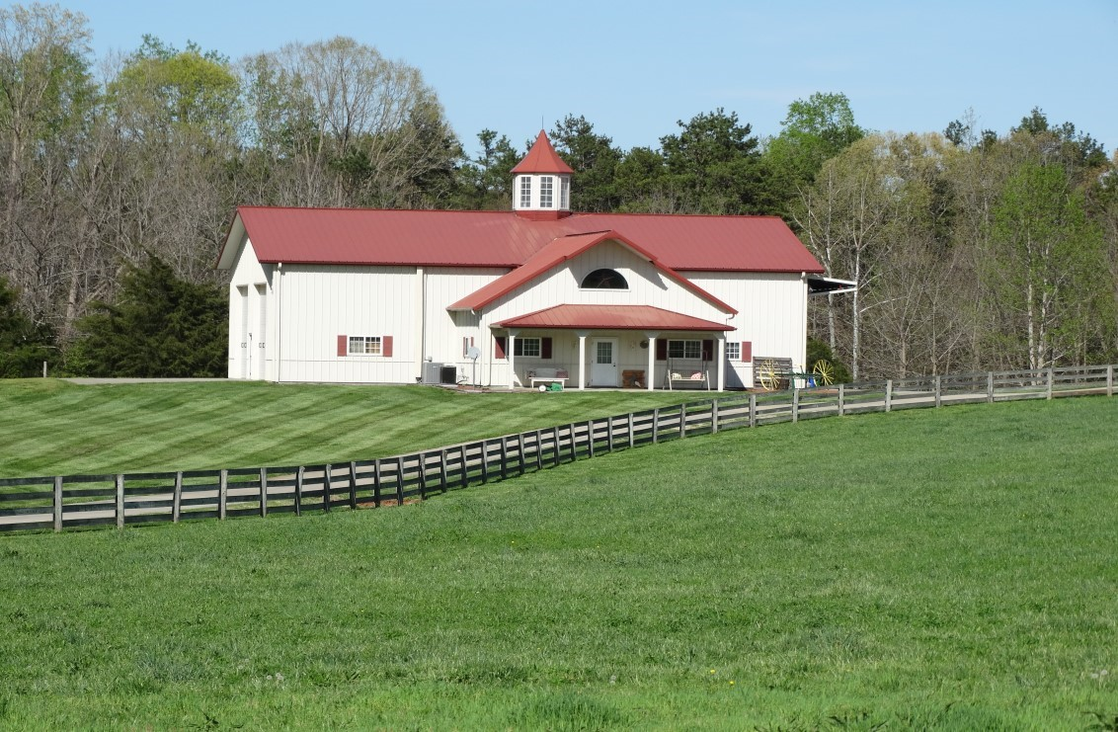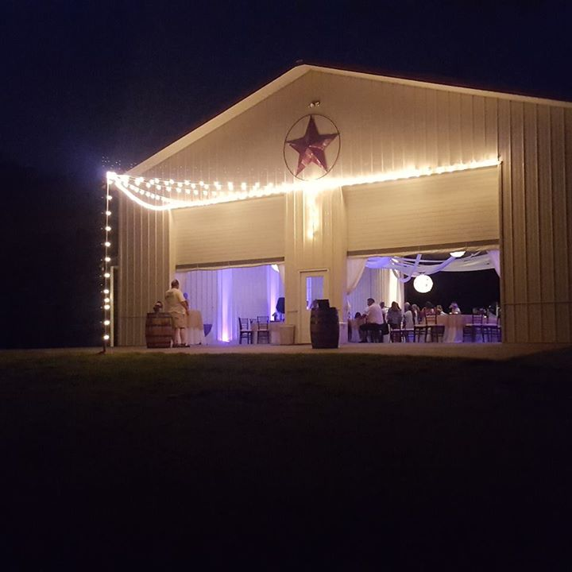

Event Center
The Event Center at Lily Pad was once an airplane hangar, but is now transformed into a fairytale style ballroom, complete with draping and lighting. The Hanger may be closed in and heated or cooled, open on one end, or completely open. Large concrete pads are at both ends inviting your guest outside to enjoy the beauty of the farm. There is a covered porch with seating for you to lounge, as well as a large covered area for seating or buffet. The expanded outside entertainment area includes well-manicured grass, a gazebo, and picturesque views at every turn. Also, located in the Hanger is a bridal changing room, separate groom changing room, a prep kitchen, 2 bathrooms, and a seating area for you and your guest. We can accommodate 10 overnight guest in the Hanger.
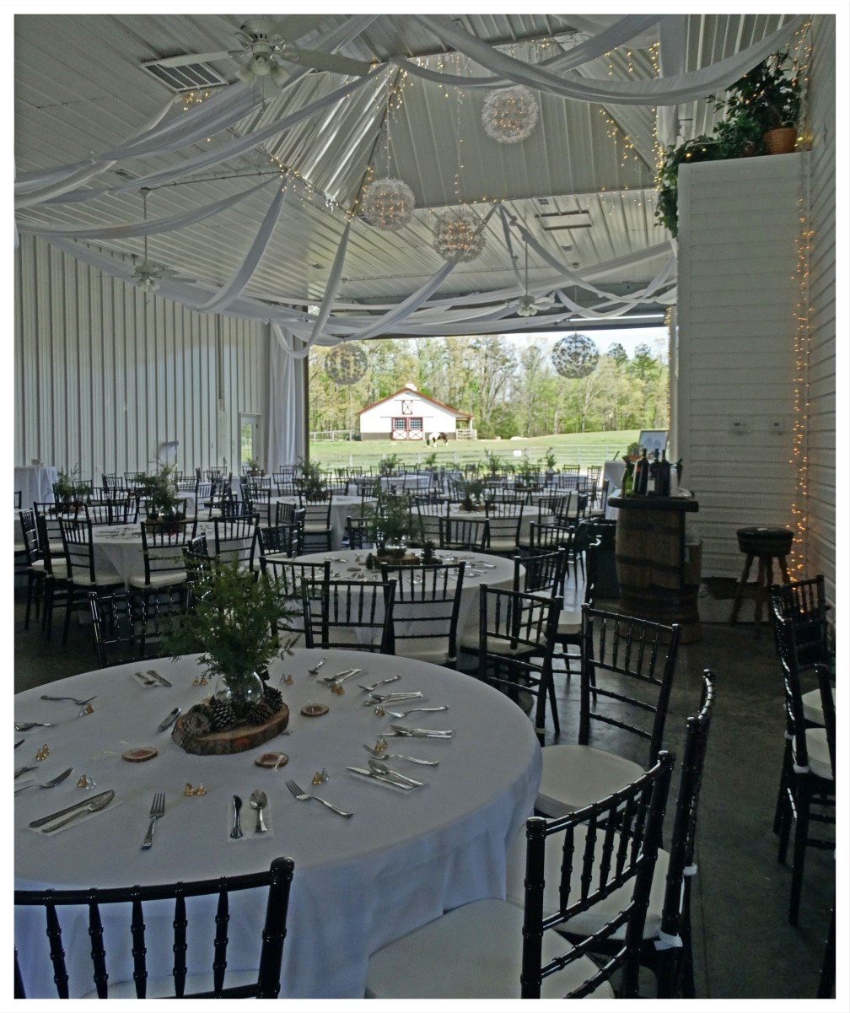
Included in all Packages: *Onsite staff for event *20 5Ft Round Tables *7 6ft Rectangle Tables *7 Cocktail Tables *200 Mahogany Chiavari *200 White Garden Chairs *See online catalog for inventory of tablescapes and decorative items *Setup/Breakdown of Outdoor Ceremony *Draping and Lighting in the Event Center *Several Possible Outdoor Ceremony Locations *Plan B Weather Plan * White Linens *Glassware for Candy Buffet Station *Onsite Parking * Limo Golf Cart * *Wooden Barrels and Whiskey Bar *Bridal Portrait Time *Basically, all you need is food, flowers & music!

The Lily Pad of NC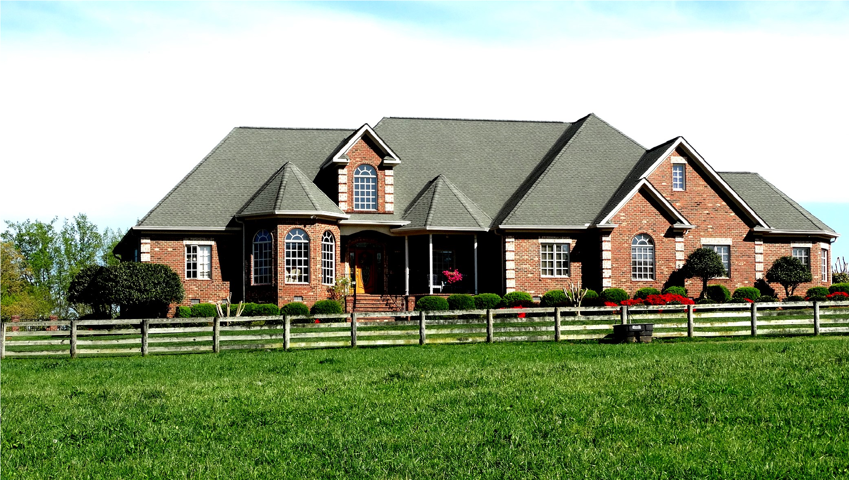
The Estate
The Estate has many amenities and possible uses for your wedding. You may host your rehearsal dinner, cocktail hour, or accommodate friends and family. The upstairs is a 2000 sq ft Grooms Lounge with a full kitchen, bath, large open living area with a flat screen tv, bar, and pool table. Downstairs is 7000 sq ft and includes a gourmet kitchen, stunning Bridal Suite, formal areas of the home, and 6 bedrooms. The back of the Estate opens into lush landscaping to our Pavilion, complete with twinkle lights. This can be used as ceremony site, rehearsal dinner, cocktail hour, plan B or C. A perfect place to entertain outdoors and enjoy time with your family and friends. Stunning backdrops and beautiful pastures surround you on this 26-acre, Timeless Estate where Farm meets Luxury! We invite you to explore your options with Lily Pad!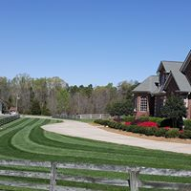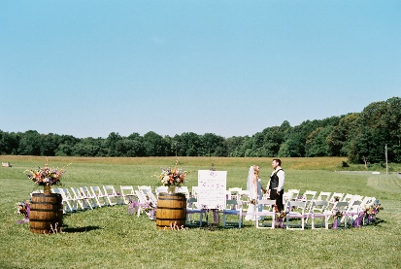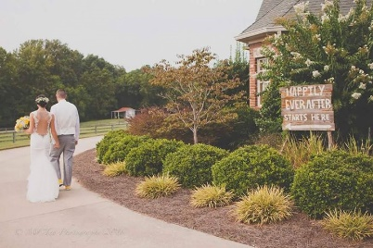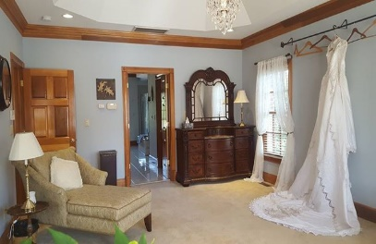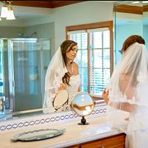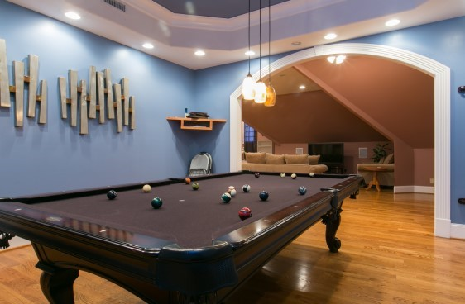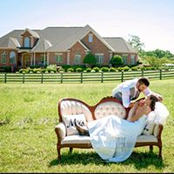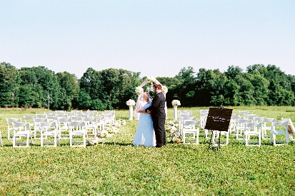

The Lily Pad of NC
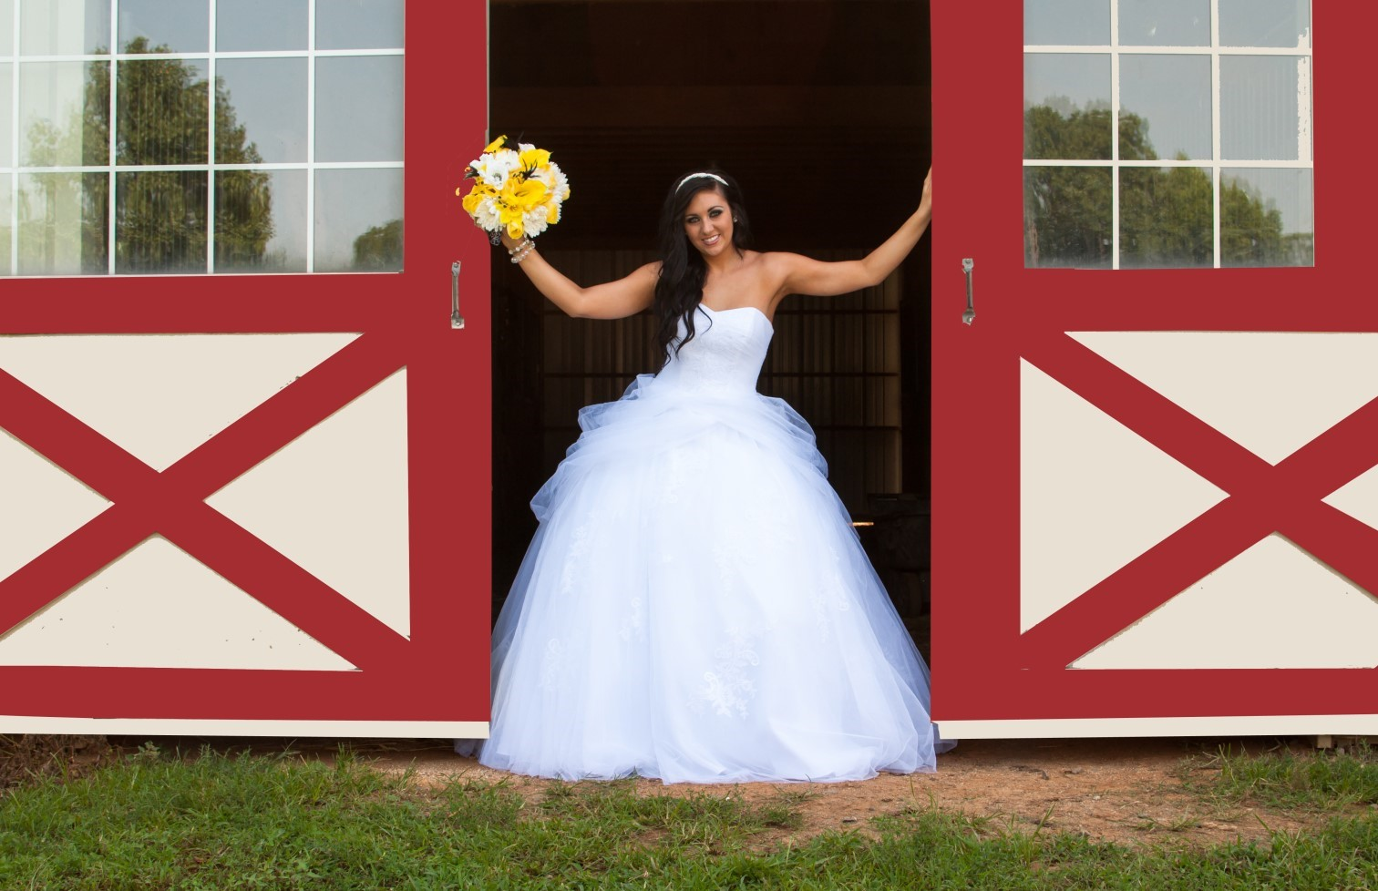

*Every Package has use of items in our online catalog @ www.thelilypadnc.com If tables, chairs, and linens had to be rented you would spend $2,500-$3,000. Not to mention all the available tablescapes and décor! All of these items are included in below packages. Basically, all you need is food, flowers, and music!

*Day Package: Access to Hanger/Event Center for 10 hours. 5 hours ceremony/reception
Friday or Sunday- $5,300
Saturday- $5,600
*Ultimate Day Package: Access to Formal Bridal Suite 3 hours, Access to Grooms Lounge 3 hours, 5 hours ceremony/reception 10 hours total
Friday or Sunday $5,600
Saturday $6,000

*Enchanted Weekend Packages:

Bronze $7,200
This package includes use of our Event Center, Estate, Pavilion, and grounds on Friday for 6 hours. This time is used for rehearsal and rehearsal dinner (50 guest). Use of the Event Center and grounds Saturday for 10 hours, Access to Formal Bridal Suite 4 hours, Access to Grooms Lounge 4 hours, ceremony/reception 5 hour maximum.

Silver $7,800
Bronze package Plus: accommodations for up to 10 overnight guest on Friday night in the Event Center
Gold $8,200
Bronze package Plus: accommodations for up to 12 overnight guest on Friday in the Estate with access to the Pavilion.

Platinum $9,000
Bronze package Plus: accommodations for 22 overnight guest (10 in the event center and 12 in the estate) with access to the Pavilion.
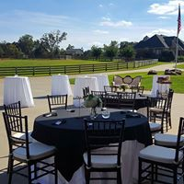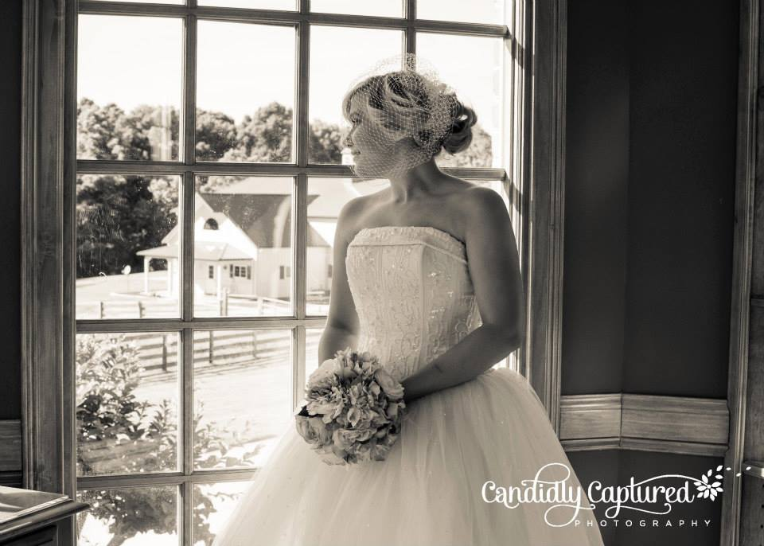
We host free tours of our farm by appointment Monday-Thursday at a time convenient for you. Feel free to call or text from 9am-9pm at 336-580-3387. Email: thelilypadnc@gmail.com Visit our website for additional information and pictures: www.thelilypadnc.com Note these are sample packages additional hours at the estate, entertainment suite, and overnight accommodations may be arranged in custom packages*Ability to use vendors of your choice with no added fees, recommendations available upon request*Additional hours for set-up of vendors, Bridal Suite, Grooms Lounge: may be purchased 45 days prior to event at $100.00 per hour *Cocktail hour in the Estate & Pavilion for two hours $500.00*Wedding Doors may be rented for $200.00. Set up included

