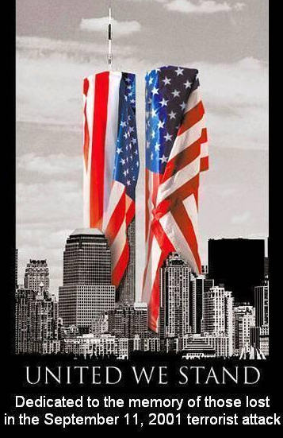
THIS IS A TRADITIONAL ASSIGNMENT.
PRINT AND COMPLETE IN INK.

Challenges of the 21st century,
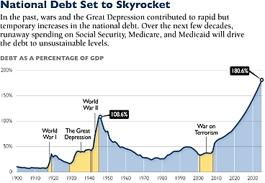
2000-Present

APUSH Review Guide for AMSCO chapter 31.
or other resources.
(images at right captured from pinterest.com and dailysignal.com)

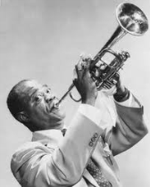
Directions Print document and take notes
in the spaces provided. Read through the guide
before you begin reading. This step will help you
focus on the most significant ideas and
information as you read.
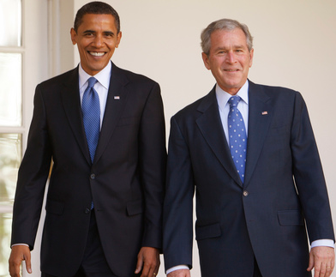

Learning Goals: .
Explain how the United States transitioned from fighting the Cold War to fighting
the War on Terrorism both domestically and internationally.
Explain the causes and effects of changing demographics within the United States from 1980-present day.
Evaluate the social, political, and economic impact of modern technologies and the changing, global marketplace on American identity.

MAIN IDEA:
As the United States transitioned to a new century filled with challenges and possibilities,
it experienced renewed ideological and cultural debates, sought to redefine its foreign policy, and adapted to economic globalization and revolutionary changes in science and technology.

From the 2015 Revised Period 9 Content Outline
Key Concept 9.1: A newly ascendant conservative movement achieved several political and policy goals during the 1980s and continued to strongly influence public discourse in the following decades.
Key Concept 9.2: Moving into the 21st century, the nation experienced significant technological, economic, and demographic changes.
Key Concept 9.3: The end of the Cold War and new challenges to U.S. leadership forced the nation to redefine its foreign policy and role in the world

Guided Reading, Challenges of the 21st century, 2000-Present, pp 679-693

- Political Polarization and the Presidency of George W. Bush, pp 654-656

Main Ideas | Definitions/Explanations/Notes | Analysis
Moving into the 21st century, the nation continued to experience challenges stemming from social, economic, and demographic changes.  The U.S. population continued to undergo significant demographic shifts that had profound cultural and political consequences. | Political Polarization…  Disputed Election of 2000… | List three causes of internal migration shifts in the United States during modern times.  a)  b)  c)
Political Polarization and the Presidency of George W. Bush continued…

Main Ideas | Definitions/Explanations/Notes | Analysis
Moving into the 21st century, the nation continued to experience challenges stemming from social, economic, and demographic changes.  The U.S. population continued to undergo significant demographic shifts that had profound cultural and political consequences.  The end of the Cold War and new challenges to U.S. leadership in the world forced the nation to redefine its foreign policy and global role.  Following the attacks of September 11, 2001, U.S. foreign policy and military involvement focused on a war on terrorism, which also generated debates about domestic security and civil rights.  In the wake of attacks on the World Trade Center and the Pentagon, U.S. decision-makers launched foreign policy and military efforts against terrorism and lengthy, controversial conflicts in Afghanistan and Iraq.  The war on terrorism sought to improve security within the United States but also raised questions about the protection of civil liberties and human rights. | Domestic Policies of the George W. Bush Administration…  Republican Tax Cuts…  Educational and Health Reform…  Economic Bubbles and Corruption…  The War on Terror…  Roots of Terrorism…  Early Terrorist Attacks…  September 11, 2001…  War in Afghanistan… | To what extent was President George W. Bush similar to President Ronald Reagan? Defend your answer with one specific piece of evidence.  To what extent was No Child Left Behind illustrative of conservatism? Explain your answer.  What was the main cause of the 2002 stock market crash?  How did the 9-11 attacks impact the stock market and economy? (ask your parents or Google)  What was the motivation for American involvement in the Middle East following World War II?  To what extent is religion the key factor in the War on Terror? Defend your answer with one specific piece of evidence.  What was the main goal in the invasion of Afghanistan?
Political Polarization and the Presidency of George W. Bush continued…

Main Ideas | Definitions/Explanations/Notes | Analysis
Following the attacks of September 11, 2001, U.S. foreign policy and military involvement focused on a war on terrorism, which also generated debates about domestic security and civil rights.  In the wake of attacks on the World Trade Center and the Pentagon, U.S. decision-makers launched foreign policy and military efforts against terrorism and lengthy, controversial conflicts in Afghanistan and Iraq.  The war on terrorism sought to improve security within the United States but also raised questions about the protection of civil liberties and human rights. | Homeland Security…  George W. Bush foreign policy…  Iraq War…  Operation Iraqi Freedom…  Elections of 2004 and a Bush Second Term…  Four More Years at War…  Washington Politics…  The Great Recession… | Compare and contrast Operation Iraqi Freedom and Persian Gulf War.  To what extent was the foreign policy of President George W. Bush an extension of Cold War ideology? Explain your answer… think about it carefully…  In what ways were the causes of the Great Recession similar to the causes of the Great Depression?  In what ways were the responses to recession by George W. Bush similar to the response to depression by Franklin D. Roosevelt?
- The Election of 2008 and the First Obama Administration, 2009-2013, pp 686-689

Main Ideas | Definitions/Explanations/Notes | Analysis
Moving into the 21st century, the nation continued to experience challenges stemming from social, economic, and demographic changes.  Following the attacks of September 11, 2001, U.S. foreign policy and military involvement focused on a war on terrorism, which also generated debates about domestic security and civil rights. | Election of 2008…  The First Obama Administration, 2009-2013  The Transition…  Presidential Initiatives…  Economic Stimulus…  Health Care…  Budget Deficits…  The Tea Party and 2010 Mid-Term Elections…  Congress in Gridlock…  Obama’s Foreign Policy…  Iraq…  Afghanistan and the death of Osama Bin Laden… | African Americans make up 12% of the United States population. What can you infer about American identity in the 21st century when you consider we elected our first African American president?  Compare and contrast Barack Obama and Hiram Revels.  What is the key difference between President Lyndon Johnson’s Medicare and Medicaid programs and President Barrack Obama’s Affordable Care Act?  Explain how and to what extent the conservative resurgence of the 1980s lives on in the Tea Party.

Obama continued… the Second Obama Administration, pp 690-691
Main Ideas | Definitions/Explanations/Notes
Moving into the 21st century, the nation continued to experience challenges stemming from social, economic, and demographic changes.  Following the attacks of September 11, 2001, U.S. foreign policy and military involvement focused on a war on terrorism, which also generated debates about domestic security and civil rights. | Arab Spring…  Asia and Europe…  Election of 2012…  Second Obama Administration…  Budget Brinkmanship…  Gun Violence…  Terrorism in Boston…  Foreign Policy…

- Rulings of the Roberts Court, pp 691-693
Main Ideas | Definitions/Explanations/Notes | Analysis
Moving into the 21st century, the nation continued to experience challenges stemming from social, economic, and demographic changes. | Rulings of the Roberts Court…  Affirmative Action and Voting Rights…  Elections and Money… | Explain how the Roberts Court differs from the Warren Court in regards to protecting the rights of African Americans.
Rulings of the Roberts Court continued…
Main Ideas | Definitions/Explanations/Notes | Analysis
Moving into the 21st century, the nation continued to experience challenges stemming from social, economic, and demographic changes.  Policy debates intensified over free trade agreements, the size and scope of the government social safety net, and calls to reform the U.S. financial system.  Conflict in the Middle East and concerns about climate change led to debates over U.S. dependence on fossil fuels and the impact of economic consumption on the environment.  The new migrants affected U.S. culture in many ways and supplied the economy with an important labor force, but they also became the focus of intense political, economic, and cultural debates.  Demographic changes intensified debates about gender roles, family structures, and racial and national identity. | Environment…  Gay Rights and Same-Sex Marriage…  Gun Rights…  Immigration…  Health Care… | Based on the Roberts Court decisions, what further chang do you expect the next few decades in the United States? For each of the topics below, describe a trend you predict about the future.  Racial discrimination…  Gender discrimination…  Gay rights…  Gun rights…  Racial and ethnic make-up of the population…

- Historical Perspectives: What Causes Booms and Busts? Page 693

Kevin Phillips’ View… | Conservative View on Markets… | Joseph Stiglitz’s View…

Based on your assessment of these viewpoints, do you predict more or less government regulation in the future?

Reading Guide written by Rebecca Richardson, Allen High School
Sources include: 2015 edition of AMSCO’s United States History Preparing for the Advanced Placement Examination and the 2012 and 2015 Revised College Board Advanced Placement United States History Framework.

