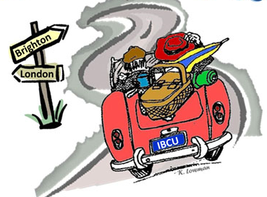
INDIANA BRITISH CAR UNION PRESENTS
2017 LONDON to BRIGHTON RUN
SATURDAY, JULY 15, 2017
On November 14, 1896, the first London to Brighton Run was held in England to celebrate raising the speed limit from 4 to 14 mph. IBCU celebrates the 121th anniversary of this event with its annual rally/tour across Indiana, for all British cars.
The Rally:
Participants will enjoy an approximate 110 mile drive along some interesting roads in central Indiana, answering challenging questions and taking photos along the way. Trophy plaques will be awarded to the top ten finishers.
Start:
The run will start at the Moral Township Community Center (next to the fire station), 8333 Frontage Road, Fairland, IN 46126 (Exit 103 off I-74 south of Indy). Breakfast (included in the registration!) will be served starting around 8am, with driver’s meeting at 9am and first car off at 9:30am.
End:
The run will end in French Lick, Indiana. Expect to arrive in French Lick around 2pm for early dinner/late lunch (not included in registration).
Cost:
Early Bird (received by June 17th) - $15 per car (lunch is on your own)
Regular (received after June 17th and day of run) - $25 per car (lunch is on your own)
To register for the event, complete the form below and send with registration fee (payable to IBCU) to:
Greg and Susan Albers
P.O. Box 466
Zionsville, IN 46077

Driver Name: ____________________Navigator Name:
Address: ________________________________________________________
City, State, Zip: ___________________________________________________
Phone: ________________________ Email: __________________________
Car Make and Model: ______________________________________________

For more information or questions, contact Mike Roe, (317) 270-3365, microtr6@gmail.com
DINNER & A MOVIE BEFORE THE 2017 LONDON to BRIGHTON RUN
As an added bonus this year, Hoosier MG’s is sponsoring a showing of the movie “Genevieve” at the Royal Theater in Danville Indiana.
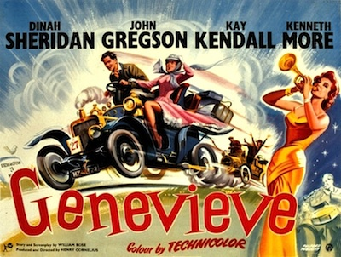
In this upbeat British comedy, two friends enter an antique car rally (The London to Brighton Run). Alan McKim (John Gregson) drives his beloved 1904 automobile, named Genevieve, while Ambrose Cleverhouse (Kenneth More) takes his vintage Spyker car. Alan and Ambrose bring their wives along for the wild ride from London to Brighton, and the trek soon turns fiercely competitive, each driver devising clever ways to sabotage the other in the hopes of winning the race

This showing is FREE to all British car owners, regardless of whether you plan on running in the rally or not. Just show proof of British car ownership (running or not) at the door. As an added bonus, each attendee will get a free Jr. Combo (Popcorn, Drink, Candy) courtesy of IBCU, including one free refill on drink and popcorn! The movie runs 86 minutes and will start promptly at 8pm on Thursday, July 13. The Royal Theater is located a short drive west of Indy just off SR36 in Danville, IN (59 S. Washington St, 46122).
Interested in dinner before the movie? Three local restaurants in Danville (Diesels, Frank’s Place, Mayberry Café) have a special offer of a free (non-alcoholic) drink with the purchase of a dinner entrée at their establishment. Thanks to Tim Macsay and Hoosier MG’sfor a great bonus addition to this annual rally.

