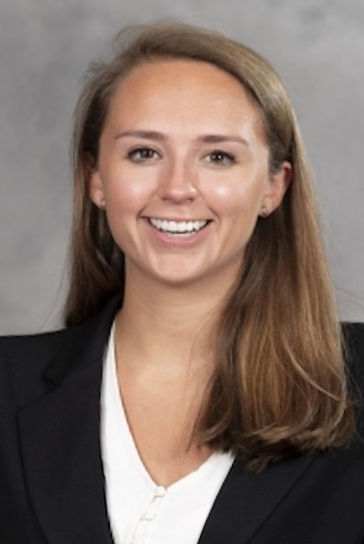
Caroline Austin
Caroline Austin, J.D. Candidate at Campbell Law School (c/o 2022) and graduate of the University of Alabama, joins the Board with a passion for early childhood prevention programming and child advocacy organizations. After seven summers working with children through the YMCA of the Triangle, Caroline took her talents to a children’s non-profit organization in Southeast Washington, D.C., where she served as a case manager to at-risk youth. In this role, she practiced a holistic approach to trauma-informed care and worked closely with schools to develop early literacy intervention plans unique to each child. In addition to holding a Youth Mental Health First Aid Certification issued by the National Council for Behavioral Health, Caroline received extensive training in working with children who have experienced developmental trauma at the nationally-renowned Wendt Center for Loss and Healing Training Institute. Caroline has plans to work in family law upon being admitted to the North Carolina State Bar.
Caroline joined the Foundation Board on 7-1-22.

