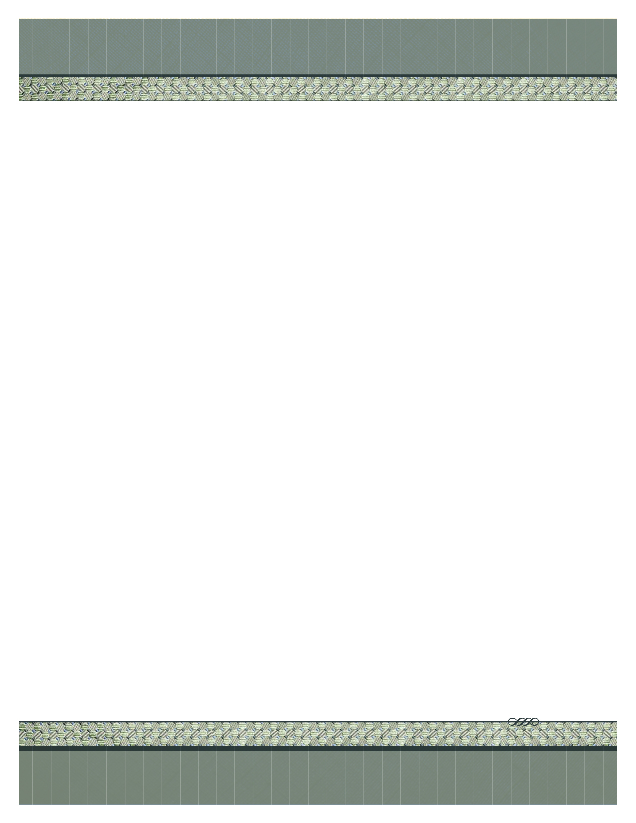

**FROM:**

NAME

ADDRESS

ADDRESS

|  |  |  |  |
| --- | --- | --- | --- |
| **Quantity** | **Description** | **Unit Price** | **Total** |
| SEASON or  DATE | Drumline Instruction or  MM/DD 7:00-12:00, 5 hours | $300 or  Hourly Rate | $300 |
|  | | | TOTAL |

DATE

INVOICE

Make all checks payable to **NAME NAME**

**THANK YOU FOR YOUR BUSINESS!**

TO:

Liberty High School

3700 Liberty Heights Ave

Phone: 702.799.2270 | Fax: 702.799.6858