Bisterne Scarecrow Results 2018

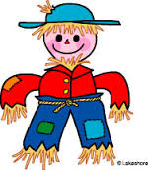

Class One - Single Scarecrow

1st – 2050 AD
2nd – Unicorn Maneia
3rd – The Bells

Class Two – Pair of Scarecrows

1st – Peter Rabbit
2nd – Worzel is in trouble with Aunt Sally
3rd – Head over Heels about Scarecrows

Class Three - Group of Scarecrows

1st – Rusty Diesel Engine
2nd – History of Scarecrows
3rd – The Bisterne Royals

Champion Scarecrow

Oh Look, There’s a Dragon

Public’s Favourite Scarecrow

Oh Look, There’s a Dragon

