SPECIAL MEETING
OCTOBER 13, 2022

A Special Meeting of the Town Board of the Town of Hampton, County of Washington and the State of New York was held at the Town Hall, 2629 State Route 22A, Hampton, New York on the 13th day of October, 2022.

PRESENT: David K. O’Brien-----------Supervisor
Donald Sady-----------------Councilman
Tamme Taran----------------Councilwoman
Andrea Sweeney------------ Councilwoman - absent
Michael Pietryka------------Councilman
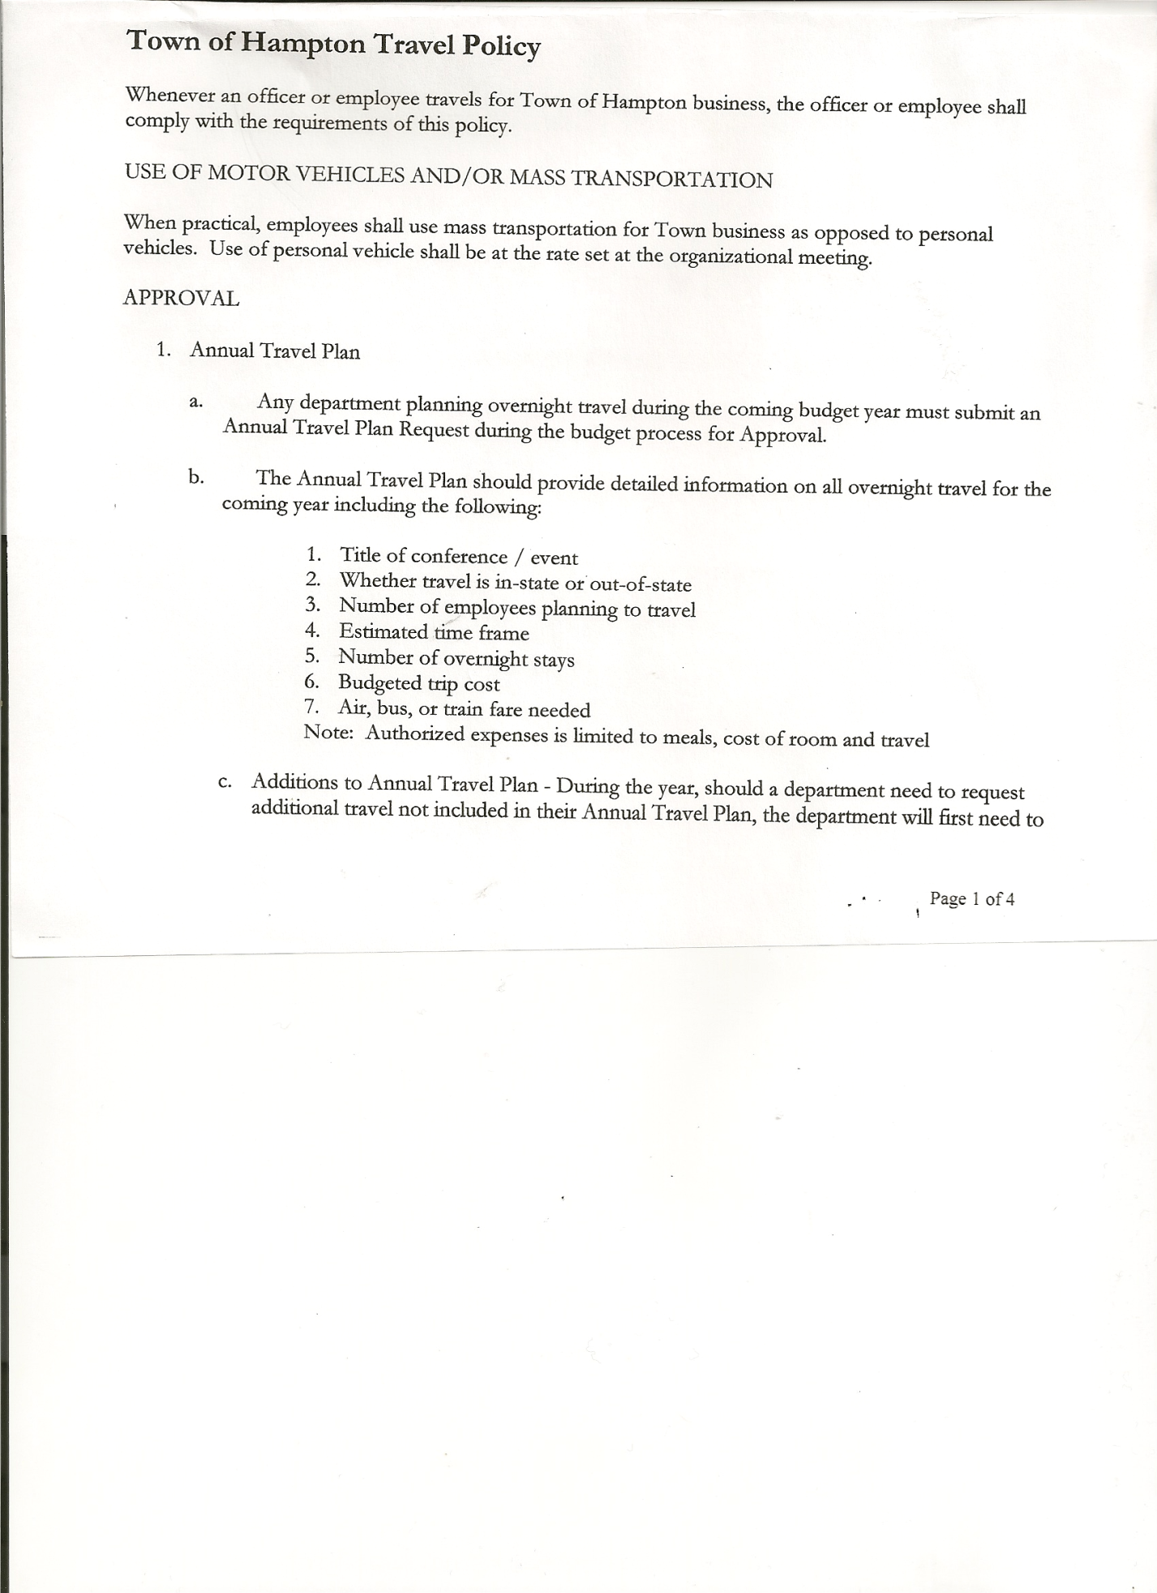
Rebecca Jones---------------Town Clerk
Camilla Shaw----------------Tax Collector/Deputy Town Clerk
Tyler McClure---------------Highway Superintendent
Kim Perry--------------------Bookkeeper/Budget Officer

Planning Board Member(s):….Bonnie Hawley, Chair, Richard Cole, Ginny Kinsey and Matthew Pratt
Also present: Artie Pratt

The Special Meeting was called to order by Supervisor O’Brien at 7:08pm, followed by the Pledge of Allegiance. Location of Fire Exits were given. Quorum of board members present.

Town Clerk Jones read the Legal Notice of the Special Meeting (copy attached), which was published in The Post-Star on 10/7/2022.

Supervisor O’Brien started the meeting by informing the Board that our current bookkeeper, Kim Perry is resigning her position, and that her position is considered a Civil Service Position. He has spoken to several individuals in town about the position. None have shown any interest in going forward. After speaking with the Town Attorney, it was advised that the Town appoint a Supervisor’s Clerk, which is not a Civil Service Position rather than a Bookkeeper. The County Treasurer, Al Nolette recommended someone and Supervisor O’Brien had a conversation with him to see if he was at all interested. He has forwarded a letter of interest to the Town Board for their consideration. Following a lengthy discussion, the following resolution was introduced.
RESOLUTION NO. 85-2022
APPOINTMENT OF SUPERVISOR’S CLERK
On a motion of Councilwoman Taran, seconded by Councilman Pietryka, the following resolution was ADOPTED:
By Roll Call Vote: Supervisor O’Brien AYE
Councilman Sady AYE
Councilwoman Taran AYE
Councilman Pietryka AYE
Councilwoman Sweeney ABSENT
RESOLVED, to appoint Lester Losaw as Supervisor’s Clerk with a salary of $12,000.00, with no mileage expense.

Fire Department monies were then discussed and an amount was decided upon.

RESOLUTION NO. 86-2022
MEETING ADJOURNED
On a motion of Councilwoman Taran, seconded by Councilman Pietryka, the following resolution was ADOPTED: : AYES 5 O’Brien, Sady, Taran, Pietryka
NAYS 0
ABSENT 1 Sweeney
RESOLVED, that the meeting be adjourned at 7:31pm.
Respectfully submitted,

Rebecca S. Jones, RMC
Town Clerk

