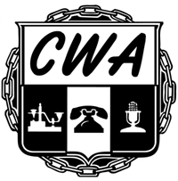
CWA, LOCAL 9588
190 WEST G STREET
COLTON, CA 92324

Dear CWA Local 9588:
I, do not wish my cased be pursued any further, and release the Communication Workers of America, Local 9588 of any and all responsibility of consequences that might occur regarding this case.

Grievance subject matter:
Employee signature: Date:
Received by: Date:

