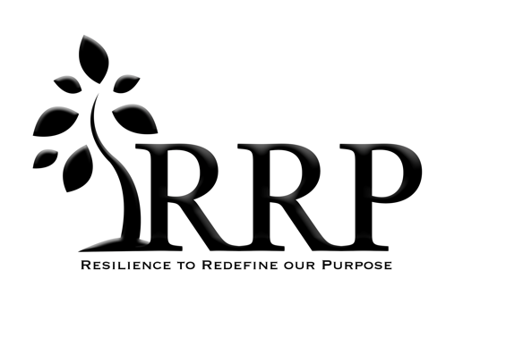
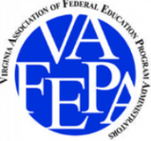
VAFEPA Annual Conference September 26 - 27, 2023
Resilience to Redefine our Purpose
Proposal Request for Break-Out Session
Deadline for Request for Proposal is April 3, 2023

Click here for application to submit a proposal for Break-out Sessions

Break-out Session Proposal
Break-out sessions are an important part of the VAFEPA annual conference. The goal of break-outs are for participants to learn important Federal Program information or any learning to help support Federal Program Coordinators and other important school personnel. Topics can include but are not limited to: Information around Title I Part A, Title II Part A, Title III Part A, and Title IV. Also, topics surrounding McKinney-Vento, Foster Care, and Needs Assessment Best Practice, Coaching Instructional Practices, etc… We want our participants to learn from a wide variety of topics surrounding Federal Programs.

If you decide you would like to lead a break-out session at this year’s conference, please complete the application form and submit it by April 3, 2023.

Important Information
- Break-out sessions are 45 minutes
- Sessions should be information about Federal Programs and relevant to VAFEPA members
- Sessions should not promote specific products or services
- One presenter or Co-presenters is accepted
- All break-out session proposals will be reviewed by members of the VAFEPA board
- If your proposal is accepted, you will be required to register to attend the VAFEPA annual conference and pay the registration cost at the Early Bird rate
- Presenters are asked to make the presentation available to post on the VAFEPA website
- Presenters are asked to utilize their own laptop.

Important Dates
- April 3, 2023: Deadline for online submission of proposal
- April 28, 2023: Notification of invitation to present
- May 5, 2023: Acceptance of Invitation to present
- Conference Registration : Due upon acceptance of proposal

Information Required for Registration
Title of Presentation (5-10 words): Clearly reveals topic and captures attention.
Break-out Session Abstract (50-100 words): Description of the objective, content, focus and interactive techniques of the session. Provide specific indications of how participants will be able to use the information presented and possible activities they will participate in during the session. This description will appear in the conference program if accepted.
Target Audience: Federal Program Directors or Coordinators, Principals, Central Office Administrators, etc…
Biography of Each Presenter (50-100 words): Description of presenters qualifications to lead a session of this topic, including educational background, work history, leadership experiences, and previous presentations. This will appear in the conference program if accepted.
Contact Information for Each Presenter: Name, Job Title, Email Address, Phone Number, School Division or Organization
Reference Contact Information: Recommendation for the presenter.
Questions
If you have any questions, please contact the VAFEPA representative emilyaltizer@mcps.org or aboggs@wisek12.org.

