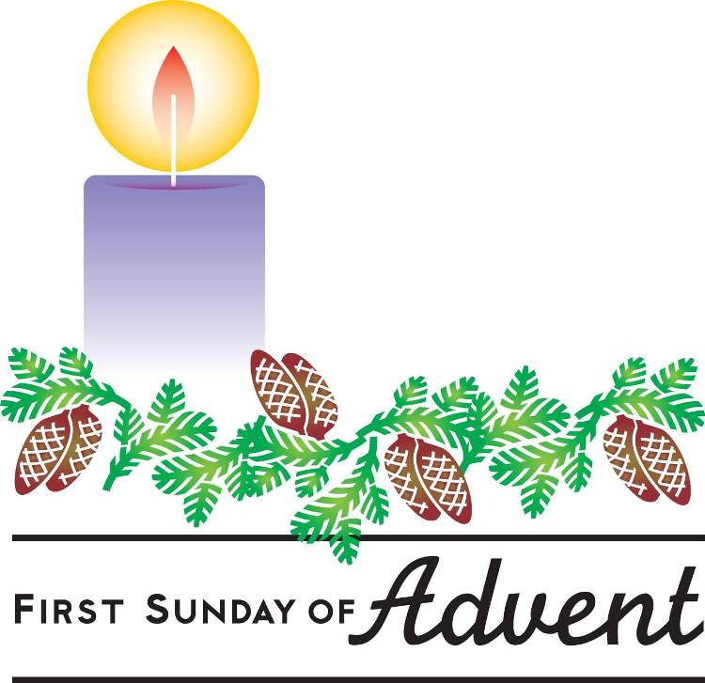

November 28, 2021
First Sunday in Advent

Carson City United Methodist Church

10:30 am
Prelude/Greeting
*Indicates stand as you are able

Call to Worship

L: A shoot will come up from the stump of Jesse, from his roots a Branch will bear fruit.

P: The days are coming,” declares the Lord, “when I will raise up for David a righteous Branch, a King who will reign wisely and do what is just and right in the land.

L: Why, should our soul’s, be downcast? Why so disturbed within us? Let us put our hope in God again, for we will yet praise him with all the company of heaven, our Savior, and our God.

P: For what you have done Lord, we will always praise you in the presence of your faithful people. And we will hope in your name, for you always fulfill your promises.

L: The day and the time have come, you have made a righteous Branch sprout from David’s line, Jesus our savior the shepherd of your flock.

P: You will keep our minds in perfect peace because our hope and trust in you.

*Hymn: People Look East UMH 206

Opening Prayer: (unison)
Heavenly Father, help us to love as Christ loved. Knowing our own weakness may we stand with all who stumble. Sharing in his suffering may we remember all who suffer. Rejoicing in his forgiveness, may we forgive all who sin against us. Oh God help us to as obedient to doing your will and following your ways, as Jesus was. We ask this in Jesus’s name who reigns in unity with you and the Holy Spirit, all glory and honor are yours eternal God now and forever. AMEN.

Contemporary Song: God with Us (Mercy Me)

Offering

Doxology UMH 95

Offertory Prayer

Gospel Reading: MATTHEW 12:13-21

Old Testament: JEREMIAH 23:5-6
Epistle Lesson: 1 PETER 3:15
Worship War Zone Song: Good God Almighty
(Crowder)

Children’s Church

THE MESSAGE

Contemporary Song: Somewhere in Your Silent Night (Castings Crowns)

Sharing of our Joys and Concerns

Call to Prayer: Thy Word is a Lamp UMH 601

Pastoral Prayer

*Hymn: I want to Walk as a Child of Light
UMH 202

Benediction

CCUMC – Announcements & Upcoming Events:
========================================

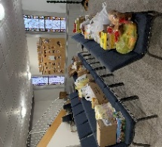
Thank you to all who donated the goodies for IM Kids 3rd Meal and everyone that assisted to end childhood hunger by helping our local communities!
========================================
COA Lunch: Returns on Tue & Thu beginning with Dec 7th.
========================================
Dorcas: Mon, Dec 6th @ 10am
========================================
Cub Scouts: Tue, Dec 7th @ 6pm
========================================
Join CCUMC at the following events on Dec 11th:

Holiday Craft/Vendor show 9 am – 2 pm in CCUMC Hall.

Snacks with Santa from 2:30 - 4:30 pm in CCUMC Hall
Come get some yummy snacks & meet & Greet Santa

M1CCU Holiday Parade - 5:00 pm Downtown Carson City
========================================
If you would like to purchase a poinsettia plant this Christmas Season in memory, or in honor of a loved one please fill out an order form, located on the Welcome Desk & by the table just before entering the Sanctuary. The poinsettias are $12.99 each. Please indicate how many plants you would like and what color. Put the amount due in the small envelopes & write poinsettia on it, and place both the sale sheet and envelope in the offering plate or turn order into the office. Orders will be placed Monday, December 10th. The plants will stay at the church until after the Christmas Eve service.

Serving and Supporting Sunday Worship Audio/Video: Pat Monroe
Children’s Ministry Audio/Video: Colin Fitzpatrick

Joys, Concerns & Prayer Request
For those battling cancers:
Beth Grienke, Jim Dunlap,
Carolyn Nykerk, Ray Seaman

For everyone who needs support,
guidance or has health concerns.

Monthly Giving
11/7 $4763.04 11/14 $1824.02 11/21 $1486.54

Nursery Schedule
11/28 Alex Krantz 12/5 Jenna Benjamin

Lighting of Candles
11/28 Collin Benjamin

Passing of Collections Plate

Children’s Church

Our Church in Ministry This Week

Sun 6:30-8 pm Women’s Group | Mon 6:30-8 pm  PT Class | Wed 6:30-8 pm  ARK

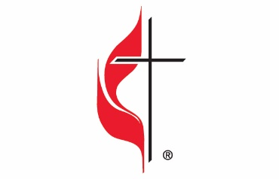

Carson City United Methodist Church
Location: 119 East Elm St., Carson City, MI
Mail: PO Box 298, Carson City, MI 48811
Phone: 989-584-3797 Email: carsoncityumc@gmail.com
Website: carsoncityumc.com
Office Hours: Monday-Thursday, 9:00 am-12:00 pm
After hours by appointment
Pastor: Ian McDonald 906-322-5318
Secretary: Bonnie Seaman 989-763-1674

Weekly Sunday Bulletin now available on our website
@ www.carsoncityumc.com

“Heavenly Father, help me to seek out and listen to wise counsel from the people You’ve put in my life”

