Crosspointe Cruisers Swim & Dive
(As of April 2018)

Parent Swim
Handbook

www.cpcruisers.com/

INTRODUCTION

Every swimmer's parents have experienced that first day of swim practice or that first swim meet where they wonder, “What's going on?... Where should I be?... What should I be doing?” The veteran families have all been there before and will be glad to demystify the world of Summer Swimming.

Although this handbook is explicitly written for use by parents of new Crosspointe swimmers, the fundamentals are true for any area swim team. It will provide some information that will help you understand what is happening while your child swims.

For more information about our team, go to our team website at www.cpcruisers.com/. Another great resource is the Northern Virginia Swimming League (NVSL) website at www.mynvsl.com. This website provides information on swim/dive meets, results, team standings, league leaders and records, as well as directions to other pools.

The people you'll run into the most in your swim team dealings are the Team Representatives (“Team Reps”) and the coaches. The Team Reps are volunteer parents who were new to swimming at one time, just like you are today. The Team Reps are responsible to the Crosspointe Board of Directors (they are volunteers, too!) for running every aspect of the swim team and are the representatives of the Cruisers team to other swim teams and the NVSL. It's a job that is impossible to do successfully without help from a great many parents.

As a reminder, a swim and dive team, particularly one as big as the Cruisers, is a very labor-intensive endeavor. All parents involved with the swim team are volunteers. Each swim and/or dive team family must volunteer to work at least twenty (20) hours during the summer to ensure the season runs smoothly (families whose eldest or only swimmer is age 6 or under -- 15 hours).

You will receive emails requests throughout the season regarding volunteer opportunities via the ACTIVE Network (same site you used for registration). Information about these volunteer positions can be found in Chapter 8 of this Parent Handbook – there is something for everyone! Training, if needed, is provided so please do not hesitate to volunteer for something new. The Cruisers’ success depends largely on parent involvement. Please become an active swim/dive team parent!

Volunteering is not all work and no fun. These meets are great social events for parents and kids alike, and we know you’ll enjoy them. You’ll have the satisfaction of knowing that you’re helping your children into a sport they can enjoy and keep fit with for their entire life. Don’t miss out!

Welcome to the Cruisers. We're glad to have you with us!

Crosspointe: Cruising Through the Summer!

Chapter 1: About the Swim Team

Our Philosophy
The philosophy of the Crosspointe swim team is that having fun and trying our best are the two most important things we can do. Most of the kids don't care if we're in a top division or a bottom division. We’d all like to be division champions, which usually means going undefeated, but only one team out of five or six can usually claim this honor. Personal development is what is most important, and for a swimmer that means improving times. We believe that by establishing a healthy environment, encouraging the kids to do their best, recognizing individual and team contributions, and offering a fun experience for the entire family, we will meet our goals.

We've all taken our kids to soccer or other sports and probably stood by as two or three parents ran the team. Swimming isn't like that. You can't run a swim program without parental help. In fact, it takes over 40 parents to time, officiate and score a typical swim meet, and that doesn’t include pool set up and tear down or running the snack bar or other non-swimming team activities.

Swimming is unique in that there's a place on the team for anyone between the ages of five (as of September 30) and eighteen who can swim across the pool without assistance. How many other sports have kids 5-18 years old and their parents on the same team participating in the same competition?

Expectations
Although swimming is considered an individual sport, our summer league is structured with an emphasis on the team. Any team is only as good as the people on it. In keeping with our philosophy articulated above, our expectations are simple:

For Parents
- Most of the adults you will deal with during the season are volunteers - parents, friends, and fellow Crosspointe neighbors. They are donating their time to offer opportunities to our children that otherwise would not be available. It is your responsibility to help them be successful in leading our team. Be positive, encourage them, and volunteer-volunteer-volunteer!

- The Cruisers Swim Team is not a swim lesson program. A swimmer must be able to reasonably swim a length of the pool to join the team. We'll help your swimmer become a better swimmer, but in fairness to the other 180+ swimmers on the team, we must insist that all swimmers be able to swim. Your child will feel better about his/her being on the team if he/she is competitive with most of the other kids of the same age.

- Honor your commitments. If you have volunteered in any capacity, we're planning on your being available unless you tell us you won’t be, preferably at least three days in advance. Please use the Volunteer Marketplace to help find a replacement. Thank you for your help in finding a substitute volunteer.

- Read and follow the NVSL sportsmanship guidelines provided during registration. Cheering for the team from the stands is encouraged, but negative or unsportsmanlike behavior must be scrupulously avoided. If your child is ever subject to inappropriate conduct or you witness any questionable incident, please report this immediately to the Team Sportsmanship, Spirit and Social Coordinator. If the Coordinator cannot be located, contact the Team Reps.

- If you, as a parent, have ANY issue to discuss with any of the coaches, ask to speak with him or her privately, before or after practices. Do not interrupt scheduled practices. If you have a concern or complaint involving a coach, please first address this to one of the Team Reps. Public critiques of coaches are unacceptable.

For Swimmers
- Honor your commitments. We are planning on your being available for all swim meets.
If you cannot attend a meet, let us know as soon as possible. We are also planning on your attending all practices.

- Pay attention to the coaches -- with over 180 swimmers, disruptions aren't fair to the other swimmers.

- Do your best -- it's a lot more important than being the fastest swimmer.

What's Mandatory?

What is mandatory is that you honor your commitments and have fun!

Chapter 2: Important Basic Stuff

Eligibility
Children of Crosspointe members under the age of 19 years old are eligible to participate if able to swim one length of the pool (25 meters) and handle a practice session. Generally, younger swimmers can qualify around the age of six or seven years old by meeting these requirements to join the team. The Head Coach and the Swim Team Rep may, however, evaluate swimmers under the age of six years old to determine if they are ready to participate as a team member. This is only to determine the appropriate placement for swimmers under the age of six years old, that is, swim team versus swim lessons. It does neither the young swimmer nor the team any good if the child is not yet ready for the swim team and is improperly placed on the team before he or she is ready.

Practices
Practice times are normally finalized in early May and are posted on our team website at www.cpcruisers.com/. Swimmers should come to practice regularly, be on time and be prepared to do their best. If you expect your child to be absent for an extended period of time, please notify their coaches AND the Team Reps.

Swimmer Apparel
Swimmers should wear a swimsuit that will be comfortable for racing. The Cruisers have a team suit, but there is no requirement to purchase or wear the suit. This, however, is not the same regarding swim caps. According to NVSL and team rules, if a swim cap is worn during a meet, it cannot be a cap that represents another team. The swim cap should either be a Crosspointe Cruiser cap, or a generic preferably solid colored swim cap. Silicone caps (that usually last longer and are preferred by most girls with long hair) are also available for purchase from the Spirit Wear Coordinator.

Goggles are used by most swimmers. “Suit Up” at the University Mall in Fairfax (www.SuitUpWaterSports.com 703-278-8202) and other local swim retailers will help your swimmer try on goggles to find a good fit if they do not already have a pair that works well for them. Once your child finds a pair that they like, you may want to buy a few extras. Goggles frequently break or suddenly start to leak and are easy to lose, especially for the younger swimmers.

You should also consider buying at least one practice suit for your swimmer. “Suit Up” supplies the team suit and spirit wear (sweats, shorts, backpacks, etc.). They and other area swimsuit retailers frequently sell suits discontinued by manufacturers at a reduced price for practice suits.

Remember to label everything! With over 180 swimmers on the team the lost and found is well stocked throughout the season with Cruiser belongings that are misplaced during practices and meets.

Swim Meets: What to Bring
Every swimmer needs at least one towel for swim meets, the bigger and thicker the better. An extra towel on which to sit is also useful. Please note that an extra towel for parents is handy, as often, the chairs are wet in the early mornings, and need to be wiped down. Folding chairs are not needed for swimmers at home meets, but may be needed at some away meets. Other accessories you should consider are sweats for cool mornings and to keep muscles warm in between swims, sun protection, and a bag to carry everything. Swimmers should also have water or sports drinks and a light snack for the meet such as fruit, granola bars or other healthy foods. Finally, and most importantly, a good attitude and team spirit is essential!

Chapter 3: Major Swim Activities

Dual Meets (“A Meets”)
The teams in each division swim the other teams, one at a time on five consecutive Saturdays, in a series of Dual Meets, so called because there are two teams competing. Based upon the results of these five meets, a division champion will be named.

Divisionals
On the sixth Saturday, each division holds a Division Individual Championship meet, commonly referred to as "Divisionals." Each team is allowed to enter two swimmers in each event and a swimmer can enter no more than two events. If a team does not have two swimmers for an event, the other teams can bid in other swimmers to fill the empty lanes.

All Stars
The sole criterion for selection to All-Stars is to have one of the eighteen fastest times swum that day in the 17 Divisional meets. If your swimmer is fast enough to be named an All Star, it is a thrill he/she will never forget. Please note that alternates are also chosen after the Division Individual Championship meet. Please pay close attention to the seeding of your child if you receive a notification that he/she has “made” All Stars. If your child is seeded higher than 18, he/she would be considered an alternate.

Relay Carnival
Another NVSL event is the Division Relay Carnival, which takes place on a Wednesday about three weeks into the season. All the teams in each division converge on one pool for an evening of relay races. Again, the Division Coordinators meet and the relay teams with the eighteen fastest times in all of the NVSL in each event then race at the All Star Relay Carnival the following Wednesday.

Developmental or Monday Night Meets (“B Meets”)
Monday night meets are considered developmental as they are not scored. They provide an opportunity for all swimmers to practice their skills. Swimmers are eligible for all events except for those in which they swam in the previous Saturday meet. Swimmers may enter up to two regularly scheduled events including the Individual Medley event.

Chapter 4: My Kid Says He's Supposed to Swim Like a Butterfly

If you're not a former swimmer, the strokes and their rules can be a cause of bewilderment. While the stroke rules are simple enough for a six year old to understand, most people do not have a copy of the US Swimming Rules, so we'll briefly describe the strokes below. The rules below are the US Swimming rules as modified for use in the NVSL. The rules are the same regardless of the age or skill level of the swimmer. Teams in other leagues may have slightly different rules.

Freestyle
The freestyle is defined as any means of swimming across the pool. Any stroke and kick are acceptable. There are, however, a few don'ts associated with this stroke, specifically: (1) you cannot walk on the bottom or pull yourself along using the lane lines, and (2) in a
50 meter race (two lengths) you must touch the wall at the 25-meter end before touching the wall at the 50-meter end. (This may seem obvious, but sometimes swimmers miss the wall at the turning end of the pool.)

Backstroke
Like the freestyle, almost anything goes on the backstroke as long as you stay on your back. As swimmers progress, they will learn to guide off the lane lines, use the overhead backstroke flags and the lane line markings to know where they're are in the pool, and count strokes from the flags to the wall.

Backstroke starts are different from all others because the swimmer is in the water, feet planted against the wall, and hanging on to either another swimmer's legs or the lip on the pool awaiting the starter's signal. "Legs" must be grabbed below the knee. Persons serving in an official capacity (such as timers or coaches) may not serve as “legs.”

If your swimmer is a backstroker, he or she will eventually learn the backstroke flip turn. This is the one exception to staying on your back and can be used only as part of a turn (not a finish) at the pool wall.

Breaststroke
The breaststroke has two components: the kick and the arm pull. The pull and its recovery must both be under the breast and cannot extend further back than the waist area. The kick is a "frog" kick and the toes must be pointed outward during the propulsive part of the kick. The arm pull and kick must be in an alternating sequence and the elbows must stay below the water except for tagging the wall at the finish. Breaststroke turns and finishes require a simultaneous two hand touch.

Butterfly
A properly executed butterfly (or “fly”) is the most beautiful exhibition of power and grace you'll ever see in a swimming pool. Quite frankly, the fly is the hardest stroke for most swimmers to perfect. There are two components of the fly; the arm pull and the kick. The arm pull must be an over the water recovery (elbows breaking the surface of the water) with the arms moving simultaneously. The kick is a dolphin style kick with legs and hips moving simultaneously. Unlike the breaststroke, there is no requirement to alternate the kick and pull. Turns and finishes require a simultaneous two-hand touch at the wall.

Individual Medley
The individual medley (or “IM”) is when an individual swims each of the four strokes in the following sequence: butterfly, backstroke, breaststroke, freestyle. We swim a 100 Meter IM, which means that 25 meters, or one pool length, of each stroke is swum. In a 100 Meter IM, every turn is a stroke change and stroke finish rules apply. This means that no backstroke flip turns are allowed.

Relays
There are two kinds of relays: freestyle and medley. Both involve a team of four swimmers, each swimming one quarter of the total distance. In the freestyle relay, each swimmer swims the freestyle. In the medley relay, the sequence is backstroke, breaststroke, butterfly and freestyle.

In all relays, each swimmer must wait until the previous swimmer touches the wall before the swimmer’s feet leave the wall. Running starts or pushes from teammates are not allowed.

Chapter 5: Swim Meets

There are two basic meets you will encounter as a parent: Saturday meets (A meets), which are scored dual meets and Monday meets (B meets), which are usually un-scored dual meets.

- Saturday Meets

Saturday meets consist of 38 individual events and 12 relays. The events swum for each stroke and age group are shown below. Remember, each pool length is 25 meters. Ribbons are awarded for 1^{s t}- 6th place.

Saturday Meet Events and Distances
Age group | Freestyle | Backstroke | Breaststroke | Butterfly | Freestyle Relay | Medley Relay
8 & Under Boys | 25 M | 25 M | 25 M | 25M | 100M
8 & Under Girls | 25 M | 25 M | 25 M | 25M | 100M
9-10 Boys | 50 M | 50 M | 50 M | 25 M |  | 100 M
9-10 Girls | 50 M | 50 M | 50 M | 25 M |  | 100 M
11-12 Boys | 50 M | 50 M | 50 M | 50 M |  | 100 M
11-12 Girls | 50 M | 50 M | 50 M | 50 M |  | 100 M
13-14 Boys | 50 M | 50 M | 50 M | 50 M |  | 100 M
13-14 Girls | 50 M | 50 M | 50 M | 50 M |  | 100 M
15-18 Boys | 50 M | 50 M | 50 M | 50 M |  | 200 M
15-18 Girls | 50 M | 50 M | 50 M | 50 M |  | 200 M
Mixed-Age Boys |  |  |  |  | 200 M
Mixed-Age Girls |  |  |  |  | 200 M

NOTES:
- To follow the order of events, go down each column starting on the left side except that the mixed-age relays are the last two events. To make it easier, reference the meet sheet that is sent to swim families’ email (A meets only).

- The mixed-age relays are swum by, in order, an 11-12 year old, a 9-10 year old, a
13-14 year old, and a 15-18 year old, usually the fastest in each age group.

Who Swims in Saturday Meets?
These meets are to see which team can score the most points, so the fastest swimmers get to swim. Three swimmers can be entered in each individual event, and no swimmer can swim more than two individual events. Since swimmers take vacations and go places such as scout camp, and a swimmer can swim in only two events (plus relays) in any meet, you don't have to be one of the three fastest swimmers to swim in a Saturday meet. Who swims an event may seem to be a mystery. However, after the first meet both teams know the other team’s swimmers times, and we try to position our swimmers to maximize our points and win. Letting the coaches and Team Reps know as far in advance as possible that a swimmer cannot attend a meet is essential to plan and seed the event.

Seeding
In Saturday meets, the home team has lanes 1, 3, and 5 while the visiting team has lanes 2, 4, and 6. The fastest swimmers swim in lanes 3 and 4, the next fastest in lanes 2 and 5, and the next fastest in lanes 1 and 6. Lane 1 is always on the right side as you stand facing the pool at the starting end.

Meet Sheets
While all NVSL meets have an announcer, the best way to follow the meet is with a meet sheet, which lists all the events, swimmers, and seed times. Meet sheets are emailed to swimmers’ families prior to each Saturday meet.

Scoring
In the individual events, a first place finish earns 5 points for the team, a second place 3 points and a third place finish 1 point. Relays are scored as 5 points for the winner and 0 points for the loser. There are 402 points up for grabs in a Saturday meet. Unless there is one or more places not awarded in an event due to DQs or lack of swimmers, a team needs 202 points to win.

In the event of a tie, the points for the places involved are equally split among the swimmers. For example, in a two-way tie for second place, each swimmer earns 2 points (3 points for second plus 1 point for third equals 4 points, half for each swimmer). No third place would be awarded because the next swimmer is fourth.

Disqualifications (DQs) and False Starts
A swimmer will be disqualified (or DQ’d) if he/she does not follow the rules of the stroke or false starts. DQs are covered in more detail in Chapter 6.

- Monday Meets

Monday meets are basically the same as Saturday meets except as follows:
There is a “6 and Under” competition in the freestyle and backstroke.
IM events are added for 10 & Unders, 11-12s, 13-14s and 15-18s.
There are usually multiple heats of each event.
Times determine the results; there is no scoring.
1st through 8th places are awarded.

- Relay Carnivals

In the Relay Carnivals, teams are not seeded. Each team’s lane assignment for the first event is based upon luck of the draw and the teams then rotate one lane to the left after each event. The meet sheet lists only the team swimming in each lane in each event.

Chapter 6: Do You Mean, My Kid DQ'd?

In swimming, the rules must be followed or a disqualification, or DQ, may result. This can be traumatic the first time a swimmer is DQ'd for just one mistake, but it isn't fair to other swimmers who swim the entire race per the rules, to do otherwise.

What is a DQ?
A DQ may result if any violation of the rules is observed by any appropriate official. Some of the more common reasons for DQing are as follows.

Freestyle: Failure to touch the wall at the turning end of the pool
Walking on the bottom
Pulling on the lane lines
Exiting the pool before swimming the specified distance

Backstroke: Rolling past vertical towards the breast at any time except during a flip turn
Leaving the wall after a turn past vertical towards the breast
Improper flip turn

Breaststroke: Incorrect kick, such as a Scissors kick or Flutter kick
Non-simultaneous two-handed touch or one-handed touch at turn or finish
Toes not pointed outward during the propulsive part of the kick
More than one stroke underwater with arms fully extended at start or turn
Head didn't break surface by conclusion of second arm pull underwater after a start or turn
Arm recovery past waist except on first stroke after start or turn

Butterfly: Non-simultaneous or one-handed touch at the turn or finish
Non-simultaneous leg movement during kicks
Arms don't break water surface during recovery (judged at the elbows)
Non-simultaneous arm movement during recovery

How Will I Know a DQ Occurred?
Unlike football, we don't blow a whistle and announce to the world that a rules violation occurred. When a Stroke and Turn Judge observes a violation, he raises his hand to signify that he has observed a violation, then writes it up on a DQ slip. The Stroke and Turn Judge then takes the slip to the referee, who verifies that a rule has been broken and who can question the stroke and turn judge to ensure that he/she was able to see the violation that was cited. The Referee then gives one copy of the DQ slip to the Team Rep and another copy to the Table Workers. Another clue that a DQ has occurred is a Stroke and Turn Judge writing and a longer than normal pause between events.

How Do I Know if My Kid DQ'd
Your kid will probably know before you do, since the Team Rep tells the coach, who tells the swimmer. You'll probably find out if you saw your swimmer finish with one of the top three times but isn't announced later in the top three places. Similarly, someone else DQ’d if your swimmer finished in 4th, 5th or 6th, yet is announced as one of the top three finishers.

Another way to find out is by reading the official Meet Results, which are posted at the pool by
4:00 p.m. the day of the meet.

A Word about Officials and DQs
Every official on the deck will always give the benefit of the doubt to the swimmer. Although the difference between legal-but-ugly versus illegal is sometimes close to call, any violation called by an official is an "I saw" not an "I think I saw".

Protesting Disqualifications
The Team Rep is the only person who can officially question a disqualification or any other call by an official. If something happens involving your swimmer which you do not think is right, talk to the coach or the Team Rep. The Team Rep will initiate action in accordance with NVSL rules if he/she considers it to be appropriate.

A Note to Parents on DQs
DQs are a part of the learning process. It is best that your child be disqualified for an error in their event than to continue to repeat the same behavior. Most swimmers learn quickly to “fix” the problem after they have been DQ’d. Instead of looking at this as a negative, use it to further encourage your swimmer.

Chapter 7: We Will Have Fun Whatever Our Division

At the pinnacle of NVSL are the six best teams and they all want to be #1. At Crosspointe, we like to win, but it isn't our reason for being. The following are some fun Cruiser activities!

Pep Rallies
A pep rally is held every Friday night at the pool with fun cheering, activities and themes. At pep rallies, the “Cruisers of the Week” for swim and for dive are announced. Check the Cruisers website (www.cpcruisers.com) for time and theme.

Lunch after the Saturday Meets
Following all away Saturday meets, the Cruisers and families have lunch at a restaurant on the way back to Crosspointe.

Team Pictures
We hire a professional photography company to take a team picture every year and we'd like your swimmer to be in it. You are not obligated to purchase a picture. Individual pictures are also available at the same time. Many of the swimmer families in the neighborhood have beautiful pictures displayed of their swimmers from their inaugural year through their senior season! Team pictures are the same time as Pancake Breakfast.

Pancake Breakfast
Cruisers enjoy pancakes, sausages and juice with their fellow swimmers and divers. Team and individual pictures are taken during the event.

Cruiser Days
Over the course of the season, Cruiser Days are fun times during which the kids can putt-putt, see a movie, hold a scavenger hunt, take a river tubing trip, ice skate, go bowling and participate in other events as outlined in the calendar on the website.

Progressive Dinner
For the Progressive Dinner, families of swimmers and divers open up their homes to the seniors who get to enjoy interacting with their peers outside of the pool for a night. There are five courses are hosted at different houses: mocktails, appetizers, salads, main course and dessert. Each course lasts no more than an hour. It's something that so many of our swimmers and divers look forward to and count down the years until they are old enough to attend themselves. The event is open to rising ninth graders through graduating seniors.

End of Season Party
The Cruisers cap off the season with an End of Season Party the evening of the day after Divisionals. We have food, a slide show, a DJ and awards. Every swimmer gets a medal or trophy.
Chapter 7: Volunteer Policy

Swim and Dive meets and events do not happen without volunteers. In recent years, the Crosspointe Cruisers have had significant challenges filling volunteer positions. After much consideration and deliberation, the Board unanimously passed the new volunteer policy as outlined below. We believe that it better supports families, athletes, and the team.

Volunteer Hours Requirements
The following are the updated volunteer hours requirements for the 2018 season:
Swim Families -- 20 volunteer hours
Dive Families -- 20 volunteer hours
Swim and Dive Families -- 20 hours*
Families whose eldest or only swimmer is age 6 or under -- 15 hours

*Note: For Swim and Dive families, fifteen (15) of the volunteer hours must be for swim events and five (5) volunteer hours must be for dive events.

Prior to an athlete’s first practice, the family must submit a $250 deposit check made out to the “Crosspointe Cruisers.” This check will be returned when the family earns 20 volunteer hours [exception: only 15 volunteer hours are required for families whose eldest or only swimmer is
age 6 and under].

The Volunteer Marketplace
Any family that cannot complete the required volunteer hours can pay to have other volunteers fulfill their requirement. The volunteer hours should be paid at a rate of no more than $15 per hour. These volunteer hour fees are in addition to the $250 check; all other requirements are in effect. Families volunteering to fulfill these hours may choose to list their name on the Volunteer Marketplace posted on the Cruiser website, to indicate that they are willing to perform volunteer hours on behalf of other families.

The family paying and receiving their hours on the family account is responsible for the following:
- Signing up for the role on the ActiveX site, using their own name for position registration;
- Advising the Volunteer Coordinator by email to ensure accurate tracking; and
- The family paying must ensure the volunteer role is filled.

The volunteer working on behalf of a family paying to have the volunteer hours worked must:
- Sign-in and sign-out for the shift;
- Work the entire shift; and
- Work directly with the paying family for any payment issues.

All coordination is incumbent upon the families entering the agreement. Crosspointe Cruisers leadership has no role or responsibility in coordinating the transaction. This alternative is intended to provide an option when circumstances prevent a family from fulfilling the requirement. It keeps the responsibility on the family to fulfill the volunteer requirement and allows team leadership to maintain focus on team, events and meet operations.

Please note that families who choose to fulfill other families’ volunteer hours through the Volunteer Marketplace are required to complete their own 20-hour requirement by the last swim/dive event of the season, and additional volunteer hours performed for fees/families do not count towards the 20-hour requirement. Furthermore, volunteer hours may not be transferred retroactively.

If you have any questions about the Volunteer Policy, the Volunteer Marketplace, volunteer positions or help with the ActiveX site, please contact the Volunteer Coordinator.
Chapter 8: Volunteer Positions

- At Meets: Who Are All These People Dressed in White?

Your first swim meet can be a bewildering experience, as you encounter a vast horde of adults dressed in white tops and blue shorts/skirts. US Swimming rules specify white as the color to be worn by all officials. This is also practical, as white is the best color to wear on a hot, humid summer morning. All volunteers on deck at a meet must wear a white shirt and navy blue shorts, skirt or skort.

Team Representative (“Team Rep”)
The NVSL Team Rep fulfills an important role as the main point of contact between our team and the NVSL. They attend preseason league seeding meetings, handle meet scheduling, hire coaches, serve on the meet seeding committee with the coaches, and represent the team in an official capacity at swim meets. The Team Rep is the designated recipient of all DQ slips for the team and is the only person with any official standing to challenge any decisions made by the referee. It sounds easy. But remember, most of the Team Rep's job is done before the meet starts.

B Meet Representative (“B Meet Rep”)
The B Meet Rep manages the Cruisers’ developmental meets (Monday B meets) and is responsible for making sure that the team follows Monday League Rules. The B Meet Rep prepares the necessary paperwork to support the Monday meets. S/he takes responsibility for coordinating with other B Meet reps of teams with which we compete as well as the main point of contact for setting up B meets.

Coaches
During the meet, the coaches’ primary responsibility is to encourage and praise the swimmers and to make sure that they get to the Clerk of the Course in time to swim.

Announcer
For home meets, he/she will announce swimmers prior to race and announces winners and events during the meet as well as make announcements to the meet attendees as requested by the Team Reps and coaches. The time commitment is the entire meet. If a volunteer is new to the position, attendance at one of the certification clinics would be required prior to serving in the position. Please see the “Officials” tab on the Cruisers website (www.cpcruisers.com/) for dates and time for clinics. Additional training is provided by shadowing an experienced announcer.

Referee
The Referee is the chief official for each swim meet. He/she is responsible for the conduct of the meets and is the final authority on the interpretation and enforcement of all swimming rules. Prior to the start of each race, the Referee ensures that all deck officials are ready and blows a whistle to signify that the starter can start the race. When the whistle is blown for an event, everyone in attendance must remain quiet so the swimmers can hear the starter. The time commitment is the entire meet. This position requires attendance at one of the certification clinics prior to serving in the position. Please see the “Officials” tab on the Cruisers website (www.cpcruisers.com/) for dates and time for clinics.
Marshal
The role of Marshal is important at meets. The Marshal is in charge of keeping walkways clear, as well as crowd and noise control. They exercise polite, but firm, control of the pool deck as well as ensuring no one enters the baby pool. Marshaling is generally straightforward work with a good view of the action. No experience is require! Marshals must be on duty starting when swimmers enter the pool for warm-ups until the last race is complete. These volunteers are responsible for ensuring that warm-ups are conducted safely and that the order is maintained during the swim meet (e.g., stop horse play, keep parents/kids from getting too close to the pool, etc.). They also get to wear a very fashionable orange or yellow vest as they conduct their duties. Split shifts are available for the meets. This position has one of the best meet viewing locations of the meet!

Clerk of the Course
The Clerk of the Course is the "gatekeeper" for all swimmers in our meets. The people who perform this function get the swimmers to the right lanes for the correct race. You can't run a race without swimmers, and the Clerk of the Course makes sure the right swimmer gets to the right place at the right time. The time commitment is the entire meet. This position requires attendance at one of the certification clinics prior to serving in the position. Please see the “Officials” tab on the Cruisers website (www.cpcruisers.com/) for dates and time for clinics.

Starter
The Starter is responsible for ensuring that all swimmers are given a fair and equitable start. The Starter will inform the swimmers of the stroke and distance to be swum and then instruct them to "Take your mark." After all swimmers are ready and still, the Starter will start the race, using a "Colorado System" (so called because it is built by Colorado Timing Systems). This system consists of a public address system, a horn, and a strobe light. The time commitment is the entire meet. This position requires attendance at one of the certification clinics prior to serving in the position. Please see the “Officials” tab on the Cruisers website (www.cpcruisers.com/) for dates and time for clinics.

Occasionally, a swimmer leaves the starting wall early. In past years, the Starter and Referee would make a special effort to stop the race and then re-start the swimmers. A new rule, based on the thinking that you shouldn’t penalize the swimmers who did not “false-start”, requires that the race proceed. The swimmer (or swimmers) who false-started will be disqualified after the race ends and after a consultation between the Starter and the Referee.

Stroke and Turn Judges
Once the race has started, the Stroke and Turn Judges are responsible for ensuring that all swimmers obey all the rules for the stroke that they are swimming. These people are always at the ends of the pool for starts and finishes and walk the sides of the pool as best they can within the physical constraints of the pool. If a Stroke and Turn Judge sees a violation of the rules, he/she raises his/her hand to signify that an infraction has occurred. A disqualification is recorded on a DQ slip, which the referee reviews and approves and forwards copies to the table workers and the Team Rep. The time commitment is the entire meet. This position requires attendance at one of the certification clinics prior to serving in the position. Please see the “Officials” tab on the Cruisers website (www.cpcruisers.com) for dates and time for clinics.

Relay Take-off Judges
During relays, you'll see Relay Take-off Judges at each end of the pool. Their job is to ensure that each swimmer touches the wall before the next swimmer in the relay leaves the deck. Two judges for each lane must agree that a swimmer has left too soon. Infractions are noted as described above for Stroke and Turn Judges.

Head Timer
The Head Timer (also referred to as “Chief Timer”) conducts a pre-meet briefing for all timers to review the rules and procedures for timers and hand out stopwatches. He/she makes lane assignments for timers (Lanes 1, 3, 5 = One home and two visiting team timers /
Lanes 2, 4, 6 = Two team timers and one visiting team Timer; pairs experienced and inexperienced timers; appoints Head Lane Timers), reviews how to determine official times; passes out supplies (stop watches, clipboards, cards, pencils), and demonstrates stop watch use. The Head Timer, the Starter and all the timers conduct a Time Check prior to the start of the meet. During the meet, the Head Timer uses two stop watches in the event of an issue with a timer/stop watch. After each heat, the Head Timer collects the time cards from the timers, reviews them for accuracy and completeness, and forwards them on to the runner/table workers. After the meet, the Head Timer will assist with collecting stop watches and supplies and place in storage. At away meets, the Assistant Chief Timer assists the Head/Chief Timer in these same functions.

The time commitment is the entire meet. This position requires attendance at one of the certification clinics prior to serving in the position. Please see the “Officials” tab on the Cruisers website (www.cpcruisers.com/) for dates and time for clinics

Timers
The timers are the most important people to every swimmer. They are the people who determine each swimmer's official time for each race. Being a timer is a good entry level position for new parents. Some parents have been timers for years and wouldn't want to see a swim meet from any other vantage point. If you can start and stop a stopwatch, you can be a timer. We'll even provide the stopwatch! Timers start their watches on the strobe light from the Colorado system and stop their watches when the swimmer touches the wall. For Saturday meets and Monday night meets, there are three timers per lane and all three times are recorded. The middle time is the official time. The Head Timer collects the time cards from the timers, reviews them for accuracy and completeness, and forwards them on to the table workers. For Time Trials, Saturday meets and the “Blue versus White B Meet,” the time commitment is the entire meet. For Monday Night B Meets, split shifts are available.

Seed the Meet
For the Monday night B Meets, the person(s) seeds swimmers according to their entry times. The volunteer(s) will mark events and heats on the time cards (home team swimmers in lanes 1, 3, 5, 7 and visitors in lanes 2, 4, 6, 8, trying to fill all lanes before adding an additional heat. Prior experience is required (though a new volunteer can work with an experienced volunteer to learn for the next meet).

Table Workers
The time cards from the timers and any DQ slips go to the table workers who determine the order of finish for each event, score the meet, and prepare ribbons for the participants. Several people from each team perform these functions to ensure that errors are caught before the results are announced. The time commitment for these positions is the entire meet.
Chief Table Worker (Table Administrator)
Chief Table Worker is the person who keeps the "flow" of the table going smoothly. S/he solves the problems as they arise and fills in when someone needs a short break. The Chief Table Worker overseas all the table workers. Together they receive time cards and note the order of finish for each event. They submit this information to the Data Coordinator and verify the score. The Chief table worker also ensures that all swimmers receive the appropriate ribbon. S/he is responsible for setting up the table area prior to the meet and take down after the meet. At away meets, s/he will serve as the Assistant Chief Table Worker.

This position requires attendance at one of the certification clinics prior to serving in the position. Please see the “Officials” tab on the Cruisers website (www.cpcruisers.com/) for dates and time for clinics.

Table Workers
Table Workers (2 per meet) receive a copy of the printed results after every one or two events and check that swimmers’ names, times [if not disqualified], places or disqualification status and teams are correct according to what is on the time cards and attached DQ slips. Also notes any new League and Team records on the printed Verification sheet for the Announcer’s use.

Data Entry
Data Entry volunteers (2 per meet) electronically records the appropriate information from the time cards and any attached disqualifications slips for each swimmer, enters scratches and substitutions when changes are received, generates award labels and produces the Official Results Report of the meet.

Awards
Awards volunteer (1 per meet) organizes the ribbons and attaches computer-generated labels.

Runners
Runners (2 per meet) receives the time cards from the Head Timer and delivers the time cards to the Table Workers. A Runner may also be assigned to deliver papers from the Referee to the Table Workers.

Meet Set-up
Volunteers for Meet Set-Up will assist with moving tables, setting up tents ad canopies, moving benches, placing lane markers, set up backstroke flags, ensure U.S. flag is in place, clear chaises from far end of pool, running extension cords, fasten skimmer blocks, assist Concessions with set-up, reserving parking for Team Reps and Coaches, and other tasks. For Saturday meets, the shift begins at 6:45 am; for Monday night meets, shift begins no later than 5:00 pm.

Meet Takedown
At the end of a meet, volunteers for Meet Takedown will assist with putting away tables, tents, canopies, benches, lane markers, etc. as well as ensuring trash is picked up from the deck, and the pool equipment and chaises are back in place.

Spirit Wear Sales
During the first week of practice and during certain home meets and pep rallies, Spirit Wear sales tables will be set up. Volunteers will help set up the table, sell Spirit Wear items, and assist with tracking sales, and return items to storage after the meet/event concludes. The Spirit Wear Coordinator will be on site to provide guidance and easy training. Split shifts will be available.

Concessions Volunteers
The Cruiser Café is the food and beverage concession stand set up in the baby pool area for home swim meets.
Concessions Lead
The Concessions Lead serves as the manager of the “Cruiser Café” for the duration of the meet. For Saturday meets, the shift begins at 6:45 a.m.; Monday night shift begins no later than 5:00 p.m. The Concessions Lead will participate in Concessions set-up, sales and clean-up and equipment/supplies stowage. All items necessary to run concessions (food and supplies) should be brought to the Concessions area. Items are either in the storage closet where the freezer is, or the storage shed in the back of the pool. The back shed storage may have drinks. The cheeses (cream cheese and sliced cheese) are stored there in the mini fridges in the back shed. At the end of the event, the Concessions Lead will also serve as the cross-check counter for the cash box pick-up to ensure that the totals match what the Cash Box Volunteer counted (cash box must be counted by two people). Note: the Cruiser Café may need to stay open longer if there are hungry swimmers. The Concessions Lead ensures that all food, beverages, supplies, tables, etc. are stowed before the end of their shift.

Concessions Griller
The Concessions Griller is the dedicated griller who will prepare the grill for cooking and finish with cleaning of the grill. Typically, the Concessions Griller will return later in the day or next day to clean the grill (as it has cooled off). Hot dogs, cheeseburgers and hamburgers are the grilled food the Cruisers Café sells.

Cash Box Delivery/Pick-Up
The Cash Box volunteer coordinates with the Cruisers Treasurer to pick up cash box before concessions starts and pick up at the end of concessions. There is a form to record the total money in the cash box at the start of sale and ending amounts. Two people (Cash Box Volunteer and Concessions Lead) need to confirm the totals for both start and end of concessions.

Cut Up/Package Fruit
Volunteers for this role will coordinate with the Concessions Coordinator to pick up fruit and supplies prior to the meets then cut up, package and deliver to the pool prior to the start of the meet. Packaging is provided; remaining packaging is to be returned to the Concessions Coordinator.

Chick-Fil-A Pick-Up/Delivery
The Chick-Fil-A volunteer will pick up sandwiches from Chick-Fil-A to arrive at the (Burke Center location) pool around 10:00 am for a Saturday meet and 6:15 pm for a Monday meet. The sandwiches need to be sold within 1 ½ hours per because of serving restrictions the Chick-fil-A franchise has placed. The Chick-Fil-a volunteer or the Concessions Lead should ask the Announcer to announce the arrival of the sandwiches for sale. The Chick-Fil-A carry bag needs to be returned to the restaurant after the swim meet. Coordinate with Concessions Coordinator the day before the meet.

Burritos/Donuts/Bagels Pick-Up/Delivery
Pick up will be from Anita’s Restaurant (burritos) and Shoppers Food (donuts and bagels) – both located in Burke at the Rolling Valley Plaza). The Burritos/Donuts/Bagels volunteer will at the pool arrive around 8:00 am for Saturday meets only. The burritos and bagels should be placed in a metal pan with aluminum to keep warm. Bagels can be pre-cut. The volunteer or the Concessions Lead should ask the Announcer to announce the arrival of the burritos for sale. Coordinate with Concessions Coordinator the day before the meet.

Pizza Pick-Up/Delivery
The Pizza volunteer will pick up pizzas to arrive at the pool around 6:00 pm for Monday night meets only. The carry-out bag(s) for the pizzas need to be returned to the restaurant the same evening. Coordinate with Concessions Coordinator the day before the meet.

Concessions Shifts 1 and 2
Concessions Shift 1 will assist with Cruiser Café set up and food/beverage sales. Concessions Shift 2 will assist with food/beverage sales and clean up.

NOTE: Concessions Cards (“Cruiser Cards”)
- Each season, the Cruisers sell $20.00 Cruiser Cards for families to spend at meets—cash and checks are accepted for purchasing cards. There is a black box that the cards are kept in to record money spent at the Cruisers Café. Simply draw a line through the dollars/cents spent for purchases per family—when used up, place the card in the cash box. For families wishing to purchase a card, locate a blank card in the cash box and write the family’s last name. File alphabetically in the black box.

- $5 Coupons: $5.00 coupons are given to our visiting Team Reps or NVSL Officials to use at Cruiser Café. Please store used cards in the cash box.

Utensils Washing
The Utensil Washing volunteer will nacho machine, snow cone machine, coffee machine, utensils. S/he will pick up and take home to wash grill utensils, nacho machine pump components, snow cone tools, syrup pumps, and any other miscellaneous utensils. If from a Saturday meet, items must be returned to the pool by Monday afternoon; if from a Monday night meet, the items must be returned no later than Thursday afternoon.

- Non-meet and Social Events and the Volunteer Positions

Pep Rallies

Pep Rally Coordinator
The Pep Rally Coordinator works with the coaches to plan the theme of each pep rally. S/he coordinates the supplies and materials required for each pep rally. The Coordinator will also help set up, run and clean up the pep rally.

Pep Rally Volunteer
The Pep Rally Volunteer will help set up, run and clean up the pep rally.

Cruiser Days Coordinator

Over the course of the season, Cruiser Days are fun times during which the kids can putt-putt, see a movie, hold a scavenger hunt, take a river tubing trip, ice skate, go bowling and participate in other events as outlined in the calendar on the website. The Cruiser Day Coordinator will plan each event, collect RSVPs, and serve on-site (or arrange for an adult designee).

Pancake Breakfast

Pancake Breakfast Coordinator
Purchases supplies/pancake mixes/syrup/sausages and dissemination to volunteers. Assists with set up of event and coordinates volunteers during the event. Participates in clean-up of event. Works with Treasurer regarding expenses/reimbursement.

Set Up for Pancake Breakfast
Assists with table/supplies/food/beverage set up prior to the event.

Cook Sausages
Day prior to the event, volunteers will pick up uncooked sausages from the Pancake Breakfast Coordinator. The day of the event, volunteers will make sausages and then deliver the pancakes before the start of the Pancake Breakfast.

Make Pancakes
Days prior to the event, volunteers will pick up pancake mixes from the Pancake Breakfast Coordinator. The day of the event, volunteers will make pancakes and then deliver the pancakes before the start of the Pancake Breakfast.

Serve at Pancake Breakfast
Volunteers will assist with serving pancakes, syrup, sausages and drinks.

Clean Up After Pancake Breakfast
At the end of the event, volunteers for Pancake Breakfast Clean Up will assist with putting away tables, packaging food, benches, etc. as well as ensuring trash is picked up from the deck, and the pool equipment and chaises are back in place.

Progressive Dinner

Progressive Dinner Coordinator
The Progressive Dinner Coordinator oversees the planning, theme, volunteers and event. The event is open to rising ninth graders through graduating seniors.

Progressive Dinner Courses Hosts
There are five courses are hosted at different homes: mocktails, appetizers, salads, main course and dessert. Each host will serve a course, which lasts no more than an hour.

End of Season Party

End of Season Party Coordinator
Everyone looks forward to the End of Season Party where swimmers are recognized and receive awards for the year and spend one last evening with the team. This position involves coordinating and overseeing the food and beverages, tables/chairs setup, decor, volunteers and a cumulative slide show of the season (run by the Swim Team Photographer). After the event, s/he works with the Treasurer regarding expenses and reimbursements.

End of Season Recognition Coordinator
The End of Season Recognition Coordinator involves reaching out to families for donations of money, gift cards, gift certificates or products that could be put together in a basket to thank our Team Reps and some volunteers who have gone above and beyond this season to help the team. The tasks include reaching out to team families, collecting the contributions, and working with the Team Rep to determine how to distribute them, how many gift cards to buy, and arranging the baskets in advance of the party.

End of Season Party Pizza Coordinator
The End of Season Party Pizza and Drinks Coordinator is responsible for placing the pizza order prior to the End of Season Party and picking up and delivering to the pool just before the start of the party.

End of Season Party Program Preparation
Working with the End of Season Party Coordinator, a timeline, theme and program will be developed. The Program Preparation volunteer will assist the Coordinator with other tasks as needed.

End of Season Party Costco Cake Pick Up
The Costco Cake Pick-up volunteer will be responsible for two visits to Costco –
(1) placing the cake order at Costco and (2) picking up the cake and delivering to the party.

End of Season Party SAMs Club Pick Up
The SAMs Club Pick Up volunteer will work with the End of Season Party Coordinator to order drinks, ice, chips and supplies for the party (CP Cruisers has a SAMs Club membership card). The volunteer will pick up ordered items the day of the event and deliver to the Glen Eagles pool.

End of Season Party Decorations Volunteer
The Decorations Volunteer for the End of Season Party is responsible for coordinating with the End of Season Party Coordinator, purchasing agreed upon items, delivering and setting up at party.

End of Season Party Ice Drinks and Set-up Assistance
Volunteers will ice drinks just prior to the event, ensure food tables are set up and covered with tablecloths, and help direct families delivering food to the correct table sections. Volunteers may be asked to assist in other areas of event set-up. The volunteers will assist and guide families bringing food to the buffet table.

End of Season Party Set Up
The End of Season Party Set Up volunteers will arrange tables, benches chairs, lounges, etc. for the party as well as assist the Announcer (“DJ”) with set up of the sound system.

End of Season Party Welcome Table
The volunteer(s) at the Welcome Table will greet arriving families, ensure that coaches’ and Team Reps’ cards are signed, collect any remaining gifts/donations, and direct families to the buffet table.

End of Season Party Announcer (“DJ”)
The Announcer (“DJ”) will assist set-up volunteers with setting up the sound system and will provide music for the party as well as assist with sound system takedown and storage.

End of Season Party Clean Up
At the end of the event, volunteers for End of Season Party Clean Up group will assist with putting away tables, packaging food, benches, etc. as well as ensuring trash is picked up from the deck, and the pool equipment and chaises are back in place.

- Other Very Important People

It would be impossible to host a swim meet without a number of people in other very important positions. These people edit newsletter articles, take pictures throughout the season, make sure ice cream and drinks are available for purchase at the pools, ensure Spirit Wear is available for sale, and so many other positions. Volunteers also announce the results, run social activities, area and do other jobs that need to be done. We need the help of every family in order to have a successful swim season.

Volunteers First Week of Practice and/or Swim Suit Fitting Day

Registration Coordinator
The Registration Coordinator is responsible for setting up the ActiveX system season and registration, assist families with questions regarding registration, compiles the registration information, and serves as the contact person for late registration and discount codes.

Registration
For the Swim Suit Fitting Day in April and for the first week of practice, volunteers will assist with collecting volunteer checks.

Spirit Wear Sales
During the first week of practice and during certain home meets, Spirit Wear sales tables will be set up. Volunteers will help set up the table, sell Spirit Wear items, and assist with tracking sales, and return items to storage after the meet concludes. The Spirit Wear Coordinator will be on site to provide guidance and easy training. Split shifts will be available.

Behind the Scenes

Data Coordinator
Responsible for entering all swimmer data into the software used in the NVSL, prints out the ribbon labels and produces an electronic report of the meet.

Vending Machine Coordinator
The Vending Machine Coordinator is responsible for ordering, stocking, maintaining (or requesting maintenance) the beverage vending machines located at both the Oak Chase and Glen Eagles pools. The volunteer is also responsible for depositing the sales money in the Cruisers bank account as well as ensuring that the vending machine have adequate coins to make change for transactions. This volunteer position starts before the pools open and ends once the pools are closed for the season.

Swim Team Photographer
The Swim Team Photographer helps to document the great swimmers, staff, coaches and volunteers for the season. These pictures are taken during meets, social events, practices and other team events. The pictures taken (by the Swim Team Photographer and Dive Team Photographer) are used in the Crosspointe Chronicle and South Run Oaks newsletter, the Cruisers website as well as part of a season-end video presented at the End of Season Party.

Spirit Wear Coordinator
The Spirit Wear Coordinator places orders for shirts, goggles, bags, etc. and distributes orders to families when they arrive, and maintains inventory for sales. The volunteer accounts for sales money and turns into Treasurer. The Coordinator will manage the sales and Spirit Wear sales volunteers at Time Trials, certain home meets, first week of practice, and other targeted home team events.

CP Chronicle Writer
The volunteer will write three articles during the swim and dive season and take some pictures (or use pictures provided by team photographers) that reflect the article(s). Articles are submitted for the July, August, and September Crosspointe Chronicle, so that will be 3 volunteer hours towards the volunteer requirement. The writer does not need to worry about the layout. The Crosspointe Chronicle editor takes care of all of the graphics and layouts. It is just a Word document and pictures with captions including names if possible.

South Run Oaks Writer
The volunteer will submit articles for publishing in the South Run Oaks newsletter during the swim and dive season and take some pictures (or use pictures provided by team photographers) that reflect the article(s). This position is worth three points.

Ice Cream Committee
Members on the ice cream committee will be responsible for the ordering of ice cream, stocking freezers at both pools, depositing in CP Cruisers bank account all ice cream sales money collected by the lifeguards for the entire pool season.

Insurance Assistant
The Insurance Assistant works with the CP Cruisers swim team’s insurance company each season to ensure adequate and appropriate insurance coverage in compliance with the Northern Virginia Swim League’s requirements and the Crosspointe Tennis & Racquet Club, Inc. (HOA) requirements.

Audit
This volunteer will assist with performing an audit of the Crosspointe Cruiser Swim and Dive Team financial records in preparation of presenting to the Pool Committee of the Crosspointe Board of Trustees.

Concessions – SAMs Club & Inventory
This volunteer assists the Concession Coordinator with weekly (approximately six) inventories of the concession food, beverage and supplies items and completes about five pick-ups from SAMs Club. This volunteer each week will pick up order from SAMs Club and deliver to the pool. S/he will need to load independently both as SAMs Club and at the pool shed. Weekly inventory of stock in the concessions closet and pool shed after meets have concluded. Inventory sheets are provided.

Pre-Season Spirit Wear Assistance
This volunteer assists with team t-shirt design and ordering.

Senior Beach Trip Coordinator
The Senior Beach Trip Coordinator coordinates the annual beach trip and serves as one of the chaperones/drivers.

Crosspointe Cruisers Board Members

Swim Team Representative Rosemarie Ugalde
Assistant Swim Team Representative <OPEN>
Dive Team Representative George Harbort
Assistant Dive Team Representative Ann Powell
Treasurer Rich Feehs
Secretary Carolyn Kosowski
Volunteer Coordinator Liz Haransky
Officials Coordinator Meredith Harris
Concessions Coordinator Susan Falkofske
Team Sportsmanship / Spirit / Social Coordinator Tracy Balarezo
At-Large Board Member (2) Josh Helms
Jeff Baldwin

Chapter 9: ActiveX Helpful Information

Register for Volunteer Positions
- Log into the Active Swim Portal. It is the same site where registered your swimmers and divers.

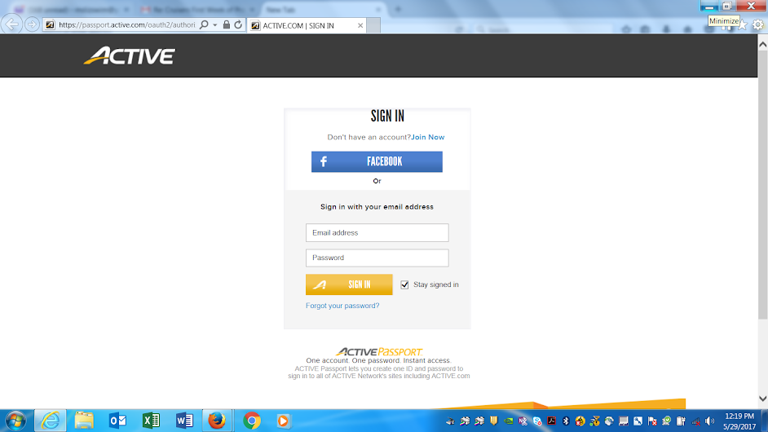

- At the top of the screen, you will see the season info and to the right, your account info.

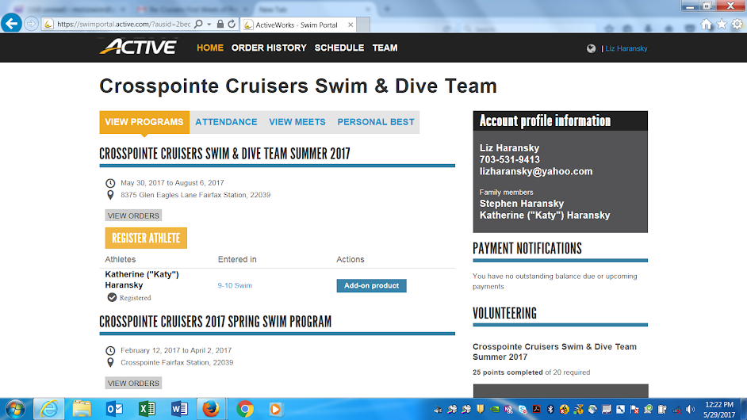

- Scroll down and you will see a section on the bottom right under "VOLUNTEERING," under which you will see all the event and meets for dive and swim. The meets and events are listed under (earliest to latest in reverse order). Click on a meet/event to view the volunteer positions. A new page will appear--scroll down just a bit to see the list of available open positions for the meet/event.

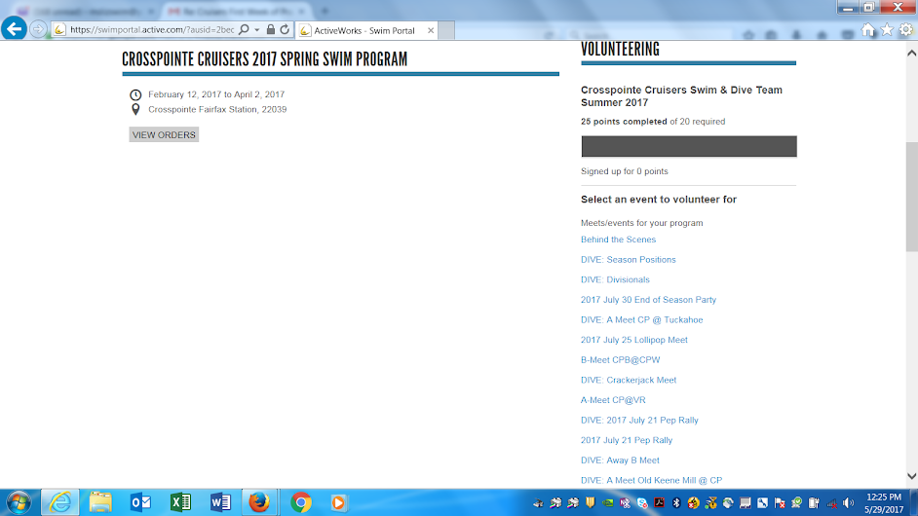

View Registered Upcoming Volunteer Positions
To see positions for which you have registered, in the Swim Portal click on "SCHEDULE" on the top bar. Your upcoming volunteer schedule will appear.

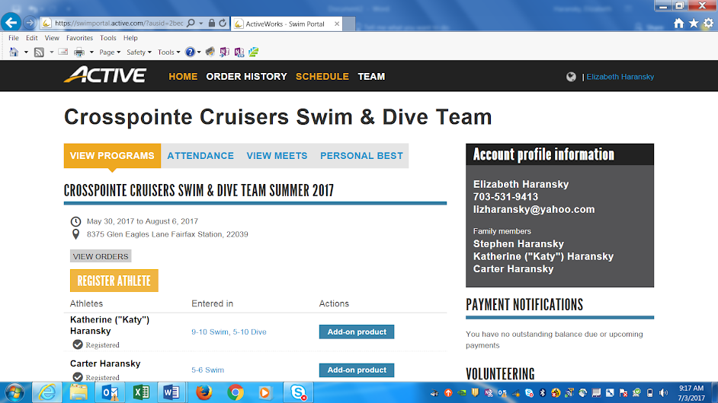

Delete Volunteer Positions
- In the Swim Portal, click on "SCHEDULE.”

- In a new screen, your upcoming volunteer schedule will appear. To delete the positions, click on "X REMOVE" on the same line as the volunteer position.
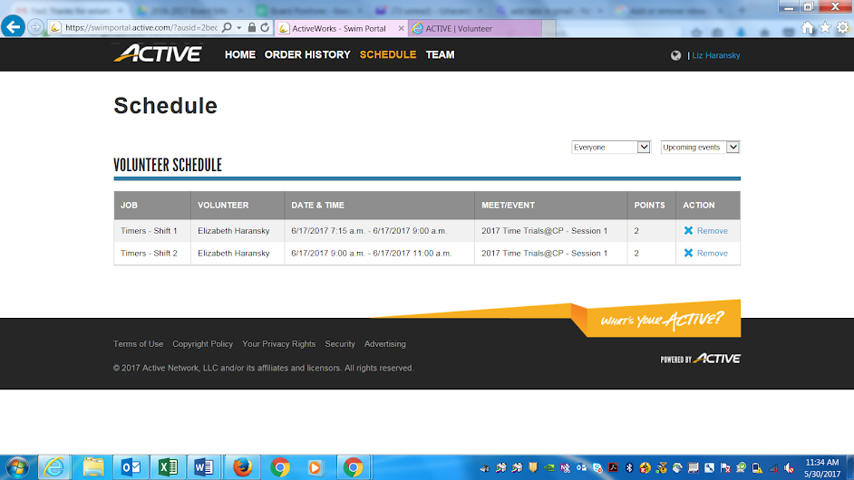.

View Family Points Status
In your Swim Portal log in, scroll down to VOLUNTEERING. A status progress bar indicates how many hours completed of the required hours.

Contact ActiveX (Swim Portal)
By email: swimtfsupport@activenetwork.com
Reference: Crosspointe Cruisers, Fairfax Station, VA

By telephone: 1-877-692-0111 ext. 3. Team Name: "Crosspointe Cruisers"

Other Questions/Issues
Contact the Volunteer Coordinator by email.

