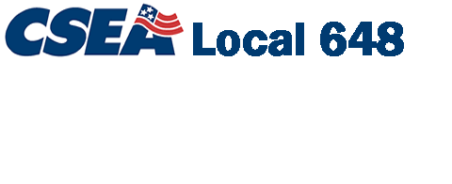
Binghamton University
CSEA Local 648 Scholarship
$200 Scholarship Award for 2022-2023 Academic Year

A total of five ($200) CSEA scholarships will be awarded for college, university or certified technical school tuition. Students may attend either Summer 2022,
Fall 2022, or Spring 2023 semester.

Eligibility: All CSEA Local 648 members in good standing.

Scholarship award may be used by member, spouse, or dependents (must be claimed as such on member’s income tax return).

Ineligibility: 2021-2022 scholarship winners are not eligible for this year’s drawing.

Application must be received by Friday, July 29th at the Union Office. Five recipients will be drawn at random along with three alternatives at the CSEA Office on September 10th.

To receive the $200.00 award: 1) the winners must complete at least one three-credit hour course (*or a technical course in which a GPA is associated with certification); 2) upon completion, winner must provide proof of completion to the CSEA Union Office, LSG-407 (i.e. transcript, etc.).

- - - - - - - - - - - - - - - - - - - - - - - - - - - - - - - - - - - - - - - - - - - - - - - - - - - - - - - - - -

Must receive application by July 29th, 2022.

Date: ___________________________________________________________

Member’s Name: _________________________________________________

Member’s Address: _______________________________________________

Department: ______________ Work # and e-mail _____________________

Student’s Name: ____________________________ (Must be a member, spouse or dependent – If you have two or more enrolled students in your family – you may submit a separate form for each; however, only one family member will receive the award).

Attended: (please circle) Summer 22 Fall 22 Spring 23 semester

Relationship to member: ___________________________________________

Return completed application to: CSEA Union Office, LSG-407, Hours 7am-11am
*i.e. Ridley Lowell, Elmira Business Institute, BOCES.

