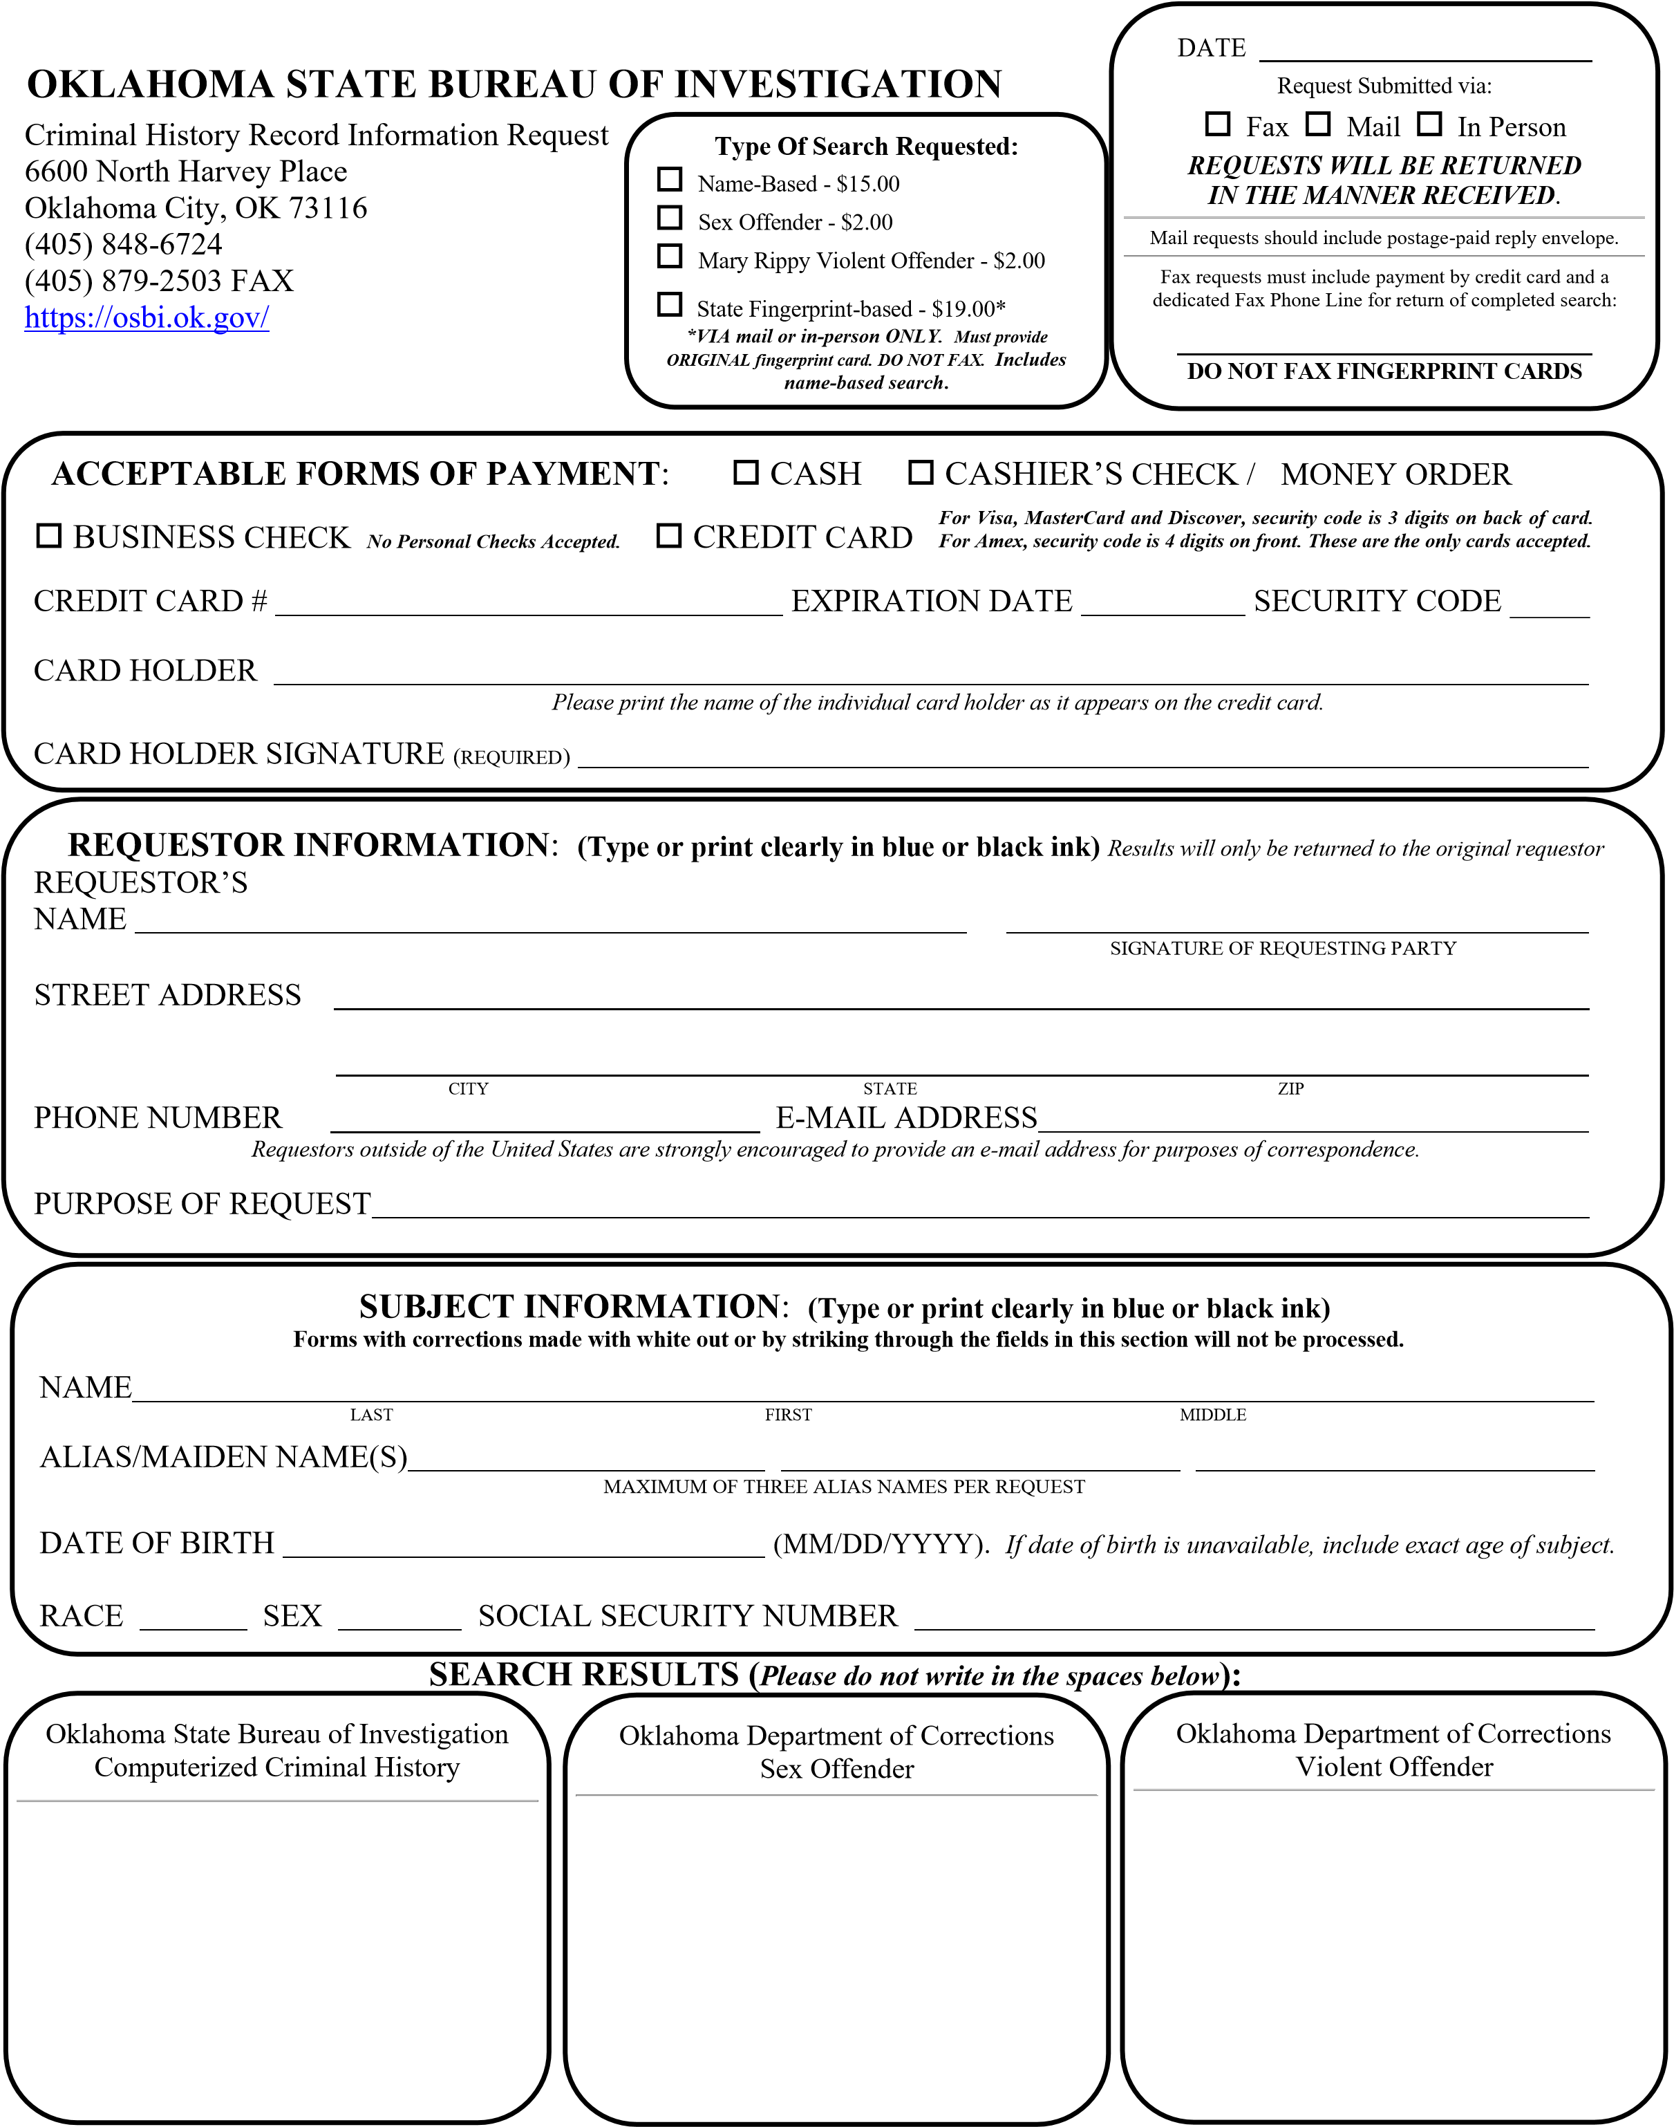
Unless fingerprint cards are provided, record information is furnished solely on the basis of name or description similarity with the subject of your inquiry. For questions on the Sex Offender / Violent Offender Registry, please contact the Oklahoma Department of Corrections. OSBI CHRU 12/2022

