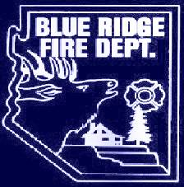

NOTICE:
BRFD BOARD MEMBER
VACANCY
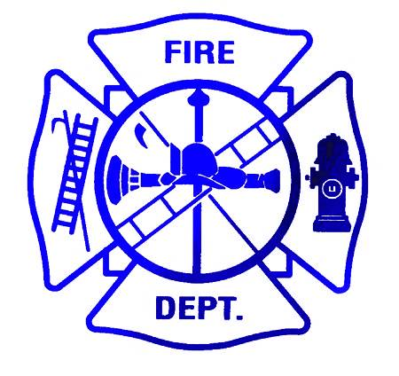

Inquire and pick up application forms at:
Blue Ridge Fire Station,
5023 Enchanted Lane,
Or on our web site: www: brfdaz.org
phone: 928-477-2751 with questions

Certain legal requirements apply.
APPLICATION DEADLINE:
Friday, November 30th, 2018 @ 5:30 PM
Board interviews will be conducted on December 8th, 2018
FINAL BOARD DECISION WILL BE MADE DECEMBER 8TH, 2018.

