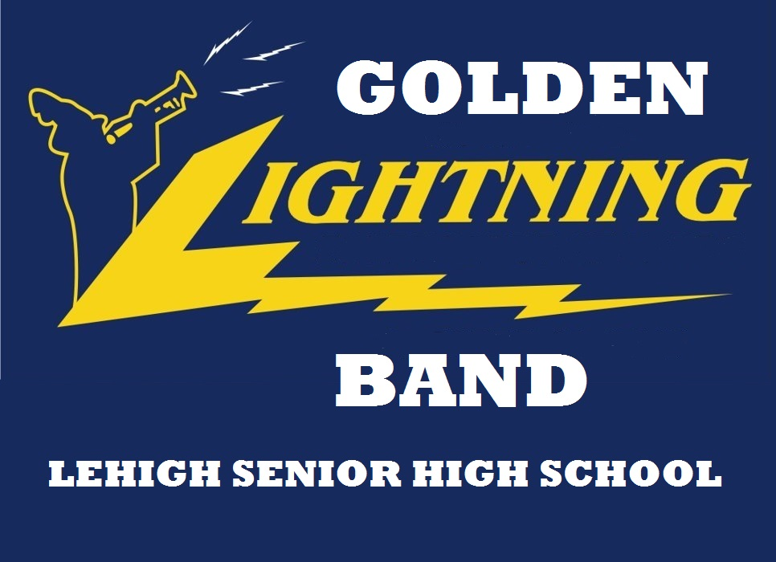
^{10th} Annual “Lightning Tournament of Bands” Advertisement Contract
Please note that it may be necessary to reduce / enlarge ads to fit actual ad size.
***ALL ADS ARE BLACK AND WHITE-NO COLOR ADS***
Date________ □ Cash or □ Check #_______ □ Family Patron Ad - $10
□ 1 /8 Page - $25
Amount Received $____________ □ 1 /4 Page - $50
□ 1 /2 Page - $100
□ Ad copy received □ Sponsor will Email ad copy** □ Full Page - $200
□ Inside Front Cover -$250
Golden Lightning Band Representative Signature: □ Inside Back Cover -$250
□ Outside Back Cover -$300
Ad sold by:_________________________________________________

Please make checks payable to “LSHS Band Parents Association”
Ad copy and payment MUST BE RECEIVED no later than Monday, September 23, 2019

**Ad copy may be emailed to lehighlightningbpa@gmail.com Please put LTB Ad in subject line of email

Postal mail address: LSHS BAND PARENTS ASSOCIATION c/o Jay Parales, Band Director
901 Gunnery Road, Lehigh Acres, FL 33971

A COPY OF THE OFFICAL REGISTRATION AND FINANCIAL INFORMATION MAY BE OBTAINED FROM THE DIVISION OF CONSUMER SERVICES BY CALLING TOLL FREE WITHIN THE STATE 1-800-HELPFLA. REGISTRATION DOES NOT IMPLY ENDORSEMENT, APPROVAL, OR RECOMMENDATION BY THE STATE.
_____________________________________________________________________________________________________________
----------------------------------------------------------------------------------------------------------------------
CUT HERE – LEAVE TOP PORTION WITH CUSTOMER AS THEIR RECEIPT.

PLACE THIS PORTION IN AN ENVELOPE WITH THE AD COPY AND PAYMENT AND TURN IN ASAP!
PLEASE “DO NOT” STAPLE THE ITEMS TOGETHER
***ALL ADS ARE BLACK AND WHITE-NO COLOR ADS***
Date________ □ Cash or □ Check #_______ □ Family Patron Ad - $10
□ 1 /8 Page - $25
Amount Received $____________ □ 1 /4 Page - $50
□ 1 /2 Page - $100
Business Sponsor _______________________________________________ □ Full Page - $200
□ Inside Front Cover -$250
Sponsor Contact______________________________ PH#_______________ □ Inside Back Cover -$250
□ Outside Back Cover -$300
Email address___________________________________________________

□ Ad copy enclosed □ Sponsor will email ad copy

Ad sold by: ___________________________________________________ Ph#: ____________________________

***Family Patron Ad only – Please print your message on line below. (100 characters maximum)***

_____________________________________________________________________________________________________

