WINDLESTONE PARISH COUNCIL

7 Front Street, Bishop Middleham, County Durham. DL17 9AJ
Tel: 07808062525 Email: karenyoung311@yahoo.com

ORDINARY MEETING

Time: 6.00pm Date: Tuesday, 5th March 2024 Venue: Hutton House, Chilton

Dear Councillor, you are hereby summoned to attend the above meeting at which the following business will be transacted.
AGENDA

- Welcome by the Chair
The Chair to open the meeting and make any necessary announcements.

- Apologies for Absence
To receive apologies for absence

- Declarations of Interest
To notify of items that appear on the agenda in which Members may have an interest.

- Minutes
To Approve the Minutes of the Ordinary Meeting of Windlestone Parish Council held on
16th January 2024 as an accurate record (attached).

- Matters Arising from the Minutes
To clarify or provide an update regarding any matter recorded in the Minutes of the Meeting held on 16th January 2024.

- Public Participation
To invite representation from Members of the Public.

- Finance
To approve and make payment for Expenditure incurred.

- Planning
To consider any matters in relation to Planning Applications submitted to the Local Authority in the Parish.

- Correspondence
To consider and report any correspondence received.

- Update RE: Council Website
To discuss options for a new Parish Council Website

- Update RE: Damaged/Loose Bollards at the end of Eden Gardens
To consider response from DCC RE: Suggestion to replace loose bollards with Steel Barrier

- Update RE: Eden Arms
To receive an update regarding the Eden Arms

- Update RE: Windlestone Hall
To receive an update regarding Windlestone Hall

- Update RE: Rushyford Roundabout/Pedestrian Crossings
To receive an update regarding DCC Rushyford Roundabout Improvements Project

- Update RE: Community Bulb Planting/Floral Display Potential Project
To consider options for planting bulbs on grass verges in Windlestone Parish

- Definitive Map/Public Footpaths
Update from Members RE: Lapsed footpaths in the Parish

- Date & Time of Next Meeting
To agree the date and time of the next Meeting

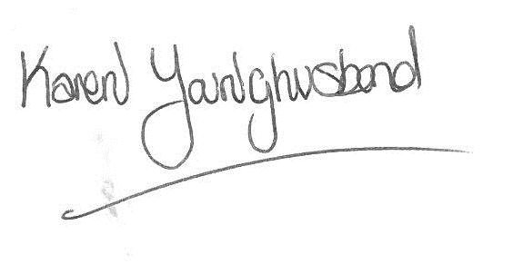
Karen Younghusband
Clerk Windlestone Parish Council

