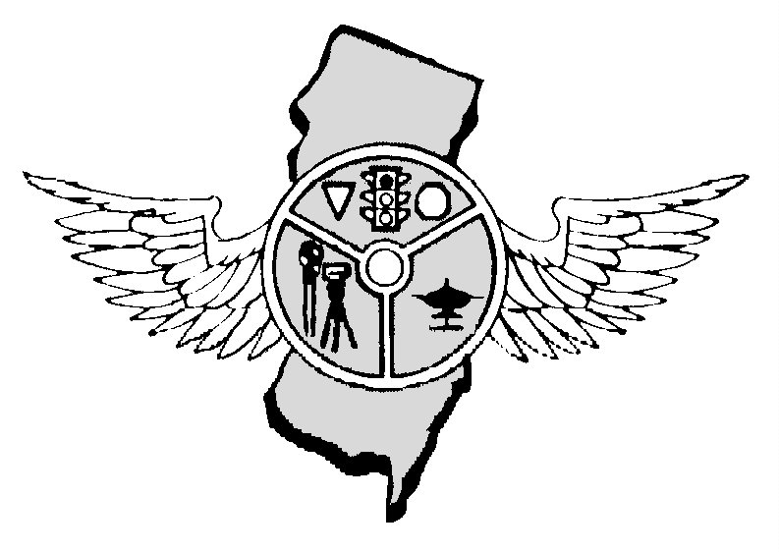

APRIL 2018 OUR 43rd YEAR

Nicholas Schock, President Tony Parenti, Executive Director, Editor Frank Fiore, First Vice-President Mark Wilson, Operations Secretary
N.J.P.T.O. A. P.0. Box 664, Voorhees, NJ 08043 - 856-220-1433 - NJPTOA.ORG or NJPTOA@HOTMAIL.COM
NEXT REGULAR BUSINESS MEETING: WEDNESDAY APRIL 4, 2018 beginning at 10:00 A.M. at AAA-Mid Atlantic, Hamilton, NJ.
PRESIDENT’S MESSAGE: As April fast approaches, so does National Distracted Driving Awareness month. I ask that all departments remain extra vigilant for these violations, especially during the statewide crackdown running April 1 - April 21. Upon completion of the mobilization, please report your data to the Division of Highway Safety even if you were not funded. The statistics will help secure funding in the future. Stay safe; see you in April (weather permitting!).
MOST VEHICLE REPAIRS: A six-point vehicle check is a gift that will keep on giving, both in better vehicle performance and fewer unexpected repairs this winter, says the Car Care Council. Inspecting six key systems ahead of time can save you the headaches and cost of an emergency breakdown later,” said Rich White, executive director, Car Care Council. “Regular vehicle maintenance is always more convenient when you’re doing it on your own schedule. By taking a few easy preventive maintenance steps now, you can have more confidence when driving in severe winter weather.” The Car Care Council recommends a six-point vehicle check before the New Year arrives: Battery – Keep the battery connections clean, tight and corrosion-free. Cold weather is hard on batteries, so it’s wise to check the battery and charging system for optimum performance. Because batteries don’t always give warning signs before they fail, it is advisable to replace batteries that are more than three years old. Antifreeze – Antifreeze (coolant) should be flushed and refilled at least every two years in most vehicles. As a reminder, do not add 100 percent antifreeze as full-strength antifreeze actually has a lower freeze point than when mixed with water. Brakes – Have the brake system checked. Brakes are critical to vehicle safety and particularly important when driving on icy or snow-covered roads. Tires – Check the tire tread depth and tire pressure. If snow and ice are a problem in your area, consider special tires designed to grip slick roads. During winter, tire pressure should be checked weekly as tires lose pressure when temperatures drop. Oil – Be diligent about changing the oil at recommended intervals and check the fuel, air and transmission filters at the same time. Consider changing to low-viscosity oil in winter, as it will flow more easily between moving parts when cold. In sub-zero driving temperatures, drop oil weight from 10-W30 to 5-W30 as thickened oil can make it hard to start the car. Wiper Blades – Cold weather can affect the life of windshield wipers, making the rubber hard and brittle and increasing the potential for cracks. Wiper blades that are torn, cracked or don’t properly clean your windshield should be replaced. Some manufacturers offer special winter blades that have a rubber boot covering the arm assembly to keep snow and ice out. When changing the blades, have the windshield wiper system nozzles cleaned and adjusted if necessary, and check the fluid level in the windshield washer reservoir. During the winter, the Car Care Council recommends keeping your vehicle’s gas tank at least half full as that decreases the chances of moisture forming in the gas lines and possibly freezing. Finally, if you’re due for a tune-up, consider having it done before winter sets in. Winter magnifies existing problems such as pings, hard starts, sluggish performance or rough idling. CINCO DE MAYO DRUNK DRIVING: Cinco de Mayo has become a night of fun and celebration in the United States - and a night of danger. Drunk driving on Cinco de Mayo threatens not just those enjoying the festivities, but others on the road as well. Law Enforcement Officers should step up their enforcement efforts on the 5th of May regardless if they have a celebration in their municipality or not.
TUNING FORKS: NJ Weights and Measures will be at our April 4 meeting to take care of the radar tuning forks for departments A-N and May 2 for departments M-Z. Please have your tuning forks bundled. There is a $10.00 charge for the test. MEETING CANCELLATION: If we have to cancel a meeting it will be posted on our website as soon as we find out the meeting is cancelled.

As of March 19, 2018 there were 102 fatalities on NJ roads compared to 93 during the same period in 2017, AN INCREASE OF 9 DEATHS.
COUNTY | 2018 | 2017 | CHANGE | COUNTY | 2018 | 2017 | CHANGE
Atlantic | 03 | 09 | -06 | Bergen | 04 | 02 | -02
Burlington | 11 | 08 | +03 | Camden | 10 | 08 | +02
Cape May | 02 | 01 | +01 | Cumberland | 04 | 02 | +02
Essex | 10 | 09 | +01 | Gloucester | 08 | 06 | +02
Hudson | 07 | 03 | +04 | Hunterdon | 00 | -0- | 00
Mercer | 04 | 07 | -03 | Middlesex | 09 | 08 | +01
Monmouth | 04 | 02 | +02 | Morris | 06 | 03 | +03
Ocean | 09 | 08 | +01 | Passaic | 02 | 03 | -01
Salem | 01 | 06 | -05 | Somerset | 06 | 04 | +02
Sussex | 01 | 01 | 00 | Union | 01 | 06 | -05
Warren | 00 | 02 | -02
Deaths: Driver,46; Passenger, 17; Pedalcyclist, 02; Pedestrian, 37. Crashes, 93.
TICKET MACHINES ON SCHOOL BUSSES: North Carolina last month became the latest state to enact a law expanding the use of automated ticketing machines on school buses. The Governor signed the legislation giving private companies the green light to mail traffic tickets of up to $1000 to the owner of vehicles accused of violating the state's bus passing rules. "Senate Bill 55 follows several instances of North Carolina students being hurt or killed by unsafe drivers while waiting for or attempting to get on or off the school bus, despite a state law requiring drivers to stop for stopped school buses," the Governor said. An analysis released Monday by the NHTSA reveals that the "drivers" who most often hurt or kill students are far more likely to be the ones behind the wheel of a school bus. NHTSA updates its tally of crashes involving vehicles used to bring children to school, and the conclusion has not changed over the past two decades. Incidents caused by automobile drivers illegally passing buses continue to be exceptionally rare. "Nearly two-thirds of the school-age pedestrians fatally injured in school transportation-related crashes were struck by school buses or vehicles functioning as school buses," the new NHTSA report found. In 2015, 11 students nationwide were struck and killed by a school bus. None were hit by automobiles while walking to or from a school bus. Over the past ten years, only 4 automobiles have ever struck and killed a school-age pedestrian after passing a school bus. In the same period, 62 child fatalities were caused by school bus drivers. Despite the results, NHTSA is currently preparing a report exploring the use of school bus cameras that is scheduled for publication early in 2018. Companies like Redflex Traffic Systems have struggled to turn a profit operating bus cameras due to the low volume of tickets issued. The North Carolina legislation was meant to come to the Australian company's rescue by boosting the price tag on a ticket to $250 for the first alleged offense, $400 for the second and $1000 for the third. Vehicle owners will not be fined if they pass a stopped bus from the opposite direction on a four-lane road if the road is considered "divided." If the road is not considered to be divided, the device will issue a ticket.
JERSEY CITY IS IN “VISION ZERO”: Jersey City becomes the first municipality in New Jersey to adopt the Vision Zero strategy, which began in Sweden in the 1990s and has since spread to cities like New York, Chicago, Los Angeles and Philadelphia. "During the past few months, Jersey City has been the scene of a number of tragic traffic fatalities that have each shaken our community and created a desperate need for a solution. Mayor Fulop said in a statement. "Signing on to 'Vision Zero' is our latest, and hopefully our final, initiative to eliminate traffic fatalities on our city's roadways." There have been three fatal crashes in Jersey City so far this year, including a pair of wrecks on Jan. 23 and Jan. 27 that claimed two lives. Jersey City averages about 300 traffic crashes involving pedestrians each year, according to Fulop's order. On average, nine people are killed each year in Jersey City on local, state and county roads. However, the executive order comes on the heels of a year that saw 14 people killed in Jersey City crashes, including 8-year-old Jerry Grant, who was fatally struck by an SUV on Oct. 28 on Christopher Columbus Drive and Grove Street. The city will send representatives including city's divisions of engineering, planning, parking enforcement, as well as the Jersey City police and fire departments, and Jersey City public schools.
POLICE MEMORIAL SERVICE: On this day we honor heroes who have paid the ultimate sacrifice. This tribute was the first Memorial Service held in the United States and was brought about by Chief Bruce Phillips of Holmdel who passed away recently. The service is at the Great Auditorium in Ocean Grove, New Jersey on Tuesday, May 22, 2018 beginning at 11:00 a.m. Please make an effort to attend, and invite other personnel from your department to join you. This is a good opportunity to show respect for fallen officers.
NEXT REGULAR MEETING APRIL 4, 2018 AT AAA MID-ATLANTIC, HAMILTON, NJ
REMEMBER TO WEAR YOUR SAFETY BELTS AND BULLETPROOF VEST WHILE ON DUTY

NJ Police Traffic Officers Association
PO Box 664
Voorhees, NJ 008043
856-220-1433
E-MAIL: njptoa@hotmail.com

2018 INVOICE

DATE | ITEM | AMOUNT
1/1/2018 | Annual Membership Dues for Police Department | $50.00
 | TOTAL: | $50.00

DATE: 1/1/2018 SIGNED: NICHOLAS SCHOCK, President
Our Tax ID number is 22-2344113
Copies of purchase orders can be faxed to 856-783-0012 or scanned for an e-mail and sent to NJPTOA@Hotmail.com.

Note: If you would like to receive the newsletter by e-mail instead of by postal mail, please send your request to njptoa.tparenti@gmail.com

(Please check mailing label. Correct if necessary by phone call, text, or e-mail)

